**1. General Provisions**

**1.1 Basic definitions and classification**

The principle of organizing a satellite communication and broadcasting system is quite simple: with the help of a launch vehicle, an artificial Earth satellite (AES) is launched into a given orbit around the Earth, on board of which a transmitter-receiver unit (radio relay) is placed, earth stations are installed on Earth with parabolic antennas and with devices for continuous guidance on the satellite antenna. Signals at fixed frequencies sent from an earth station are received and amplified by an artificial satellite radio relay and, after conversion to other frequencies, are emitted by an artificial satellite antenna in the direction of correspondent earth stations, where they are received, amplified and converted until a message is allocated.

We give definitions of the basic concepts related to Satellite Communication Systems (SCS), guided by the “Radio Regulations” [1], GOST and the established practice of applying the terms.

***Space radio communication*** - radio communication in which space stations located on a satellite or other space objects are used.

A ***space station*** (SS) is a station located on an object that is located outside the main part of the Earth’s atmosphere (either located there or intended for output), for example, on an artificial satellite.

***Earth station*** (ES) - a radio communication station located on the earth's surface (or in the main part of the earth’s atmosphere) and intended for communication with space stations or with other earth stations through space stations or other space objects, for example, passive (reflective) satellites. Unlike earth stations, stations of terrestrial radio communication systems that are not related to space communication systems or radio astronomy are called terrestrial.

***Satellite communications*** - communications between earth stations through space stations or passive satellites. Thus, satellite communications is a special case of space radio communications.

***Satellite line*** - a communication line between earth stations with the help of one satellite, in each direction includes the Earth – Space section (Figure 1.1) (“line up”) and the Space – Earth section (“line down”) .

Space station

**ES**

**ES**

**ITS**

**ITS**

Космическая станция

ЗС

ЗС

МТС

МТС

Космическая станция

ЗС

ЗС

МТС

МТС

Космическая станция

ЗС

ЗС

МТС

МТС

Космическая станция

ЗС

ЗС

МТС

МТС

Космическая станция

ЗС

ЗС

МТС

МТС

Космическая станция

ЗС

ЗС

МТС

МТС

Космическая станция

ЗС

ЗС

МТС

МТС

Космическая станция

ЗС

ЗС

МТС

МТС

Figure 1.1 - Satellite line

***Satellite broadcasting*** - the transmission of broadcasting programs (television and sound) from transmitting earth stations to receivers through a space station - an active repeater. Thus, satellite broadcasting is a special case of satellite communication, characterized by the transmission of a certain class of one-way (simplex) messages received simultaneously by several ACs or by a large number of receiving stations (circular transmission).

Earth stations are connected to switching nodes of communication networks (for example, with a international telephone station - ITS), sources and consumers of television and sound broadcasting programs using landlines, or are installed directly at information consumers.

Depending on the type of earth stations and the purpose of the system, according to the Radio Regulations, the following communication services are distinguished:

- fixed satellite service (FSS) is a radio communication service between earth stations with a given location when one or more satellites are used. These ES stations located at fixed points on the surface of the Earth are called FSS earth stations. The fixed-satellite service also includes feeder links (lines for delivering programs to the space station) for other space radiocommunication services, for example, for broadcasting satellite or satellite mobile services.

The main signals transmitted through the FSS communication lines are the signals of telephony, data, telegraphy, facsimile, television and sound programs.

The communication lines down which the signals of the last two mentioned transmission modes are directed are excluded from the FSS if they are directly received by the general public, since then they belong to the broadcasting-satellite service (BSS).

FSS systems are designed to provide communication between stationary users. Initially, they were deployed exclusively for the organization of highways and regional (zone) communications. Such systems based on VSAT terminals are used in electronic commerce networks, exchange of banking information, wholesale bases, trading depots, etc.

The most significant commercial fixed-line systems include Intelsat, Intersputnik, Eutelsat, Arabsat and AsiaSat;

- mobile satellite service (MSS) - between mobile spacecraft (or between mobile and fixed spacecraft) with the participation of one or several space stations (depending on the location of the mobile spacecraft, land, sea, air mobile satellites are distinguished services).

Initially, mobile ground stations were developed as special-purpose systems (sea, air, automobile, and rail) and were aimed at a limited number of users. The first generation mobile CCCs were built using geostationary spacecraft with direct (transparent) transponders and had low bandwidth.

MSS subsystems were created mainly for networks having a radial or radial-node structure with large central and base stations, which provided work with mobile ground stations. The flows in the networks with the provision of channels on demand were small, therefore, they mainly used single- or small-channel ground stations. Typically, such networks were intended to create departmental and corporate communication networks with remote and mobile objects (ships, airplanes, cars, etc.), to organize communications in government agencies, in disaster areas, and in emergency situations.

At present, the division of MSS systems by types of information transmitted on the radiotelephone communication network (Inmarsat-A, -B and -M, AMSC, MSAT, Optus, AceS) and data transmission systems (Inmarsat-C, Omnitracs, Euteltracs, Prodat )

Of all MSS systems, the most powerful orbital group belongs to the Inmarsat international system;

- broadcasting-satellite service (BSS) - a radio communication service in which the signals of space stations are intended for direct reception by the population. In this case, both individual and collective reception is considered direct; in the latter case, the broadcast program is delivered to individual subscribers using a particular terrestrial distribution system — cable or over-the-air — with a low power transmitter. Note that the term "broadcasting" combines television and sound broadcasting. The broadcasting-satellite service defined in this way does not include all types of satellite broadcasting systems, but only those that are designed to receive relatively simple and inexpensive receiving installations with a quality sufficient for the subscriber, but often lower than it is required from the main lines for the submission of programs to terrestrial broadcasting stations.

Currently, all broadcasting systems are built on the basis of satellites in a geostationary orbit.

The following frequency ranges are allocated for RCC systems: C (4/6 GHz), Ku (11/14 GHz).

Table 1.1 shows the international names of the frequency ranges used in satellite communication and broadcasting systems and the services in which these frequencies are applied.

  Table 1.1 - Frequency ranges for satellite communications

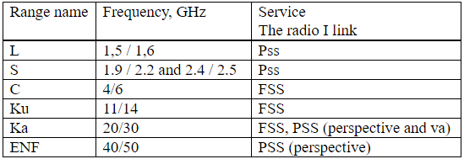

Frequency sharing and interference. Many frequency ranges according to the ITU Frequency Allocation Table and the notes thereto are allocated to several services. This means that these frequency ranges are shared.

The ITU Radiocommunication Regulation defines three categories of allocations: primary, authorized and secondary services. Primary and authorized services have equal rights, with the exception that when preparing frequency plans, the primary service will have priority over the choice of frequencies over the authorized service. Secondary services are not entitled, compared with primary or authorized services, with respect to the possibility of transmitted or received harmful interference. They can only claim protection from other secondary services, the frequencies for which are allocated later. When the frequency range is allocated to one service, it is necessary that the interference between different networks of this service does not exceed the allowable limits. When a band is shared between two or more services, similar methods are used to ensure that stations in secondary services do not interfere with stations in primary services and that interference between stations in services with equal status distributions does not exceed acceptable limits.

Depending on the type of information transmitted, there are distinguished universal multifunctional systems whose AP exchanges different types of information (such as Intelsat, Orbit, Canadian CCC Tel-esat, etc.), and specialized ones for the transmission of one type or not - several homogeneous types of information (for example, the Ekran satellite-based broadcasting system, NTV-Plus for the circular distribution of television and sound broadcasting).

According to the covered territory, location and affiliation of the AP, the management structure of the CCC can be divided into:

- international, which includes stations of various countries; such systems can be global (with worldwide coverage) or regional.

An example of an international global system is Intersput-nick.

International regional systems include such systems as Evtelsat (Europe and North Africa), Arabsat (Arab countries) and others;

- national, all APs of which are located within one country, including zone ones, all APs of which are located within one of the zones (regions) of the country, and departmental (business, company) systems, APs of which belong to one department ( organizations, the company) and transmit only business information and data in the interests of the agency (Bank of Russia Dedicated Satellite Communications Network “Banker”).

**1.2 Principles of building a communication line and broadcasting**

1.2.1 The main components of a satellite communications system:

- the space segment of the satellite communications system consists of satellites and ground equipment, providing the functions of tracking, telemetry and transmission of telecommands (TTC) and the material and technical supply of satellites.

- earth segment. The term "earth segment" refers to the part of the satellite communications system, which is formed by earth stations used to transmit and receive any kind of communication traffic signals transmitted to and from the satellite and forming a junction with terrestrial networks.

There are currently four major satellite communications network technologies. All of them have their own advantages and disadvantages, and not one of them is universal. To improve the efficiency of work in many modern networks, several technologies are successfully combined at the same time. The main difference between them is the method of using the satellite transponder resource.

Consider these technologies:

- SCPC (Single Channel Per Carrier) is actively used to build small networks with heavy traffic. Each SCPC that implements SCPC has a dedicated constant segment of the capacity of the satellite transponder and maintains a constant connection. The main advantage of this technology is that it guarantees the necessary transmission capacity of the satellite communication channel, and the main disadvantage is the lack of the ability to dynamically redistribute the relay resource between network nodes;

- DAMA (Demand Assigned Multiple Access) provides a satellite relay resource on demand. In networks with DAMA technology, the communication channel is allocated to the user only for the duration of the communication session, which significantly saves the resources of the satellite repeater. The channel structure in this network is similar to the SCPC channel structure. Some implementations of DAMA technology provide the ability to establish connections with different bandwidths for different communication sessions. DAMA is ideal for creating telephone networks with a fully connected topology. The relay resource is distributed by the central station of the network, which can be considered the main disadvantage of the technology, since the functioning of the entire network depends on the state of one station;

- TDMA (Time Division Multiple Access) provides multiple stations with dynamic access to a common channel with time division. Unlike DAMA technology with its sufficiently long connection setup time, such access is provided much faster. However, TDMA network ZSSs are quite expensive, since any of these stations - even with the smallest traffic - must transmit data at a rate equal to the total bandwidth of the time-shared channel. In TDMA networks, a central control station is generally absent;

- TDM / TDMA (Time Division Multiplexing / Time Division Multiple Ac-cess) - a combined network technology with a star topology. In the TDM / TDMA network, the central AP communicates with user stations using one or more fixed TDM channels (with time multiplexing), and user stations access the central AP via TDMA channels. Since all user stations directly interact only with the central MSS, it becomes possible to use rather low-power stations, compensating for the lack of their energy using a large diameter antenna and a powerful transmitter at the central MSS. Due to this imbalance of station parameters, it is possible to significantly reduce the cost of projects with a large number of user stations. The mandatory presence of a central AP (performs the function of a network hub) determines the high requirements for its availability - because the functioning of the entire network depends on the state of this station.

In a TDM / TDMA network, data transmitted between any two user stations passes twice through a relay satellite (“double hop”). In this case, a significant (1-2 s) signal delay occurs, which makes this network less suitable for the use of telecommunication applications that are sensitive to such delays.

Support for the core technologies discussed above is implemented in many modern satellite communications hardware. Very often it makes sense to apply several technologies at the same time on the same network. For example, a combination of TDM / TDMA and DAMA technologies can be recommended for building a large-scale corporate telecommunications infrastructure. The latter of them will provide telephone and facsimile communication, make it possible to organize audio and video conferencing, while using the TDM / TDMA subnet, it will be possible to transmit data.

Satellite transmission systems are characterized by a specific combination of signal processing in the group frequency band, compression, modulation and multi-access.

Multiple access is the ability of several earth stations to transmit their signals simultaneously to the same satellite transponder, which allows any earth station located in the corresponding coverage area to receive signals sent by several earth stations.

And also, the signal sent by one earth station to the repeater can be received by several earth stations located in the corresponding coverage area.

Consider multiple access according to the type of sharing of the repeater. Three main categories correspond to this approach: frequency division multiple access (FDMA), where each station has its own carrier frequency; time division multi-station access (TDMA), where all stations use the same carrier frequency and time division bands; Code Division Multiple Access (CDMA), where all stations are simultaneously, sharing a single band, and the signals are differentiated by code combination.

Of all the methods of multiple access, frequency division multiple access (FDMA) is most widely used in satellite communication systems. FDMA works by issuing different frequencies for each respective earth station, so that the satellite resources are shared between them. This system is currently used for international communications. The harmful effect of such a system is that many signals pass through the satellite’s repeater at the same time, resulting in noise caused by intermodulation between these signals due to the non-linearity of the repeater. In order to reduce intermodulation interference, it is necessary to maintain the output power level at the output much lower than the saturation point. This is called "power reduction." In addition, the transmit power at the output of each earth station must be precisely controlled.

FDMA can be introduced with various modulation-multiplexing methods, such as ChRK-FM (frequency division of channels - frequency modulation), VRK-FMn (time division of channels - phase manipulation) and OKN (one channel per carrier). The most widely used method is ChRK-FM, in which the carrier signals are modulated in frequency by a group-band signal obtained by the frequency combination of channels. The OKN method for each telephone channel uses its own carrier signal of a radio frequency with modulation of FMN and FM; It is suitable for earth stations with a relatively small number of channels.

The use of digital methods such as VRK-FMN and error correction coding, instead of frequency modulation in systems with FDMA, provides an increase in the capacity of the repeater.

Time Division Multiple Access (TDMA) is a digital multiple access method that allows a satellite to receive signals from individual earth terminals at separate non-overlapping time intervals called packets in which information is compressed (for example, PCM telephony) . In this process, the components of intermodulation are not formed in the nonlinear repeater, as is the case with FDMA, since only one signal passes through the satellite relay at this time. Each earth station should determine the time and distance of signal propagation to the satellite and the moment when the signal must be sent so that it arrives at the satellite in the allotted time interval. Figure 1.2 shows a typical network configuration with TDMA, in which each packet of bits with a high signal speed arrives at the satellite at its assigned time interval.

Compared with the FDMA system, the system with TDMA has the following features:

* due to the lack of influence of intermodulation, the repeater on the satellite can work almost in saturation mode, which provides more efficient use of satellite power;
* with TDMA, the capacity does not drop sharply with an increase in the number of stations. The use of CIR (digital speech interpolation) allows you to double the capacity of the transmission system. The INTELSAT-V satellite repeater with a bandwidth of 80 MHz, as a rule, can provide about 1600 channels (without DIR) and 3200 channels (when using DIR) at a speed of 64 kbit / s in the channel.

Introduction of new traffic requirements and its changes are easily ensured by changing the length of packets and their positions.

When working with systems TDMA there are several different problems associated with synchronization.

In order to demodulate the packages of PSK signals, it is necessary to restore non-existent and clock frequencies within the sequence at the beginning of each packet. For this, the TDMA demodulator typically has very high speed circuits for recovering carrier and clock frequencies.

Another critical synchronization problem arises when timing packets at each access station to prevent packets from overlapping in the satellite relay. This control is called packet synchronization, which is performed so that each packet retains a certain distance in time relative to the position of the reference packet (received from the control station) in the satellite relay.

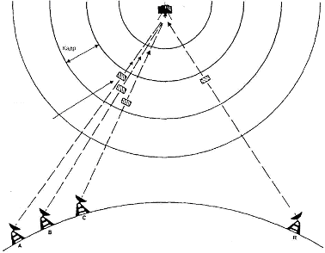

Frame

The position of the currently transmitted packet

Earth Terminals Control station

Figure 1.2 - TDMA Network Configuration

The third category of multiple access systems, in which the signals use the entire bandwidth of the repeater at the same time: these systems use spread spectrum methods, they are called CDMA systems. With this transmission method, a specific code is assigned to each signal transmitted to the satellite. At the reception, from all the received signals, the station extracts the signal intended for it according to the code and extracts the basic information. For this operation, when it is necessary to identify one signal among several others that share the same frequency band at the same time, the correlation method is usually used.

1.2.2 Qualitative indicators of satellite channels.

Satellite channels in accordance with ITU-R and ITU-T documents are usually normalized as follows:

 - norms for the channel parameters of the PM or group paths, depending on the channel length, correspond to the norms for channel parameters of the land line with a length of 5000 km;

 - in terms of quality indicators, depending on the length, the channels of air pollutants and TV channels are equal to the channel of a land line with a length of 2500 km;

- the satellite image channel with respect to signal-visometric noise is equivalent to a channel of a land line with a length of 5000 km, and for other indicators - to a channel of a land line with a length of 2500 km. From here, for example, the norms of the signal-visometric noise ratio for the satellite channel can be determined as follows:

### КС

### ЗС

### ЗС

Figure 1.3 - SCE for the line Earth - AES – Earth

20lg 0,7B/Uшвиз=57+10lg 2500/5000=54дБ(1,0%).

TV channels (image channels): for normalization and comparison of channels with different structures and lengths, hypothetical reference chains (SCEs) are used. Figure 1.3 shows the SCE for the Earth-AES-Earth line, and at the transmitting station there is a modulator for transferring the modulating spectrum to the RF carrier, and at the earth receiving station there is a demodulator for separating the spectrum of modulating frequencies. During normalization, active connecting lines between the satellite system AP and switching centers are not included in the SCE.

One of the most important indicators is normalized in the image channels - the signal-visometric noise ratio.

The frequency response of the visometric (weighing) filter allows you to take into account the properties of vision in the perception of fluctuation interference in various parts of the spectrum. At present, a weighting filter according to Rec. MKKR567-3 with a time constant of τ = 245 ns (in previously implemented systems, a filter with τ = 330 ns is used). The filter time constant characterizes the decrease in its frequency response. Using the dependence 2πf√22 × τ = 1, we can determine the frequency f√22, by which the decay of the frequency response is 3 dB.

Qualitative indicators of the analogue channels of the TVS and ZV satellite systems correspond to the data given in table 1.2.

A number of additional parameters are standardized in digital channels, including immunity to quantization noise. In the upper class channels used for transmitting stereo broadcast signals, a number of additional parameters are also normalized (the gain difference in channels A and B is from 0.8 to 3 dB in different parts of the band, the phase difference is 15 ... 40 °, distinct transition conversations –50dB, etc.).

Table 1.2 - Standards for pollutant channels (HEC) established by ITU-T recommendations.

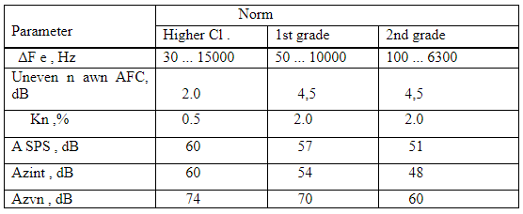

In order to provide the required signal-to-noise ratio in the channels of the TVS and ZV channels, pre-emphasis (PC) - recovery (VK) and compander circuits are used. Currently, in satellite analog systems with the transmission of signals of the TVS and ZS pollutants on subcarriers, circuits with a time constant of τ = 75 μs are used, in Rec. ITU-R 651 proposes a PC with τ = 15/50 μs for a digital sound coding system.

PM channels and group paths: the SCE scheme shown for the image channel is also valid for this case. Standards for PM channel parameters are set in accordance with ITU recommendations. As for group paths, almost all the norms for satellite system paths coincide with the corresponding norms for group paths of terrestrial transmission systems.

The development of communication equipment should take into account requirements for the quality of transmission at the output of a hypothetical reference digital communication line (Recommendations 521 and 622). These requirements in relation to a telephone with pulse-code modulation (PCM) are characterized by the maximum permissible bit error rate (BER) and are equal to the following values:

BER <10-6, 10 min. average value for more than 20% of any month;

BER <10-4, 1 min. average value for more than 0.3% of any month;

BER <10-3, 1 s average value for more than 0.01% of any year.

For services other than telephony, these limits may be different: in particular, when transmitting data, the maximum allowable error rate can be significantly lower.

**2 Satellites orbits and service areas**

**2.1 General**

Figure 2.1 - The orbit is elliptical

Orbit is the trajectory of the motion of an artificial Earth satellite.

After the satellite is put into orbit, rocket engines are turned off, and the satellite, like any celestial body, moves by inertia and under the influence of gravitational forces, the main of which is Earth's gravity.

If we accept that the Earth is an ideal ball and only the Earth's gravitational force acts on the satellite, then the satellite’s motion obeys Kepler’s laws known from astronomy. The orbit has the shape of an ellipse (Figure 2.1), in one of the foci (and not in the center) of which the Earth is located. The orbital plane passes through the center of the earth and remains stationary in time. Since energy is not consumed when moving in airless space, the total mechanical energy of the satellite (kinetic and potential) does not change for a long time. This leads to the fact that when moving away from the Earth, the speed of the satellite and its kinetic energy decrease, while approaching the Earth they increase. Equation of the satellite elliptical orbit in the polar coordinate system

r = p / (l + ecosq) (2.1)

where r -is the modulus of the radius vector (i.e., the distance from the satellite to the center of the earth);

q -is the angular coordinate of the radius vector (astronomers call this angle “true anomaly”);

e- is the eccentricity of the orbit;

p = b2 / a = a (1 - e2) - focal parameter;

a, b - major and minor semiaxes of the ellipse.

The eccentricity e can have values ​​in the range 0 <e <1. At e = 0, the ellipse turns into a circle, the foci merge with the center, r = p. The orbit point corresponding to the minimum distance to the center of the earth is called the perigee point of the orbit (r = rп); the maximum point of apogee (r = ra). The angles are counted from the direction to the perigee in the direction of satellite motion, i.e. perigee corresponds to qп = 0, and apogee - qа = 180 °.

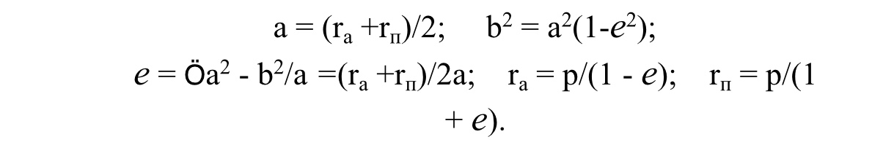The parameters of the ellipse are interconnected by the relations

The focal points of the ellipse are distant from its center by a distance ae. Altitude of the orbit (satellite height above the Earth's surface) H = r - R, where R is the radius of the Earth.

Figure 2.2 - Orbital plane

An important characteristic of the satellite’s orbit is the inclination of its plane to the plane of the Earth’s equator, characterized by the angle i between these planes (Figure 2.2). The inclination distinguishes equatorial (i = 0), polar (i = 90 °), inclined (0 <i <90 °, 90 ° <i <180 °) orbits.

Figure 2.3 - Geocentric system OXYZ

The point at which the orbit crosses the equatorial plane as the satellite moves north is called the ascending node of the orbit (point A in Figure 2.2). The point of intersection of the radius vector with the Earth’s surface, drawn to the satellite’s location from the center of the Earth, is called the sub-satellite.

Obviously, from the sub-satellite point C (Figure 2.3), the satellite is seen at its zenith, i.e. the axis axis of the AP antenna when pointing it at the satellite should

be perpendicular to the surface of the earth.

At any other point N of the earth's surface, the position of the axis NB of the beam of the AP antenna differs from zenith and is characterized by two angular magnitudes: azimuth A and elevation angle g.

Figure 2.3 shows two coordinate systems - geocentric and topocentric.

The OXYZ geocentric system originates in the center of the Earth, the ХОY plane coincides with the equatorial plane, the OZ axis is directed from the center to the north pole, the ОX axis is directed to the spring equinox (in the case of the so-called inertial geocentric system shown in the figure 2.3) or lies in the plane of the initial meridian, for example, Greenwich (then it is a relative geocentric system that preserves the same position relative to points on the Earth's surface); the OY axis complements the system to the right. The topocentric system NxhV has a beginning at point N on the Earth's surface. The xNV plane (tangent to the Earth’s surface at point N, the Nx axis is directed north, that is, along the tangent to the meridian passing through N, the Nh axis is normal to the Earth’s surface, i.e., along the radius ON, in side from the center of the Earth, the axis NV complements the system to the right. The direction from the N point of the satellite is shown in Fig. 2.3 by the NB line. The projection of NV onto the NxhV plane is the ND line, the NBD plane is perpendicular to the tangent plane NxhV.

Now you can define the elevation angle (elevation angle) as the angle BND between the direction to the satellite BN and the projection ND of this direction on the plane tangent to the Earth’s surface, and the azimuth as the angle between the direction to the north Nx and the projection ND of the direction to the satellite on the tangent plane. The position of point N on the earth's surface is characterized by its longitude lN, the angle between the Greenwich meridian plane and the plane of the meridian passing through N and latitude j N, the angle between the radius ON and the equator plane.

Knowing the coordinates of the satellite in a geocentric system, we can calculate the azimuth A and elevation angle g for any point N. In this case, we must take into account the non-ideal surface of the Earth, the height of the point N above the surface of an ideal globe [3]. If we consider the Earth as an ideal ball, the station’s elevation above sea level is zero, with the satellite’s orbital period exactly equal to stellar days, then the azimuth and elevation angle for an AP antenna working with a geo-stationary satellite can be calculated from:

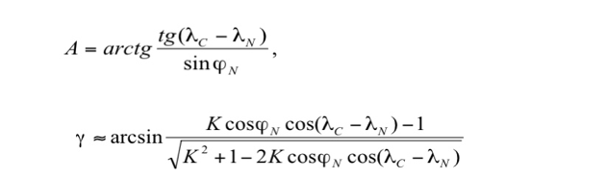

where lс is the satellite longitude;

lN is the longitude of the earth station;

К = Н + RЗ = 42,170 km is the radius of the orbit relative to the center of the Earth;

RЗ = 6.63 thousand km - the radius of the Earth;

H = 36 thousand km - the height of the orbit;

a = A + 1800 for earth stations located in the Northern Hemisphere and satellites located west of the earth station;

a = 1800- A for earth stations located in the Northern Hemisphere and satellites east of the earth station;

a = 3600- A for earth stations located in the Southern Hemisphere and satellites located west of the earth station;

a = A for earth stations located in the Southern Hemisphere and satellites east of the earth station;

g is the geometric elevation angle of the point in the geostationary orbit;

jN is the latitude of the earth station.

By a certain value of the elevation angle you can find the boundary of the satellite visibility zone.

A satellite’s visibility zone is understood to mean the Earth’s surface, from which the satellite can be seen at an elevation angle greater than some acceptable value. In reality, in order to avoid shadowing of the satellite by terrestrial objects, elevations, as well as an increase in noise due to reception of noise radiation from the Earth, the boundary of the radio visibility zone is determined from the condition g> 5 ° or g> 10 °.

The minimum elevation angle is primarily affected by the attenuation of radio signals in the atmosphere (due to heavy rainfall). For frequencies above 10 GHz, the signal attenuation level significantly affects the required elevation angle, transmitter power reserves or system design. For example, a system having a 6/4 GHz band can operate with a minimum elevation angle of 50, while a system with a 14/12 GHz band requires a minimum elevation angle of about 100.

The part of the visibility zone, where the specified communication quality is ensured at certain parameters of the AP, is called the coverage area (in fact this is the service area, within which the mandatory EMC condition with other radio facilities must be fulfilled), and the ability to receive signals from earth stations having a certain equivalent isotropically radiated power.

The energy that is received from the satellite is determined by the power per specific area µW / m2. We can conclude that the larger the area we will shoot the signal that comes from the satellite, the greater the useful power we can use. This power is small, it is at the level of cosmic and thermal noise. Therefore, a useful signal must be received from such an area and from that point in space from which it will exceed the surrounding noise and the noise of the receiver itself. Thus, the satellite coverage area depends on the size of the receiving antenna: the larger the diameter of the antenna, the larger the coverage area.

Figure 2.5 shows the diameters of the receiving antennas in meters near the boundaries of the service areas.

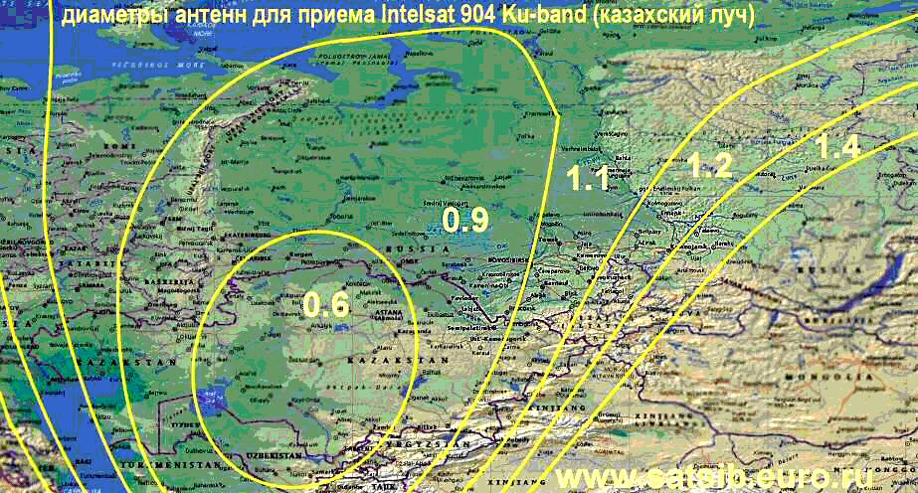

Figure 2.5 - Intelsat 904 Visibility Area (Ku-band Spot 2)

It is possible to form various service areas by changing the size and shape of the rays of satellite dishes.

The most important orbit parameter is the orbital period T, defined as the time between two consecutive passage of the satellite through the same point in the orbit. To establish communication, it is convenient for a satellite to appear over the same regions of the Earth at the same time. This requirement is met by synchronous orbits with a period of revolution multiple of the time of the Earth's revolution around its axis (stellar days, T3 = 23 h 56 min 04 s

According to Kepler’s laws, the lower the satellite’s orbit, the smaller the period of circulation. The parameters of several synchronous orbits are given in table 2.1.

In satellite communication systems (CCC), the main indicators determining the size of the service area, the quality of service and the energy of the radio links are the type of orbit and its characteristics.

The type of orbits used. According to this criterion, all CCSs are divided into two classes - systems with spacecraft (SC) in geostationary orbit (GEO) and in non-geostationary orbit. In turn, non-geostationary orbits are divided into low-orbit (LEO), mid-altitude (MEO) and elliptical (HEO).

Table 2.1 provides an opportunity to assess the advantages and disadvantages of satellite systems using spacecraft in various orbits.

Thus, a clear drawback of low-orbit systems is the large number of spacecraft needed to cover the entire Earth.

But the small altitude (relative to GEO) of the spacecraft allows the use of small space stations, the manufacture and orbit of which is much cheaper than the satellites placed in the geostationary orbit.

Table 2.1 - Characteristics of systems using spacecraft in GEO-, MEO- and LEO-orbits

|  |  |  |  |
| --- | --- | --- | --- |
| Indicator | GEO | MEO | LEO |
| Orbit altitude, km | 36000 | 5000-15000 | 500-2000 |
| The number of spacecraft in the orbital constellation for global coverage | 3 | 8-12 | 48-66 |
| Coverage area of one spacecraft (radio visibility angle 50),% of the Earth’s surface | 34 | 25-28 | 3-7 |
| Spacecraft stay in the radio visibility zone (per day) | 24 hour | 15-2 hour | 10-15 min |
| Speech Delay, ms |  |  |  |
| Regional communication | 500 | 80-130 | 20-70 |
| Global communication | 600 | 250-400 | 170-300 |
| Switching time from one satellite to another, min | Not required | 50 | 8-10 |
| Spacecraft radio visibility angle at the border of the service area | 5 | 15-25 | 10-15 |

Figure 2.6 shows the orbits of the spacecraft, the Van Allen radiation belts are highlighted in gray. At these altitudes, there is a very high concentration of charged particles captured by the Earth’s magnetic field, which, by bombarding the solar panels and the spacecraft’s body, destroy them. Therefore, spacecraft do not place spacecraft in radiation belts. Low orbits below the first radiation belt.

GLONASS spacecraft and 20,000 km GPS satellites are located above the second radiation belt at an altitude of 19,000 km. These are radio navigation satellite systems. The most distant geostationary orbit.

**2.2 Geostationary orbit (GSO)**

The orbit of the geostationary satellite is circular (eccentricity e = 0), equatorial (inclination i = 0 °), synchronous orbit with a rotation period of 24 hours, with the satellite moving eastward at an altitude of about 36,000 km.

The GSO orbit was calculated and proposed in 1945 by the English engineer Arthur Clark, later known as a science fiction writer, for communication satellites. In England and many other countries, the geostationary orbit is called the Clark Belt.

Most existing CCSs use the geostationary orbit, which is most advantageous for satellite placement, whose main advantages are:

- the possibility of continuous round-the-clock communication in the global service area and the almost complete absence of a frequency shift due to the Doppler effect;

- three satellites are enough to cover almost the entire territory of the Earth;

- no antenna movement system is needed to track the satellite.

The Doppler effect is a physical phenomenon consisting in a change in the frequency of high-frequency electromagnetic waves during the mutual movement of the transmitter and receiver. If the satellite moves in orbit, the Doppler effect will depend on the radial component of the velocity. This effect can also occur when the satellite moves in orbit. On communication lines through a strictly geostationary satellite, the Doppler shift does not occur, on real geostationary satellites it is little significant, and on highly elongated elliptical or low circular orbits it can be significant. The effect is manifested as the instability of the carrier frequency of the oscillations relayed by the satellite, which is added to the hardware instability of the frequency that occurs in the equipment of the onboard repeater and earth station. This instability can significantly complicate the reception of signals, leading to a decrease in the noise immunity of the reception.

The relative change in frequency at the receiver will be equal to

Δf/f0 = V× cosψ / с

where c is the speed of light;

V is the speed of the transmitter relative to the receiver;

Vr is the radial component of the speed of the transmitter relative to the receiver;

ψ is the angle between the velocity vector and the direction of communication.

Geostationary satellites, located at an altitude of about 36 thousand km and moving with the speed of rotation of the Earth, seem to “hang” above a certain point on the earth’s surface, which is located at the equator (the so-called sub-satellite point). In fact, the action of forces associated with the ellipticity of the Earth’s equator, the gravitational attraction of the Sun and the Moon, and also the pressure of solar radiation cause the satellite to drift in longitude and move north and south of the equator along the track in the form of the number “8”. To counter these forces, “station hold” systems are used on board the satellites. The main parameters that determine the angular spacing of neighboring spacecraft in orbit are the spatial selectivity of onboard and ground antennas, as well as the accuracy of spacecraft retention in orbit: the greater the deviation, the lower the potential capacity of the orbit. According to modern requirements, the accuracy of station longitude retention should be ± 0.10.

Communication through a geostationary spacecraft has no service interruptions due to the mutual movement of the satellite and the ground station. The orbital resource of modern geostationary spacecraft is also quite high and is about 15 years.

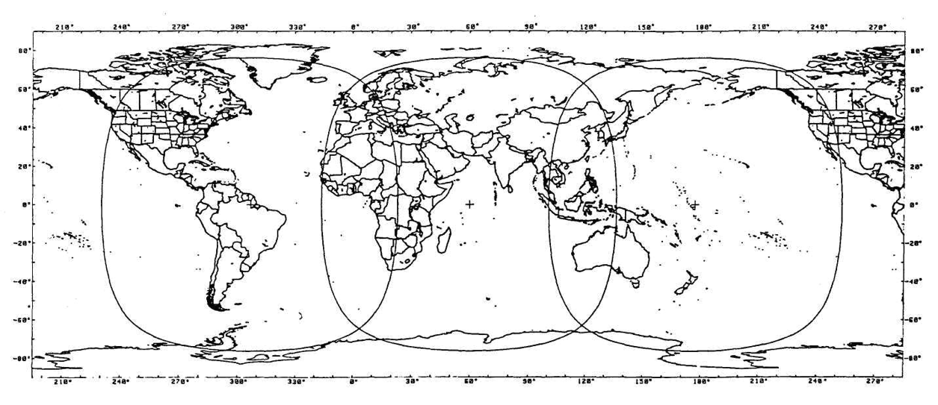

Figure 2.7 - The satellite coverage area of ​​the world on GSO

(The INTELSAT system with three global beams in the regions of the Atlantic, Indian and Pacific Oceans. –Satellite points).

However, such systems have several disadvantages, the main of which is signal delay. Satellites in geostationary orbits are optimal for radio and television broadcasting systems, where delays of 250 ms (in each direction) do not affect the quality characteristics of the signals. Radiotelephone communication systems are more sensitive to delays, and since the total delay in systems of this class is about 600 ms (taking into account the processing and switching times in terrestrial networks), even modern echo cancellation techniques do not always allow for high-quality communication. In the case of a "double hop" (relay through the ground station-gateway), the delay becomes unacceptable for more than 20% of users.

The geostationary spacecraft coverage area does not include high latitude areas (above 76.50 north latitude and south latitude).

The distance of a satellite repeater to a distance of 36,000 km requires high energy costs.

**2.3 Mid Altitude Orbits**

Satellites in mid-altitude orbits were the first to develop companies traditionally producing geostationary spacecraft. Medium-altitude systems provide better service characteristics for mobile subscribers than geostationary ones, since a larger number of spacecraft is simultaneously in the subscriber’s field of view. Due to this, it becomes possible to increase the minimum visibility angles of the spacecraft to 25-300.

So, the radio visibility of two satellites in the ICO system is provided for 95% of the daily time, and at least one of its spacecraft is visible at an angle of more than 300. And this, in turn, allows you to reduce the additional energy reserve of the radio line, necessary to compensate for propagation losses in the near zone (in the presence of trees, buildings and other obstacles in it).

When choosing the location of a non-geostationary orbital constellation (OG), it is necessary to take into account the natural limitations - these are the Van Allen radiation belts, they are grayed out in Figure 2.6. The first stable belt of high radiation begins at an altitude of 1,500 km and extends to several thousand kilometers. The second belt of equally high intensity (10 thousand imp./s) is located at altitudes from 13 to 19 thousand km.

The mid-altitude satellite route passes between the first and second van Allen belts, i.e., at an altitude of 5 to 15 thousand km. The service area of ​​each spacecraft is significantly smaller than the geostationary one, therefore, for global coverage with a single coverage of the most populated areas of the globe and shipping areas, it is necessary to create an exhaust gas of 8-12 satellites. The total signal delay during communication through mid-altitude satellites is not more than 130 ms, which allows them to be used for radiotelephone communications.

Thus, medium-altitude satellites outperform geostationary satellites in terms of energy performance, but lose out to them in terms of the spacecraft’s stay in the radio-visibility zone of ground stations (1.5 - 2 hours).

As for the orbital resource of medium-altitude spacecraft, it is only slightly less than that of geostationary ones. The satellite’s period of revolution around the Earth for medium-high circular orbits is about 6 hours (at an altitude of 10,350 km), of which only a few minutes are in the shadow of the Earth. This makes it possible to significantly simplify the technological solutions used in the onboard power supply system, and, ultimately, to bring the spacecraft life to 12-15 years.

The structure of systems in mid-altitude orbits (ICO, Spaceway NGSO, Rostelestat) differs slightly. In all these systems, the orbital grouping is created at approximately the same altitude (10 352-10 355 km) with similar orbital parameters.

**2.4 Low circular orbits**

Systems with equatorial and polar orbits have existed for about 30 years and are used mainly for research purposes, remote sensing, navigation, meteorological observations, photographing the Earth's surface. For the organization of mobile and personal communications, these systems began to be used only in the last 5-7 years. Today, the most intensively mastered are low inclined and polar orbits with a height of 700-1500 km, as well as equatorial ones with a height of 2 thousand km.

Satellites in low orbits have significant advantages over other spacecraft in terms of energy characteristics, but they lose to them in the duration of communication sessions, the coverage area and the active life of the spacecraft. If the satellite’s rotation period is 100 minutes, then on average 30% of the time it is on the shadow side of the Earth. Rechargeable on-board batteries experience approximately 5 thousand charge / discharge cycles per year, as a result of which their service life, as a rule, does not exceed 5-8 years.

The choice of a range of heights from 700 to 2 thousand km for low-orbit systems is not accidental. On the one hand, in orbits with an altitude of less than 700 km, the atmosphere density is relatively high, which causes eccentricity fluctuations and orbit degradation (a gradual decrease in apogee altitude). In addition, a decrease in the height of the orbit leads to an increase in the number of regular maneuvers to maintain a given orbit, therefore, to an increase in fuel consumption.

On the other hand, in orbits above 1.5 thousand km, where the first Van Allen radiation belt is located, long-term operation of electronic on-board equipment is practically impossible unless special methods of protection against radiation are used. The use of these methods leads to a significant complication of on-board equipment and an increase in the mass of spacecraft.

However, the smaller the orbit, the smaller the instantaneous coverage area, therefore, a much larger number of satellites is required for global coverage. If a low-orbit system should provide global communication with continuous service, it is necessary that the orbital constellation includes at least 48 spacecraft. The orbital period of the satellite in these orbits is from 90 minutes to 2 hours, and the maximum spacecraft stay in the radio visibility zone does not exceed 10 - 15 minutes.

2.5 elliptical orbits

The main parameters characterizing the type of elliptical orbit are the period of the satellite’s revolution around the Earth and eccentricity (an indicator of the ellipticity of the orbit). Currently, several types of elliptical orbits with a large eccentricity are used - Borealis, Archimedes, "Lightning", "Tundra" (table 2.2). All of these orbits are synchronous, that is, a satellite launched into such an orbit rotates at the speed of the Earth and has a period of revolution that is a multiple of the time of day.

Table 2.2 - Types of elliptical orbits and their main parameter

|  |  |  |  |
| --- | --- | --- | --- |
| Type of orbit | Height  apogee, km | Period  treatment, h | The number of turns per day |
| Borealis | 7840 | 3 | 8 |
| Archimedes | 28000 | 8 | 3 |
| Lightning | 40000 | 12 | 2 |
| Tundra | 71000 | 24 | 1 |

is characteristic of satellites in elliptical orbit that their velocity at the apogee is much lower than at the perigee. Consequently, the spacecraft will be in the visibility range of a certain region for a longer time than the satellite, whose orbit is circular.

So, the Molnia spacecraft launched into orbit (apogee 40 thousand km, perigee 460 km, inclination 63.50) provides communication sessions lasting 8-10 hours, and the system of only three satellites supports global round-the-clock communication. Elliptical orbits with a lower apogee, for example, Borealis (apogee 7840 km, perigee 520 km) or Archimedes (apogee 26 737 km, perigee 1000 km), are designed to provide regional communication.

The Doppler effect has a negative effect on the operation of satellites in a highly elliptical orbit. For example, for a highly elliptical orbit of the Lightning type, Δf / f0 (2.2) in the perigee region reaches a value of 0.002, therefore, the equipment is switched on only at an altitude of 15 ... 20 thousand km, i.e. 1.5 - 2 hours after the passage of perigee.

Spacecraft with a lower apogee beat satellites in highly elliptical orbits in energy characteristics, losing to them in the duration of the sessions. To ensure continuous round-the-clock communication using synchronous-solar orbits, Borealis will require at least 8 spacecraft (located in two orbital planes, four satellites in each plane). They will allow serving subscribers at angles of radio visibility of the spacecraft of at least 250.

Systems with spacecraft in elliptical orbits are also not devoid of "natural" restrictions. The constant location of the spacecraft in an elliptical orbit is ensured only with two values ​​of the inclination of the orbit plane to the equator - 63.40 and 116.60. This is due to the influence of the inhomogeneities of the Earth's gravitational field, due to which the major axis of the elliptical orbit experiences a torque, which leads to fluctuations in the latitude of the sub-satellite point at the apogee. Another factor affecting the choice of parameters of elliptical orbits is associated with the need to take into account the dangerous effects of the Van Allen radiation belts, which the spacecraft inevitably crosses during its orbit.

The main characteristics of non-geostationary orbital constellation.

Although most of the known non-geostationary systems are built on the principle of "rings", each of them has its own ballistic parameters and a unique orbital structure. The orbital plane (“ring”) includes several satellites moving in low Earth orbits, which form a communication belt on the Earth’s surface. Satellites

one orbital plane is usually placed evenly along the orbit.

The structure of the exhaust gas characteristics is the orbit parameters, types of orbital planes, characteristics of service areas and probability-time indicators.

The parameters of the orbital grouping are the type of orbit (LEO, MEO, GEO, HEO), the number of orbital planes of the spacecraft, the number of spacecraft placed in each plane, as well as the height and inclination of the orbits. The relationship between these and other exhaust gas indicators is determined on the basis of geometric relationships that characterize the position of the spacecraft relative to the ground station located at the border of the service area.

The distance from the ground station to the spacecraft during its flight is a variable, since the satellite passes through the radio visibility zone of the ground station at different angles. The slant range depends on the angle of the range, which is measured from the center of the Earth between the directions to the spacecraft and the boundary of the service area.

The main criterion for the effectiveness of radiotelephone systems based on non-geostationary exhaust gas is global connectivity. In this case, “connectivity” means the ability to connect subscribers located in one or different service areas and to support a continuous (or quasi-continuous) communication channel between them. Continuous connectivity is ensured if at least one satellite is in the radio visibility zone of both subscribers.

Obviously: the higher the orbit, the less satellites are required to globally cover the earth’s surface. Here, the concept of “coverage ratio” should be defined. This value is equal to the number of satellites simultaneously located in the radio visibility zone. The higher the multiplicity, the more reliable the connection.

Multiple connectivity is provided if several spacecraft are simultaneously in the radio visibility zone of subscribers for a given time.

For example, a surface coating is considered double if at least two spacecraft are in the area of ​​the ground station. For systems with satellites at medium altitudes, this condition is already satisfied when 10-12 spacecraft are available.

In systems with spacecraft in non-geostationary orbit, in which the position of the satellites is not constant, the quality of service is determined by probability-time parameters. Among them, the main ones are the average duration of a communication session, the average waiting time (or the duration of service outages) and the time of information delivery or service delay.

As an example, consider the communication session parameters of the Orbcomm system. If up to latitude 500, the average duration of a communication session is about 10 minutes, and the average waiting time is 3-4 minutes, then with increasing latitude the interruptions between communication sessions also increase - the longest waiting time for a session (81.9 minutes) is observed at latitude 650. The point is the fact that at these latitudes ground stations do not fall into the optimal radio visibility zone. To remove this restriction, the developers of the Orbcomm system revised the initial concept of building the system relative to the number of satellites: it is planned to increase it from 28 to 48.

As for service delays, in contrast to radiotelephone communication networks, where the delay usually does not exceed 250-300 ms, large values ​​are characteristic of packet data networks. Usually they are estimated as delivery time, i.e. time during which the message is delivered to the end user.

If both users are in the common radio visibility zone of the spacecraft, the delay is usually small and is determined by network protocols and switching equipment parameters. When transferring messages onboard the spacecraft (“mailbox” mode), delivery time depends on the mutual arrangement of subscribers and can be several hours.

The structure of the orbital planes determines the ballistic parameters of the multisatellite system, which substantially depend on the relative position of the spacecraft in the orbital group. Currently, two types of exhaust gas are used in the CCC - uncorrectable and correctable.

For an uncorrectable exhaust gas, the ballistic parameters of the orbits are selected so that the specified waiting time for the communication session is ensured without correction of the orbit elements. An increase in the number of spacecraft in an uncorrected exhaust gas slightly reduces the waiting time. Such exhaust gases are characterized by a small mass of spacecraft, low power consumption, lower requirements for orientation accuracy. All these features of uncorrectable exhaust gases play a decisive role in the creation of light and inexpensive spacecraft. Non-correctable exhaust gas is mainly used in systems designed for the transmission of short packets (Gonets-D1, Orbcomm, Starsys, etc.).

Corrected orbital grouping is usually applied when necessary, the global uniform coverage of the earth's surface. Its dynamic stability is supported by a special installation for orbit correction. To ensure the minimum waiting time for a communication session, the orbit planes should be spaced along the longitude of the ascending node, and the satellites are evenly distributed along the orbit in each plane. The main advantage of the corrected exhaust gas is the implementation of the specified time characteristics with a minimum number of satellites in the system, which is especially important for global radiotelephone communication networks.

The accuracy of maintaining the mutual placement of the spacecraft in orbit during the entire period of operation should be very high, since the displacement of the spacecraft relative to each other leads to the appearance of unattended areas in the coverage areas.

In all systems using a corrected exhaust gas, navigation equipment is installed onboard the spacecraft to determine the orbit parameters from GPS / Glonass satellite signals. This allows you to control the exhaust gas parameters autonomously, i.e., use the services of ground-based spacecraft tracking stations only in emergency situations. The correction intensity depends on the accuracy with which it is required to keep the spacecraft in orbit. The most stringent requirements for the accuracy of control over the parameters of orbits are in systems with inter-satellite communication lines (Iridium, Teledesic), where satellite displacement can lead to disruption of the correct functioning of the entire system.

In global CCS, it is also necessary to ensure uniform coverage of the entire Earth’s surface and the absence of “dead zones”, for which it is necessary to keep the spacecraft at the calculated point with the maximum possible accuracy (± 0.20). As calculations show, correction in systems such as Iridium will be needed no more than once every 0.5-1.5 months, which means the following: if the spacecraft's active life is 7 years, then the engines will turn on about 100 times.

Global service can be provided if the spacecraft is launched into a polar orbit with an inclination of 900. To transmit short data packets, only one satellite with an electronic “mailbox” on board is enough: with each new revolution it will appear over a new area of ​​the globe, supporting global service. Meanwhile, the use of several polar orbital planes is associated with the danger of satellite collisions.

In order to prevent a spacecraft collision at the poles, an angular spacing between the orbital planes is required, forming a minimum “miss” distance. This leads to additional difficulties in the formation of exhaust gases; therefore, today, near-polar orbits with an inclination of 80-860 are actually used.

**3 Space segment**

The space segment of the satellite communications system consists of satellites and ground-based equipment that provide the functions of monitoring, telemetry and telecommand (TTS) and satellite logistics.

The satellite subsystem, known as payload or onboard repeater, includes all communication repeaters and antennas.

The equipment supporting the normal operation of the SPACECRAFT main subsystems for spatial orientation, thermal control, telemetry control, navigation (GPS/GLONASS receivers, etc.) is structurally not part of the payload, but belongs to the space platform.

**3.1 Space platform**

The space platform is the basic part of the SPACECRAFT on which the payload (on-Board relay complex), the power supply substation and the on-Board control complex are distributed, ensuring the normal operation of the SPACECRAFT during orbital flight during the entire period of its active existence.

The onboard control system consists of several subsystems. One of them provides the correct orientation and stabilization of the satellite in space. It is known that the effective mode of operation of solar panels and radio lines depends on the direction of the solar panel (they should always be oriented to the Sun) and antenna systems (all-Gda directed to the Earth).

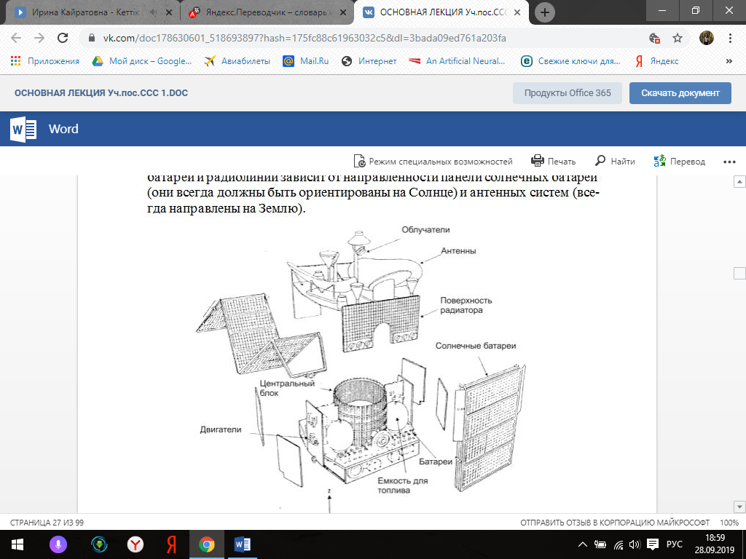

Figure 3.1 - Satellite FSS (expanded view). Telecom I

The onboard control system also contains a telemetry system. The telemetry and telecontrol system is designed to monitor and control the operation modes of all CS systems and transmit this information to the CS. The rate of transmission of information on the command and telemetry radio lines is usually from a few hundred bits to 100 kbit / s.

Important functions are performed by the thermal control subsystem, which ensures the maintenance of the thermal regime of the payload (satellite equipment) within the specified limits. The usual operating temperature range of onboard equipment is from -20 to + 50 C

The main characteristics of the platform are its weight and size, the power of the on-Board power supply system (BOT) and the period of active existence (SAS).

The mass of the space platform is characterized by at least four indicators:

- the launch mass (mass at launch) is the mass of the entire SPACECRAFT (space platform) together with the payload and fuel reserve;

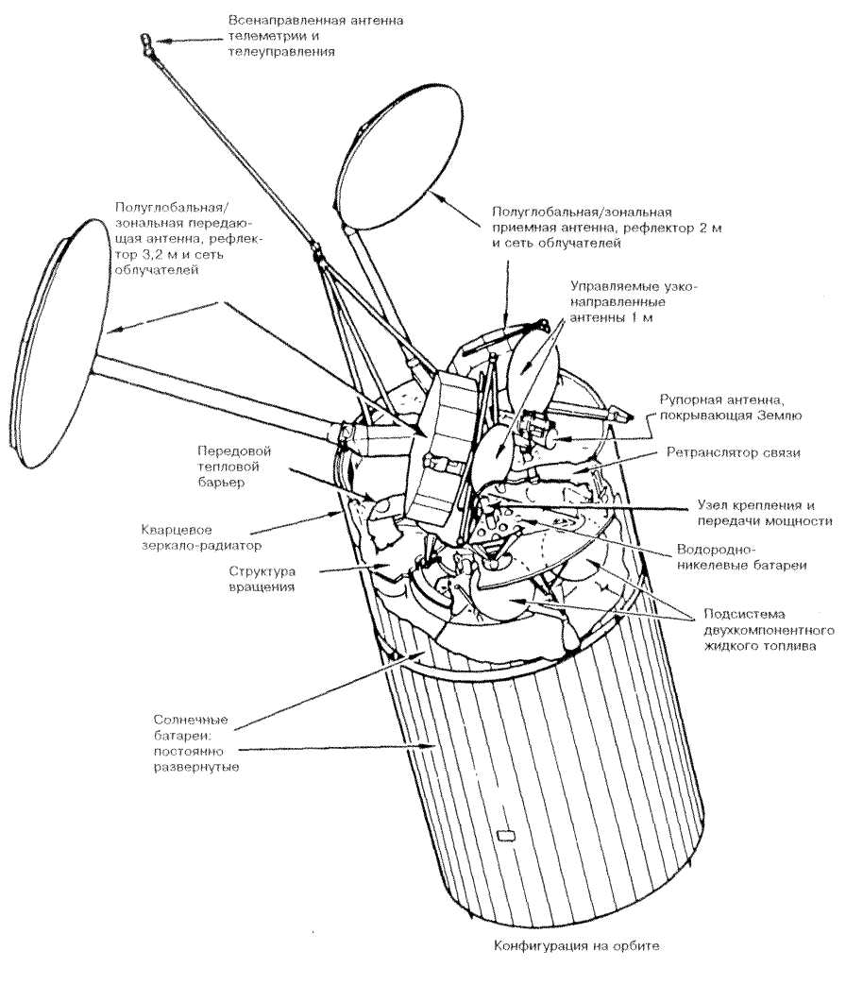

Figure 3.2 - Intelsat VI satellite (rotation stabilization)

- the mass of SPACECRAFT in orbit (mass in orbit) - depends on the type of space platform. If special propulsion systems are installed on Board the satellite, which require a fuel reserve, the mass can be determined both for the beginning of the active life (BOL, beginning of life) and for its end (EOL, end of life);

- dry mass (dry mass) is the mass of SPACECRAFT without fuel;

- payload mass-includes the mass of an onboard relay complex with buffer power supplies and an antenna placed on a space platform.

The term of active existence of the platform is defined as the time of SPACECRAFT operating time for failure or degradation of its main characteristics (reduction of communication channel capacity, etc.).

Characteristics of space platforms developed by the American company Hughes Aircraft Systems (USA) are shown in table 3.1.

Table 3.1-geo-system Satellites

|  |  |  |  |  |  |  |  |
| --- | --- | --- | --- | --- | --- | --- | --- |
| Satellite | The type of the underlying platform | SPACECRAFT mass in orbit, kg | Power BOT, W | Overall dimensions, m | Span of solar panels, m | CAC, years | Cost, million dollars |
| AMOS 1 (Israel) | AMOS | 580 | 1231 | 2,3x2,.4x2,1 | 10,55 | 10 | 250 |
| АMSC 1 (USA) | HS 601 | 1510 | 3600 | 2,5x3,5x7,9 | 20,96 | 12 | 182 |
| Inmarsat-3 (Inmarsat) | GE 4000 | 1200 | 1670 | 2,1x1,8x1,7 | 16,7 | 13 | 80-90 |
| Thaicom 3 (Thailand) | Spacebus 3000 | 2500 (стартовая) | 5400 | 1,8x2,3x2,3 | 25 | 12 | 200 |
| Note-BOT-power supply system; SAS-active life. | | | | | | | |

SPACECRAFT with the size of solar cells more than 15 m and weighing more than 1500 kg are referred to as large SPACECRAFT, for example, AMSC 1 from table 3.1. Satellites of AMOS 1 weight and dimensions, refers to small SPACECRAFT.

Geo position stabilization devices installed on the satellite can be Autonomous. There are two main ways to stabilize a geostationary satellite: rotation stabilization and three-axis or direct stabilization.

Rotation stabilization is the simplest type of stabilization of a satellite in space due to rotation of a part of a satellite with a frequency of 80...100 Rev/min. you can see that the gyroscopic rigidity and stabilization of angular position characterized by the orientation of the axis of rotation. Correction of the position of the satellite can be performed by periodically switching on the low-thrust engine, since disturbing factors reduce the rotation frequency of the satellite, affect the direction of the axis of rotation.

Double rotation is more widespread, when a rotating drum and a rotating platform are used in the satellite design, i.e. the direction of rotation of the platform is constantly opposite to the direction of rotation of the drum. Due to this, the platform has almost zero angular velocity, occupies a stable position on GEO.

Three-axis stabilization is carried out by controlling the angular position of the satellite relative to each of its axes. This control is performed by directly measuring the angular variations relative to all three axes, or by using devices such as a flywheel with a kinetic moment that acts simultaneously as a gyroscope and a rotation stabilizer. High-speed rotating flywheel allows you to keep the direction of the Sun solar panels, providing gyroscopic rigidity of one, two or three axes of the satellite. In order to maintain a constant orientation of the satellite in the conditions of disturbances that always occur on GEO, these devices are equipped with sensing elements and sensors.

Satellites with a rotating flywheel, which stabilizes one axis of the satellite due to its gyroscopic properties, are the most widely used. The orientation of such satellites is controlled by changing the speed of rotation of the flywheel, the occasional use of a low-thrust engine and stabilization to maintain a constant orientation of the axis of the flywheel's own rotation.

The position control system of the satellite is necessary to hold the radio beam of the antenna (or several antennas) of the satellite to the specified areas of the Earth.

The process of controlling the position of the satellite in orbit includes the following procedures: measuring the position of the satellite by sensors: comparison of measurement results with required values; calculation of adjustments that should be made to reduce errors; the introduction of these revisions, including the respective propulsion systems.

There are several methods for obtaining data on the roll of the satellite and tan-gage (the axis of rotation of a stationary satellite parallel to the axis of the Earth). One of the methods of measuring and holding the satellite, used in the Ki range and giving high accuracy, is based on the use of a special PI-lot beam formed at the earth station and directed towards the receiving antenna of the space station. This signal is recorded and processed on Board to obtain information on the direct orientation of the onboard antennas. In addition, if the pilot signals from two sufficiently spaced earth stations, the direct measurement can detect the rotation error of the radio beam, and then eliminate the roll and pitch of the satellite.

First of all, the destabilizing factors causing the deviation of the real parameters of the orbit from the ideal ones are the gravitation of the moon and the Sun. Other factors are: the gravitational gradient (the difference in the forces of gravity caused by the difference in distances from the center of mass of the Earth to different parts of the satellite); irregularities in the shape and unevenness of The earth's gravity field; the earth's magnetic field; the pressure of solar radiation; uncompensated movements of internal motors, gears, levers. All forces except internal torques, although small, have a constant effect. Internal torques are large but short-lived.

As a result of these destabilizing factors, the satellite cannot fly in a mathematical orbit.

On Board any satellite there are propulsion systems, which on teams the operator with Earth stabilize his position on GEO. If necessary, the satellite changes its position in orbit in the North-South and West - East directions with the help of pusher engines. It is for the operation of the correction engines on Board the satellite is a certain amount of fuel.

In some cases, the fuel is used to change the position of the satellite to GEO. For example, the Russian company "NTV-Plus" arenas-mended a French satellite TDF 2, who for many years was in position 19° W. using its own propulsion system, the satellite re-place the position of 36° E, where there were two AES GALS this company. As a result, viewers of five "NTV-Plus" programs since November 1, 1997 can watch them from one direction.

The ground-based observation service is constantly working not to keep the satellite in an ideal orbit (this is almost impossible), but to control it so that it remains in an acceptable window, i.e. it leaves no more than a certain angle from a given position in geostationary orbit above the equator. The radio regulations recommend that the non-stability of the position of modern geostationary satellites in longitude and latitude should not exceed ± 0.1°. An angle of 0.1° corresponds to a distance of about 74 km.

When monitoring the orbit of a satellite, the tolerance window is fully used to minimize fuel consumption for maintaining the position. To reduce the number of corrective maneuvers, allowed a certain bumpiness of satellites in longitude and latitude during the day and a certain drift within the tolerance window. With a small tolerance window, as in THE Kopernikus satellite, weekly corrections are required, with a larger one - once every two weeks or even less.

Figure 3.3 shows the layout of some television satellites on GEO for broadcasting to the European region. At position 36° E are three companion: GALS 1, GALS 2 TDF and 2; at position 19,2° E - ASTRA, six satellites (1A...1G); at position 13° E, five bird NOTE satellites and one EUTELSAT II F1 satellite.

Due to unavoidable errors in maneuvering and orbit determination, the satellites do not move along exactly the same trajectories and not quite in phase. For this reason, the number of satellites that can be placed in the access window is limited. Today's technology allows you to safely hold in the window 0,1° from four to six satellites.

With the use of on-Board measurements on satellites, their number in the tolerance window will increase.

The control center also takes into account the inclination of the relative elliptical orbit relative to the Equatorial plane of the Earth. This degree of freedom makes it even safer to keep satellites in the tolerance window, since even with the displacement of individual relative orbits in the East-West direction, satellites remain constantly at a distance.

On Board any of the satellite are the propulsion system, which the operator commands from the Ground to stabilize its position in orbit. The lifetime of the satellite is limited by the amount of fuel for the correction engines that it can take on Board.

Depending on the type of satellite, its "life activity" is from 7 to 12...15. At the end of this period, on the remains of fuel on the co-Mande from the Earth, the satellite is displayed on the so-called "cemetery or-bit".

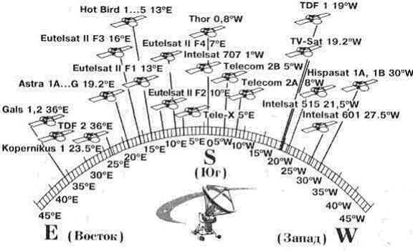

Figure 3.3 - The layout of the TV satellites in GEO

Power system. Depending on the number of receivers of active repeaters and other devices, the equipment of the geostationary satellite consumes 6...7 kW.

The batteries of the satellite are always facing the Sun, nothing can ever shade them, so that the equipment of the satellite continuously receives the necessary amount of electrical energy.

Photovoltaic solar panels have served for years as the main means of converting solar energy into electrical energy to power satellite devices. Converters are semiconductor photo-elements, series-parallel connection of which forms a solar battery. The latter is performed in the form of several panels with a total area of 20 m2, with up to 8000 solar cells. The span of solar panels is from 10 to 25 m. the Typical power per unit area is within 10...110 W / m2 with average efficiency = 7...11%, in the best samples - up to 15% (maximum theoretical-25%). Each solar cell develops EMF equal to 0.3...0,4 V.

In case of falling into the shadow of the IC, the power supply is provided by the batteries, which are located on the CS, called "buffer power supply".

The thermal control system maintains the temperature of the ICS in pre-cases suitable for normal operation of the equipment (from -200 to +500C). In space, heat transfer occurs mainly as a result of radiation into a vacuum. For devices of the satellite it is through constructive communication with external radiant heaters, constant light which severely restricts the capacity of heat transfer.

External sources of thermal energy affecting the satellite are thermal radiation from the Sun and the Earth, as well as solar radiation reflected from the illuminated part of the Earth. These impacts have different spectral and geometric characteristics and therefore are not equally felt (perceived) by the satellite surface.

In addition, the payload consists, as a rule, of subsystems with localized (concentrated) heat generation, for example, powerful amplifiers on the LBV (traveling wave lamp), klystrons, etc.

The thermal control system at the satellite uses rigid-fixed optical solar reflectors, special materials to create light surfaces with high thermal conductivity (beryllium, magnesium), methods of special thermal conditioning.

**3.2 Onboard repeater complex**

The complex of relay equipment that a spacecraft puts into orbit is called a payload or on-Board repeater.

The structure of the onboard relay complex (brtc) is determined by its purpose, or the scale of coverage of territories (global or regional communication), the method of information processing on Board the CS, the number of relay channels (receiving, transmitting or transmitting), the speed of information exchange, as well as the selected technical solutions and technologies used. The brtc may include not only so-called subscriber repeaters (intended for the formation of "consumer" rays), but also re-translators of feeder and/or inter-satellite lines (service communication).

Inter-satellite lines provide communication between SPACECRAFT in adjacent positions in the same orbit or in adjacent orbits. It is implemented in low-orbit systems (Iridium).

The payload subsystem must be reliable enough for the satellite to perform its tasks, which implies adequate back-up capabilities of the system. The choice of launch vehicle and the characteristics of the spacecraft impose limitations on size, mass and electrical power consumption. The requirements for compatibility with other satellite subsystems, including design, power supply, thermoregulation, telemetry, remote control, distance measurement, position control and their electro-magnetic compatibility under operating conditions, should also be taken into account.

Types of repeaters

Repeaters without signal processing on Board

Basically, satellite repeaters receive different communication signals, amplify them, convert their frequencies and transmit back.

Both broadband and divided into channels of construction of repeaters can be applied. Most of the existing satellite re-translators in the fixed satellite service are built on the basis of broadband receivers and subsequent channel transmitters.

With regard to connections between different RF channels (radio frequencies), there are two main cases, depending on whether the repeaters are connected to one or more transmission beams.

Consider a simple case where the received signal is sent to only one transmitting beam. Signals in the receiving band are amplified and translated into the transmission band. Two types of frequency conversion can be used:

- unified system that converts the frequency bands of reception directly in frequency the transmission bands ;

- a dual conversion system in which the frequencies of the received signals are first converted to intermediate frequencies for partial amplification and then converted back to the frequencies of the transmitted signals.

The block diagram of the onboard repeater with direct frequency conversion for the 6/4 GHz band is shown in figure 3.4.

Frequency conversion in this repeater is carried out once. For frequency conversion, a mixer (Cm) is used, to which a signal from a highly stable heterodyne is applied. The gain provided by this unit is indicated in parentheses. Amplification is provided by two series-mounted amplifiers. 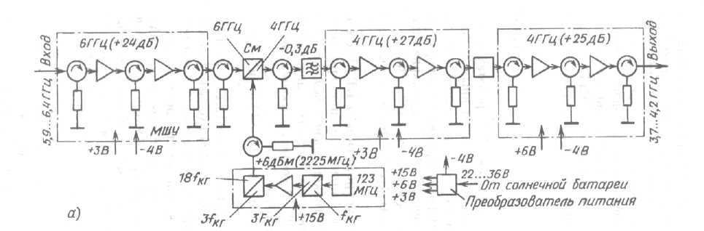

Figure 3.4 - Block diagram of the onboard repeater with direct frequency conversion.

The second type, that is, double conversion, is sometimes preferred because of the following advantages:

- eliminates potential instability due to the feedback in the amplifier circuit with high gain;

- excluded components of crossmodulation or harmonics to adopt Maemo signals and the local oscillator of the frequency Converter within the frequency band of the useful signal;

- is provided by the intermediate frequency, convenient switching and cross-connections between the payloads operating in different frequency bands of transmission and reception. The disadvantage is that two heterodynes and two frequency converters are required.

The repeater provides approximately 100-110 dB of gain (maybe even more, 120 dB on broadcast satellites) in two stages: low-level gain in the wideband receiver, followed by high-level gain in the power amplifiers in the channel-split subsystem. Attention should be paid to electromagnetic compatibility (EMC) due to the use of high gain factors and wide bandwidths.

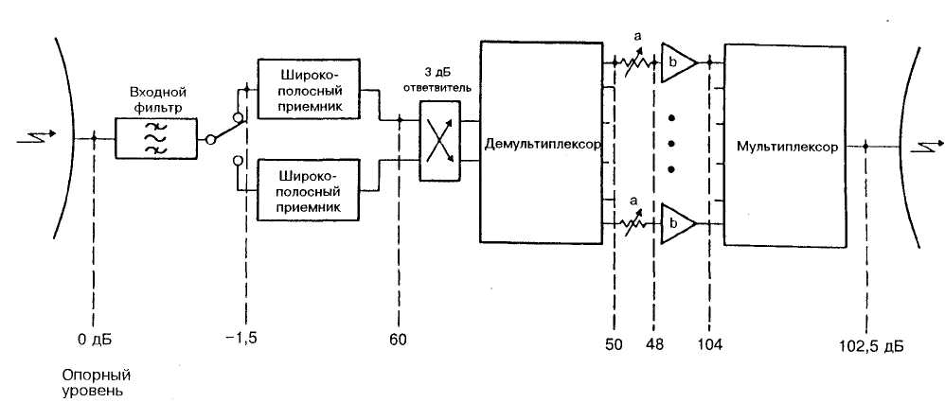

Figure 3.5 - A typical diagram of relative levels in the repeater. a: switchable attenuator; b: high power transmission amplifier

Repeaters with signal processing on Board

Now systems working with several beams are used, for example, INTELSAT-IVA and V. These beams provide independent transmissions. However, it is often necessary to connect users whose area is covered by different rays. In such cases, one channel of the line up of one beam should be connected to the corresponding channel of the line down of the other beam.

In digital satellite systems, quality and efficiency can be improved by the use of on-Board signal-processing repeaters that are capable of switching, regenerating or processing signals in a group band. This technique has not been widely used on commercial satellites to date, but will be used in the future.

RF signal switching

You can provide three types of radio frequency switching operations on the microwave:

a) switching of information packets from one RF transmission channel to another;

b) switching of information packets from one fixed ultrasonic beam to another;

C) switching the scanning narrow beam from one earth station to another.

Operation (a) can be performed on Board a satellite by a fast frequency Converter. It can provide interconnection of earth stations operating at different carrier frequencies.

Operation b) provides a reciprocal link earth stations, have-ing access to different narrow beams by cyclic connection signals mdvr via the on-Board switching matrix (MDR-KS). The microvoltage switching matrix is controlled by a programmable distribution control element synchronized by a stable clock sequence source. Each earth station in the network synchronizes the transmission of its data packets with a program sequence of switches on Board the satellite in order to establish communication with earth stations that have access to other beams.

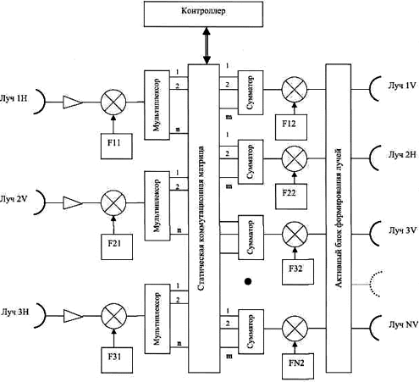

Figure 3.6-Block diagram of circuit-switched brtc

The onboard relay complex (brtc), schematically presented in figure 3.6, provides for the formation of a single digital stream in each of the receiving beams, which is demultiplexed on Board. N channels after demultiplexing are routed according to the inter-beam communications established in a switching matrix. Thus routes (communications) can be changed on commands from the Earth depending on requirements which are imposed at creation of a new network of satellite communication.

After the formation of m information channels for each of the transmitting beams, these channels are multiplexed and enter the transmitting path of the corresponding beam. The described complex belongs to the type of circuit switching on a satellite with direct relay.

Repeaters to regenerate the signals

If the transmitted digital information is recovered on Board the satellite by signal regeneration, the “up "line is separated from the “down" line, which provides the following important advantages:

- the total error coefficient of the communication system is the sum of the error coefficients on the up and down lines, and is not determined by the total signal-to-noise ratio. The E. I. I. M. of earth stations and satellite can therefore be reduced;

- the influence of nonlinear distortions of the two lines does not accumulate;

- avoiding interference due to multipath that occurs on Board the satellite connection on the RF between channels;

- modulation of signals on Board the satellite allows the RF amplifier to be supplied with signals virtually free of am-amplitude modulation components, so RF amplifiers can operate at saturation level without significant deterioration in quality characteristics;

- satellites with MDR-KS on-Board switching matrix may be implemented in the circuits of the group of strips; this gives significant advantages (in terms of weight, size, power consumption) compared to microwave switching matrices which must be used in repeaters without regeneration; a switching matrix in a group strip can consist of simple logic circuits. Custom-designed components could enable the implementation of high-speed large matrices with low power consumption and small dimensions;

- can be created more flexible redundancy schemes on Board;

- master clock generator of the system can be placed on Board to facilitate recovery of clock and frame synchronization in systems with mdvr-KS;

Processing the stream of bits

With digital information on Board a satellite, a number of best practices could be applied. One of the most attractive features of on-Board processing is bit rate conversion. In mdvr-CS systems with a large number of participating earth stations, with very different traffic requirements, low-traffic stations typically have low efficiency because they are designed for high transmission rates, but can only operate their resources for a small percentage of the time. In such cases, significant advantages will be obtained if the satellite is equipped with regenerative repeaters operating at different bit rates. Each participating station will operate at the bit rate most appropriate for its own traffic.

Interconnections between stations operating at different bit rates will be carried out using speed converters and switching matrices on Board the satellite.

Main characteristics of repeaters

The efficiency of the onboard repeater is determined by the range of operating frequencies, eiim (effective isotropically radiated power), q-factor (G / T) and the density of the power flow on the Earth's surface, capacity, service life.

Throughput - the main integral indicator of the brtc, which determines the efficiency of the SPACECRAFT. Depending on the type of information transmitted, two criteria are usually used to assess throughput. In voice communication systems, this is the number of channels, equivalent to telephone, which fall on one trunk. In low-bit packet data transmission systems, the criterion is the cumulative flow of information transmitted through one SPACECRAFT for a given period of time (one hour, per day).

SPACECRAFT throughput depends on the number of trunks, their energy parameters (EIM and G/T), characteristics of antenna systems and methods of access and processing of information on Board the satellite.

A very important characteristic of the onboard repeater is the number of barrels (instead of the term “trunk” is often used the English term “transponder”). The trunk of the repeater is called the transceiver path in which radio signals pass in a common frequency band. The number of trunks on different satellites is in the range 6...48. The trunks ' bandwidth is also different (27; 34; 36; 40; 72; 77; 112; 120 MHz, etc.).

To exclude the mutual influence of signals from different trunks and transmission channels on the received signal on the SPACECRAFT, frequency plates are used. Frequency plan barrels SC "Horizon" is shown in figure 3.8.

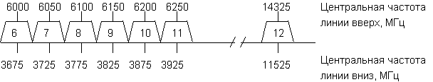 Figure 3.7 - frequency plan of SC "Horizon»

EIRP is defined by the formula and is expressed in watts (W) or decibel watts (dBW)

EIRP=РЭ+GА+ηВТ, dBW

where re-transmitter power, dBW;

GA-antenna gain, dB;

-W is the transmission coefficient of the waveguide path, dB.

Or EIRP =РЭ*GА*ηВТ, W

where re-transmitter power, W;

GA-antenna gain;

-W is the transmission coefficient of the waveguide tract.

As a rule, the values of the EIRP of modern personal satellite communication systems operating in L/S-band do not exceed 30 to 45 dBW for systems with SPACECRAFT in geostationary orbit, 20-35 dBW - KA at medium orbits and 5-25 dBW SPACECRAFT for low-altitude orbits.

Quality factor. The q-factor determined by the ratio of the antenna gain to the total noise temperature of the onboard receiver (G/T) is determined by the following formula

G/T=10lg(G/T), dB/K

Typically, this value should not exceed the range defined by the values: from -12 to +3 dB / K. the Spread within this range depends on the size of the antennas used and, to a lesser extent, on the parameters of the electronic equipment.

For example, table 3.2 shows the q-factor values (G/T) of the Express SPACECRAFT.

Table 3.2-q-values (G/T)

|  |  |
| --- | --- |
| Antenna | G/T in the center of the beam, dB / K |
| А7 (17°х17°) | -11,5 |
| А8 (5°х11°) | -2,8 |

The power flux density of the onboard repeater affects the conditions of its electromagnetic compatibility with other electronic equipment, so it is strictly regulated. The characteristics of the onboard antennas in each beam are usually chosen so that the power flux density generated on the Earth's surface is constant and independent of the direction of the radiation.

There are international recommendations regulating the density of power flow W (dBW/m2) on the Earth's surface. This issue is discussed in more detail in the Chapter on electromagnetic compatibility.

The service life of the satellite reaches 10 ... 15 years (high reliability of the elements, flexible and branched redundancy scheme).

Antenna subsystem. Antennas are one of the most specific sub-assemblies for performing satellite tasks. The limited frequencies available, the increased transmission capacity and the "tightness" in geostationary orbit have increased the need for frequency reuse through spatial and/or polarization signal isolation. The bandwidth occupied by signals transmitted in a single beam and at a single polarization typically does not exceed 500 MHz in both the 6/4 GHz and 14/11 GHz bands.

Telemetry, remote control and distance measurement systems require special antennas. In the launch and transition phase, biconic antennas with a "doughnut-shaped" diagram are required when the spacecraft is stabilized by rotation before switching on the perigee or apogee engine. Once in geostationary orbit, telemetry and telecontrol systems can continue to operate on a biconic antenna. However, in order to save power, telemetry and remote control signals can be switched to the main communication antenna with high gain; in this case, the biconic an-Tenna can serve as a reserve if the spacecraft accidentally starts to rotate.

Designs

The antenna design depends on the spacecraft design:

- rotation-stabilized satellite.

In the case of a satellite stabilized by rotation, there is no fixed, Earth-facing panel that can be used to mount the antenna subsystem.

The only possible design is a paraboloid mirror with a removed irradiator mounted on a platform with reverse rotation. The mirror folds up during launch. Intelsat-VI (figure 3.2) is an example of this construction;

"a three-axis stabilized satellite.

In this case, there is a fixed panel facing the Ground, which can be used to mount the antenna truss. There are two options:

(a) tower structure

The mast supports the irradiators. The mirrors are mounted on the earth-facing side of the satellite (example: Intelsat - V-figure 3.8). The disadvantage of this design is the length of the feeder required to connect the antenna irradiators to the repeater power amplifiers;

b) design "Mickey mouse Ears".

Mirrors can be mounted on the East or West side of the satellite. In this case, the irradiators can be attached directly to the body of the satellite (the length of the feeders decreases). Need mechanisms for the deployment of mirrors that are folded at the sides of the satellite during its launch.

The antennas in the form of two reticulated paraboloids of the satellite Eutelsat-P are shown in figure 3.10.

The performance of the antenna

The main characteristics of the satellite antenna are as follows:

- coverage contour (beam configuration);

- form the directivity and the sidelobe level;

- purity of polarization;

- applied power;

- RF sensitivity.

The coverage area visible from the satellite is determined by the contours of the radiation (or ISO-EIM).

For example, figure 2.5 shows the visibility zone of Intelsat 904 (Ku-band Spot 2).

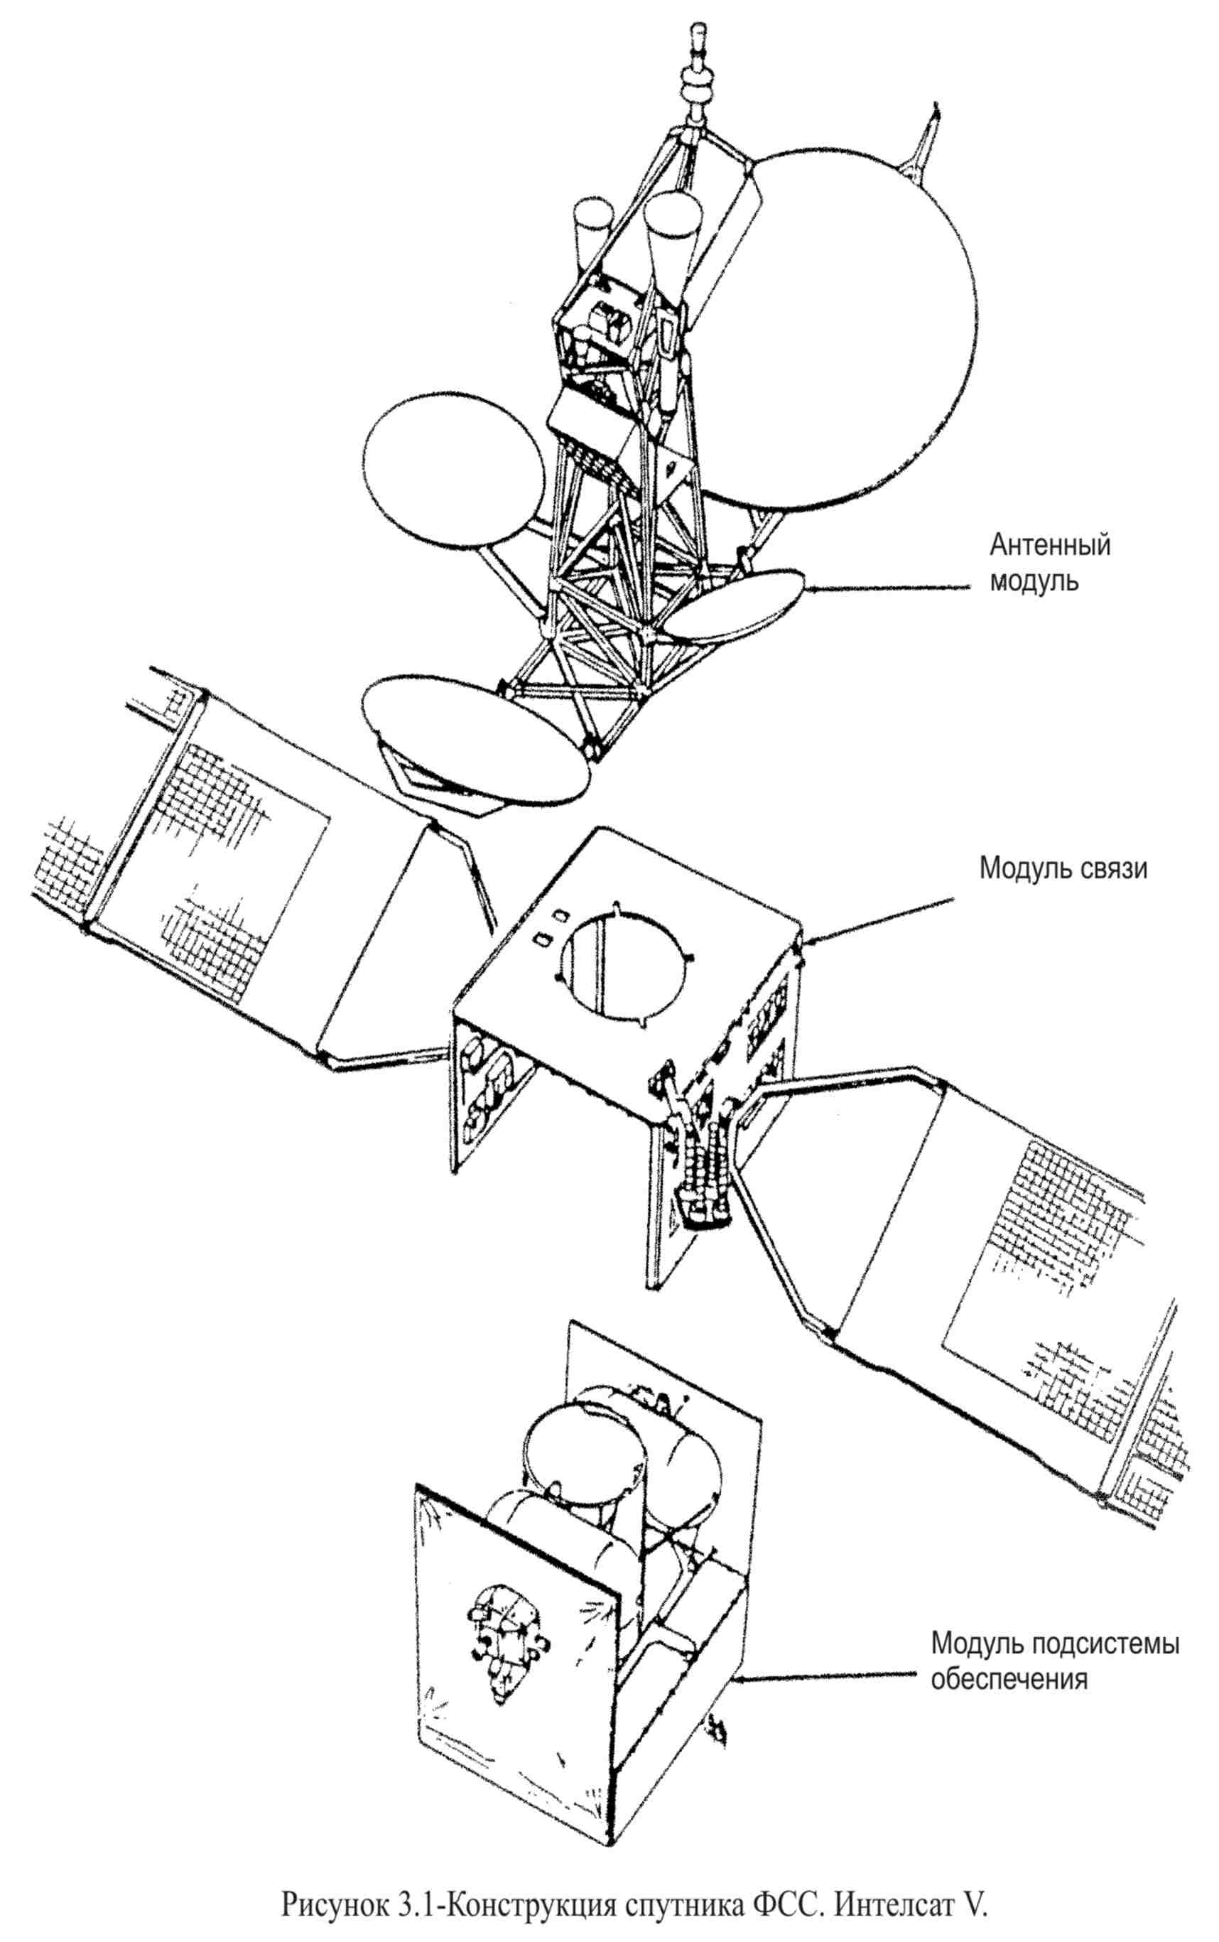

Figure 3.8-FSS satellite Design. Intelsat Vi

Modern satellites use antennas with a specially shaped beam within the service area contour to avoid overflowing.

Theoretically, it can be shown that the geometric shape of the antenna beam cross-section is a good approximation of the geometric shape of its radiation (figure 3.11 shows the geometric location of the beams and the corresponding contour of the satellite antenna coverage at 319° W).

A better approximation of the contours of the desired service area would require more irradiators and an increase in the size of the reflector. Table 3.3 shows the effect of improving the shape of the coating on the size of the antenna.

Form charts, and the levels of side lobes is determined only powerful satellites for direct television broadcasting in recommendations 652 CCIR.

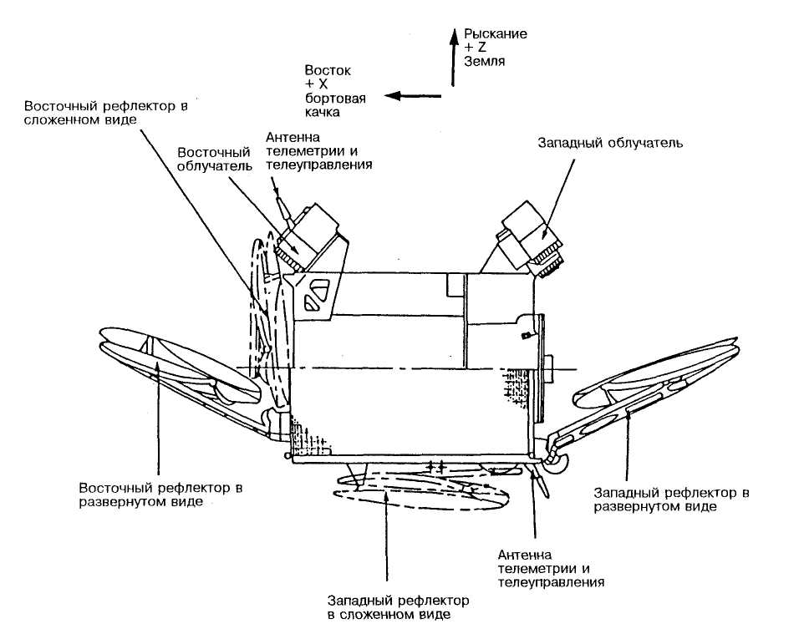

Figure 3.9-Eutelsat-II satellite Configuration

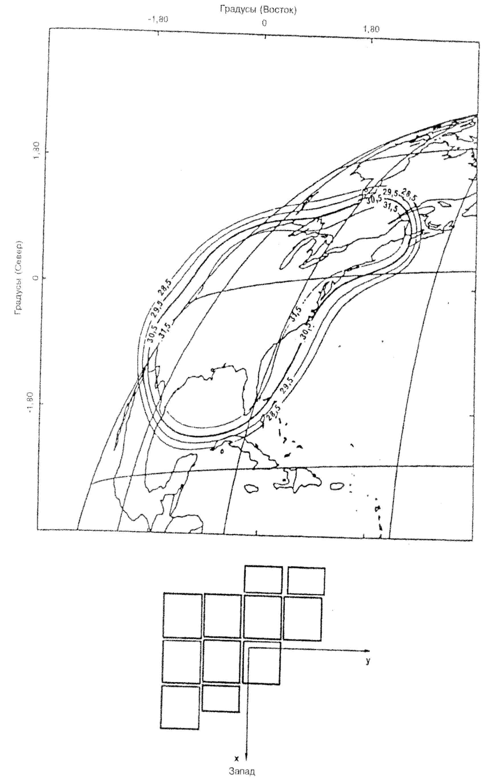

Figure 3.10 - improve the appearance of the coating and the required configuration of the reflectors

Table 3.3 - dimensions of INTELSAT satellite antennas

|  |  |  |  |
| --- | --- | --- | --- |
| Generation of INTELSAT satellites | IVA | V | VI |
| Weight of antenna system (kg) | 51 | 69 | 313 |
| Maximum reflector diameter (m) | 1,34 | 2,44 | 3,2 |
| The maximum number of feed horns | 37 | 90 | 146 |

Polarization discrimination. The limited frequencies available for use and the congestion of the geostationary orbit increase the need for frequency reuse by polarizing signal decoupling.

Circular or linear polarization can be used. For crustal polarization, horn irradiators usually have a circular or hexagonal cross-section. However, in the case of linear polarization, the horns must have a rectangular cross-section, and the number of horns required to generate rays of a special shape can be reduced.

For linear polarization the best way to achieve good polarization decoupling is the use of paraboloids with dual mesh; advantages over a system with a continuous reflector and polari-sational interchange in the irradiator are: less complex feed, lack of sensitivity to the frequency and separation of foci which allows you to apply two different irradiator for re-use of frequencies.

A mesh paraboloid consists of a dielectric (transparent) "cha-Shi" supporting a metal (reflective) mesh. Two " bowls "of this type can be placed one behind the other, for example, one with horizontal rows of wire, and the other with vertical rows, to form a"double-mesh bowl".

The polarization isolation required for frequency reuse has a typical value of 27 dB. The satellite EUTELSAT-II on the antenna with a mesh reflector achieved better than 36 DV.

Interchange of rays. When service areas can be covered by well-isolated beams, similar to different" semi-global "and" zone " satellite beams, two separate beams can use the same frequency bands (Intelsat-VI uses the same frequency band six times: twice for polarization decoupling and four times for beam decoupling).

**Multifunctional satellites mainly use 4 types of antennas:**

**- global (radiation pattern width 17° ×17°);**

**- polyglobulia (8,7°×8,7°);**

**- zonal (5°×5°; 5°×11°; 3,5°×7°);**

**- narrow (1...2°).**

Antennas can be transmitting, receiving or transceiver, can have the ability to re-aim the center of the beam, or configured in the factory to aim at a given point of the earth's surface. The scheme of connection of transponders to antennas can be quite diverse. For example,for the ISS “Express-6A”, 80E (SE ”Space communication”, Russia), the connection diagram looks like this, as shown in figure 3.11.

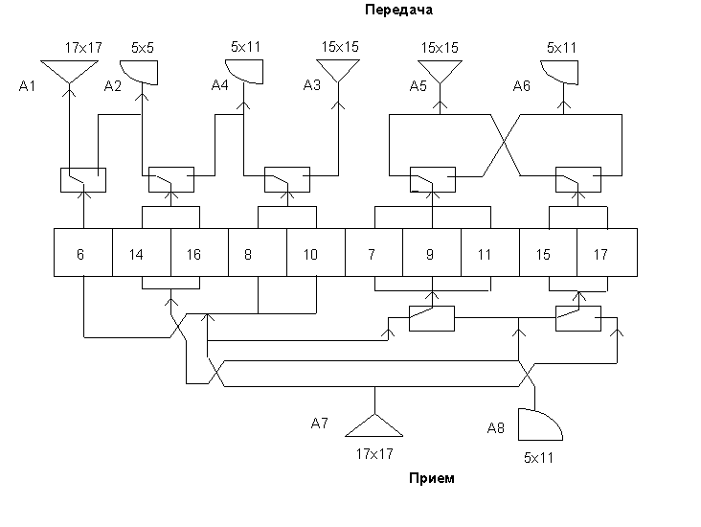

Figure 3.11-connection Diagram "Express" antenna"

Receiving and transmitting equipment. When designing on-Board equipment, two main requirements are taken into account, which distinguish the "Board" from the "ground": ensuring the lowest possible energy consumption and radiation resistance of the element base. It should be noted that ("thanks" to the second requirement) the cost of equipment designed for operation on SPACECRAFT is ten times higher than the price of similar devices of ground complexes, and the need to use special screens to protect against radiation damage increases the weight of the equipment.

In systems with SC in medium-high and low orbits, semiconductor amplifiers with a power of up to 60 W for the L-band are usually used: up to 20 W for the C - band and 5-10 W for the Ku-band. Unlike amplifiers with LBV, this equipment operates at a lower supply voltage, more compact and reliable.

Signals coming to the satellite receiving antenna are extremely weak, and the repeater must amplify them and send them to the transmitting antenna in the retransmitted frequency band.

In a repeater, signals usually deteriorate to some extent. These impairments, which must be kept within acceptable limits, are caused by many causes, including the following main ones:

− the nonlinearity of the amplifier causing intermodulation (several carriers in one amplifier) cross-modulation and inter-symbol interference in digital transmission;

− interference between signals transmitted in adjacent frequency bands;

− multiple signal paths between input and output;

− amplitude and phase variations in the bandwidth caused by filter characteristics that cause signal distortion and the resulting noise or errors in the band.

One amplifier is usually not enough to develop the full power required for all RF channels. In addition, due to the nel-neity of the amplifier, it is necessary to work with a certain decrease in the output power relative to the maximum, and with an increase in the number of amplified signals, this level decreases even more. Therefore, the strengthening should be carried out in two stages:

(a) total low-level amplification of all useful full-band signals coming from the receiving antenna;

b) amplification of signals in the subband or RF channel (part of the full band) to the desired output level.

Filters and couplers are used to split the original band into sub-bands after the overall low-level gain at the input of the amplifier circuit and to combine them again into a common band at the output before they reach the transmitting antenna.

Receiving device. In the input stages of on-Board receivers are currently most often used low-noise amplifiers (MOSFETs) on field-effect transistors. The noise factor of such a receiver is less than 3 dB in the frequency range of 1.5-4 GHz and not more than 4.5 dB for the 11-14 GHz band. Reduction of noise characteristics of on-Board receivers is possible when switching to a new element base. The creation of MSU on the basis of transistors with high electron mobility will allow to achieve the noise coefficient for the 1.5-4 GHz band almost 2 dB, and for the 11-14 GHz band - 3.5 dB. In this case, the amplifier will be much more reliable and even more compact (due to the higher degree of integration of the elements).

Wideband receiver subsystem. This subsystem provides the first stage of signal amplification and transfer from the receiving frequency band to the transmission frequency band in the case of a system with a single frequency conversion. In a dual conversion system, a wideband receiver amplifies the signals and converts the receiving frequency to a Pro-day frequency. The noise factor should be low enough to have as little effect as possible on the C/N ratio on the up line.

Intermodulation components limit the signal level at the receiver output to varying degrees, depending on the transistors used. Typically, the receiver gain is approximately 50-60 dB (see figure 3.12). There should be a margin for losses in the frequency Converter, filters and connectors. The gain distribution should provide an acceptable level of intermodulation components and maintain an acceptable value of the noise coefficient.

Wideband receivers are fully solid-state. They must be extremely reliable, as any failure will affect all signals transmitted in the full frequency band. Therefore, they should have a reserve.

Pre-amplifiers can use tunnel diodes, transistors, or parametric stages. New technology of field-effect transistors on gallium arsenide replaced tunnel diodes and parametric amplifiers. A bandpass filter must be enabled at the input of the preamplifier to protect against interference at the mirror frequency and from all out-of-band signals.

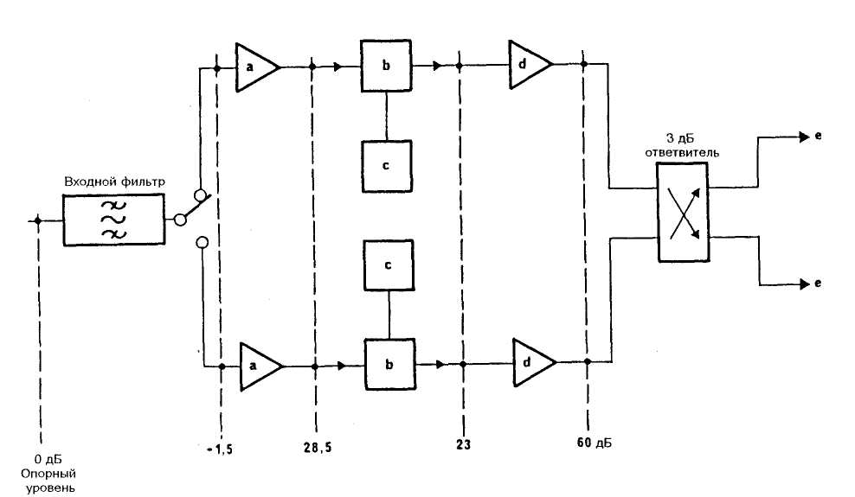

Figure 3.12-example of a broadband receiver (with backup) with typical diagram of relative levels

a: pre-amplifier d: amplifier b: mixer

e: part of the channel separation C: heterodyne

Either bipolar transistors (4 GHz) or gallium arsenide field effect transistors (4 GHz and above) can be used in amplifiers. For operation in the 30/20 GHz frequency bands, transistors with fast electrons are promising from the point of view of low noise level.

Frequency converters, usually on diodes, are designed for the pressure of radiation at the frequency of the heterodyne, its harmonics and high-order pre-formation products. The heterodyne, which should have a power of about 10 dBm, can be a conventional oscillator with quartz frequency stabilization with cascades of frequency multipliers, or with phase auto-tuning, or a generator with a volume dielectric resonator stabilized in a comparison scheme with a quartz oscillator. The hydrogen must be highly stable over time and in the temperature range, and its phase noise must be kept to a minimum.

Subsystem separation channels. The second stage of amplification is carried out in the transmission frequency band by a group of amplifying paths, in each of which signals are amplified in the section of the full frequency band divided into frequency channels.

The signals from the wideband receiver output are divided into frequency channels by means of a series of circulators and bandpass filters with aligned characteristics. This set is called the input de-multiplexer. After amplification in the power amplifiers, the signals at the repeater outputs are combined again in one common frequency band using a set of filters called an output multiplexer or multiple multiplexers.

The distribution subsystem of the repeater channels is thus from the input demultiplexer, amplifier channel output multiplexer.

As for channel bandwidth, there is no General standard. In bands 6/4 GHz is generally accepted frequency spacing channels at 40 MHz, but it is not universal, and in bands 14/11-12 GHz used different values of bandwidth 27, 36, 45, 54, 72 MHz, etc.

The input demultiplexer at the receiver output divides the entire transmission frequency band into frequency channels corresponding to the amplifier paths. The separation filters of the demultiplexer should have characteristics with sufficiently steep slopes to avoid the formation of many signal paths through adjacent amplifying paths, and with sufficiently flat areas in the passbands to keep the distortion within acceptable limits. Filters usually have amplitude and phase characteristics equalizers. Filters can be combined with circulators in two groups (fed from two outputs of the receiver), one for even channels, and the second for odd channels.

Each amplifying path corresponds to a specific frequency band allocated by the filters of the input demultiplexer. The main part of the path is the power amplifier connected to the corresponding filter of the output multiplexer, usually through an insulator. As an amplifier can be used LBV or solid-state power amplifier. The output power of an LBW amplifier for the 4 GHz band is usually between 5 and 10 watts, although sometimes lbws with an output power of up to 40 watts are used. Solid-state amplifiers operating in the 4 GHz band have a power output of up to 10 watts, and devices with a power of up to 30 watts have been created.

Transmitting device. The main functional part of the transmitting path is the power amplifier of the transmitter. Various types of such devices are used in onboard systems.

In geostationary SPACECRAFT communication systems, one of the main types of amplifiers for transmitters traditionally remains amplifiers based on a traveling wave lamp (LBW). Although today their efficiency exceeds 40% (the efficiency of the LBV itself is about 60%), this indicator is not stable during operation and falls rapidly, especially when the output power of the transmitter decreases in the linear section of the dynamic characteristics. When operating in multi-carrier mode, to achieve the best energy performance of the line, it is required to provide a signal-to-noise ratio of 20 to 30 dB, which leads to losses that reduce the efficiency of the LBW-based amplifier to 10-20%.

For operation in the frequency bands 11-12 GHz there are LBV low power-from 10 to 20 watts and medium power-from 40 to 65 watts. In addition, LBW with an output power of up to 250 W are already used in satellites for television broadcasting. Solid-state power amplifiers suitable for commercial applications for operation in the 11-12 GHz bands are not yet available due to their low efficiency of converting DC energy into signals at radio frequencies. In addition, the amplification path may include the following elements:

- fixed attenuator for equalizing losses in the channel in the input demultiplexer and the difference of the gain values in the TWT. Its output must be the same nominal level in each path;

- attenuator, working on commands from Earth, according to the desired overall gain, the type of transmitted signals, etc.;

- sometimes an amplifier with automatic gain control to compensate for fluctuations due to atmospheric conditions on the line up (in the case where a single signal is transmitted in the channel);

- leading amplifier when the power amplifier is insufficient to provide the required full gain under all conditions;

- the linearizer to compensate for nonlinearity of a TWT or solid-state-St amplifier.

Linearization (pre-selection) can be used to ensure the operation of the LBV or solid state amplifier with a smaller decrease in output power. Due to reliability requirements, the amplifier path and, in any case, the power amplifiers must be redundant.

The placement of power amplifiers can sometimes be problematic, as these amplifiers must be mounted on panels to radiate heat into outer space. The cable connections with the corresponding filters of the output multiplexer must be tight, and the operation of the backup equipment must not worsen the operating conditions (increase in losses, change in thermal equilibrium).

The losses in the output multiplexer should be small, as any losses between the output of the last amplifier and the antenna input have a direct impact on the eiim. For this reason, the filters are directly connected to one waveguide (collector) leading to the transmitting antenna. The output multiplexer on the satellite does not require performance equalizers, as they can be installed on earth stations.

**3.3 Launching the satellite**

Launch vehicles and spacecraft. Reliable delivery of spacecraft (SC) into orbit is a complex matter and involves significant financial costs. Thus, putting one SPACECRAFT into geostationary orbit can cost $ 45-200 million., which is a significant part of the cost of the entire project.

Currently, the choice of a particular launch technology is usually determined by three factors: the cost of launch, reliability and technical capabilities of the missile.

The market for rocket and space technology is very extensive. It presents both traditional disposable carriers such as ELV (expendable launch vehicle), and rockets created by new technologies, such as RLV (reusable launch vehicle) - reusable means of launching satellites to or-bit.

The criteria for selecting launch vehicles are usually the purpose of the satellites, the payload mass, the requirements for the design of the SPACECRAFT, and, accordingly, the method of its delivery to orbit.

Depending on the mass of the payload carriers are divided into classes: heavy and light. Heavy able to output in any Orbi-the satellites with a payload exceeding 1 tonne Rockets light class-sa is intended primarily for output SPACECRAFT in low earth orbit. Members of a family of launch vehicles (modifications of the same series) may differ in design number of stages (usually from 2 to 4) or the type of upper stage.

As for the methods of delivering satellites into orbit, they are also not-how many. Traditional launch methods are from open-air launch sites and from mine launchers. In the near future, launches from sea or air launch facilities may constitute a serious contention for them. An important role is also played by the method of launching the SPACECRAFT into orbit.

Today, the most commonly used scheme is the following: first, the satellite is put into a reference orbit (the so-called geostationary transition orbit - GTO), and from it the energy optimal flight to a given orbit is carried out. It should be borne in mind that this scheme can be implemented only in the presence of a special propulsion unit or upper stage as part of the launch vehicle with the possibility of at least twofold activation of the main engine in zero gravity.

The "direct" scheme of launching SPACECRAFT into orbit is energetically less profitable.

Accuracy characteristics of the delivery of the satellite at the estimated point of or-bits is now quite high: the error positioning KA on you-cell may be 5-15 km, and the error of the inclination is usually not more than 0.05-1°.

Heavy-class launch vehicles include such families as Ariane, Delta, Atlas, Long Mach, proton and Zenit (tabica 3.4). They provide a launch to geostationary, medium and low okolatem-wide orbit as single satellites and groups of KA.

A group launch, in which up to 12 satellites are simultaneously launched into orbit, is the most effective, since it reduces the cost of creating an orbital grouping, as well as the total load on the launch complex.

Figures 3.13 and 3.14 show the launch vehicle and the payload placed on it: KazSat and Express AM.

In addition, stricter requirements for the number of missile launches is of great importance for the ecology of space and the planet (to solve the problem of "space debris").

The Ariane launch vehicle from the very beginning was conceived as a "European", i.e. providing satellite launches for European countries. In her co-building was attended by many leading aerospace companies: Aerospatiale (France), Matra Marconi Space (England, France), Fiat-BDR Difea Spazio (Italy), DASA (Germany).

In June 1988, Ariane 40 was launched, which belongs to the 4th generation of launch vehicles. Currently, almost half of all commercial launches are carried out with its help.

Table 3.4-heavy-duty launch Vehicles

|  |  |  |  |  |
| --- | --- | --- | --- | --- |
| Type of booster* | First-run | Max. load for different orbits, kg | | Cost, million dollars |
| LEO | GTO/GEO |
| "Протон-К" (Россия) | 11 апр. 1994 г. | 20000 | 3900/2600 | 65 |
| Ariane 5 (ESA) | 4 июня 1996 г. | 18000 | 6800 | 125 |
| Delta III (США) | 27 авг. 1998 г. | 8346 | 3810 | Нет данных |
| H2A222 (Япония) | После 1999 г. | 18000 | 7500 | Нет данных |
| Long March CZ-3B (Китай) | 14 февр. 1996 г | Нет данных | 4850 | 70 |
| Titan 4B (США)2 | 23 февр. 1997 г | 21640 | 18600/8620 | 350 |
| Note  1 the country in which the manufacturing company is registered is indicated in parentheses.  2 the most expensive booster. | | | | |

Development of Delta carriers has been conducted since the mid-50s by McDonnell Douglas (USA). The first launches (since 1960) production were mainly in the interests of the military departments and Federal services of the United States, and the commercial launch took place in August 1989 RA-chum family Delta as one of the most reliable. The most famous mi-re RN Delta II model 7925 helped to launch 24 satellites of the GPS, 50 KA 8 Iridium and Globalstar. Russian rocket "proton" created GKNPTs them M. V. Khrunichev. It provides a sufficiently high reliability of starts-0.96 (data for the last 10 years). "Proton" brought into orbit Russian satellites Gorizont, gals, Express, foreign Aaiasat 3 satellites, Astra 2A, 4 Echostar, Panamsat 8 and 21, the satellite Iridium (3 starting at 7 KA), etc. All launches carried out from the cosmodrome "Baikonur".

Small-capacity launch vehicles are designed for the creation of low-orbit groups. They perform both group and single runs. Light low-orbit satellites can be launched into orbit using traditional fixed or mobile launch kits, including from aircraft. Since the launch of light satellites does not require significant material costs, it is such satellites that countries that do not have their own spaceports prefer to use.

Currently, there are a number of" one-time " carriers, whose energy capabilities ensure the launch of SPACECRAFT into low and medium-altitude orbits (table 3.5). In this class of missiles the most ass-larny American Ahhena (formerly LLV - Lockheed Launch Vehicle), Conestoga, Pegasus, Taurus, and Russian "Space".

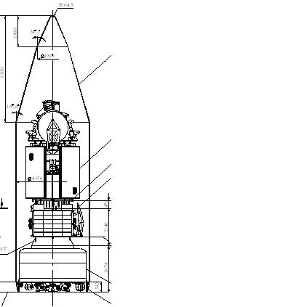

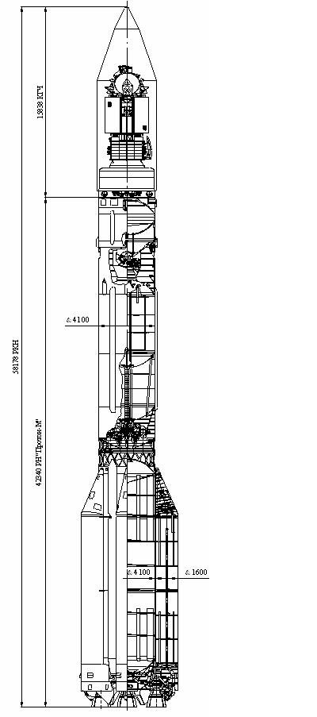

KA Express AM

Standard device SPACECRAFT separation Express AM

КА KazSat

Figure 3.13 – payload Proton M

Ahhena developed and manufactured by Lockheed Martin Missiles (Sunnyvale, California) since 1992. The first launch of Athena 1 (LL V1) was unsuccessful, but today it is - one of the most proven platforms.

According to the characteristics of the rocket Conestoga close to the Russian "Cosmos". Its development, manufacture and organization of commercial use is carried out by AIR Systems (USA). The first launch of the carrier took place in September Figure 3.14-proton M launch Vehicle 1982.

The Kosmos light launch vehicle was created on the basis of a medium-range Intercontinental ballistic missile and is designed primarily to launch satellites into low orbits. Produces such missiles ON "Flight" (Omsk). With the help of Kosmos-ZM, a large number of domestic and a number of foreign satellites have been put into orbit.

Table 3.5 - boosters light class

|  |  |  |  |
| --- | --- | --- | --- |
| Type of booster | First  launch | Max. the weight orbits for LEO/GTO, kg | Cost, million dollars |
| "Рокот" (Россия) | 26 дек. 1994 г. | 1850 | Нет данных |
| Athena 2 (США) | После 1999 г. | 1985/1490 | 22 |
| Conestoga(США)2 | 23 окт. 1992 г. | 2100 | 12-25 |
| Eagle-S2 (США) | После 1999 г. | 1300 | 30 |
| Pegasus XL (США) | 27 июня1994 г. | 455 | 13 |
| Taurus (США) | 13 марта1994 г. | 620/430 | 15 |
| Note  1 the country in which the manufacturing company is registered is indicated in parentheses.  2 Missile with maximum payload. | | | |

A geostationary satellite is usually launched by a multistage rocket through an intermediate orbit. Modern RA-keta-carrier is a complex space flying APPA-rat, which is driven by the reactive force of the rocket propulsion.

The structure of the launch vehicle includes a missile and head units. The rocket unit is an Autonomous part of a composite rocket with a fuel compartment, propulsion system and elements of the stage separation system. The propulsion unit includes a payload and a fairing that protects the design of the spacecraft from the force and thermal effects of the incoming air flow during flight in the atmosphere and serves for mounting on its inner surface elements that participate in the preparation for the launch, but do not function in flight. The main fairing makes it possible to simplify the design of the spacecraft and is a passive element, the need for which disappears after the launch vehicle exits the dense layers of the atmosphere, where it is discharged. The payload of the spacecraft consists of relay communication and broadcasting equipment, radio telemetry systems, the actual spacecraft body with all auxiliary and supporting systems.

The principle of operation of a one-time multi-stage booster is as follows: while the first stage is operating, the rest can be considered together with the true payload as the payload of the first stage. After its separation, the second one begins to work, which together with the subsequent stages and the true payload forms a new independent missile. For the second stage, all subsequent (if any), together with the true payload, play the role of a payload and so on, that is, a payload. its flight is characterized by several stages, each of which is like a stage for the message initial speed of another single-stage missile within its co-becoming. Rejection of the first and subsequent stages of the carrier is carried out after complete combustion of fuel in the propulsion system.

The path that the launch vehicle passes when launching the spacecraft into orbit is called the flight path. It is characterized by active and passive areas. Active leg of the flight - a flight of steps of the carrier with the engine running, passive part - the flight of spent RA-chetnych blocks after the separation from the launch vehicle.

The time and place of the launch vehicle launch play an important role in placing the spacecraft into the appropriate orbit. It is estimated that the cosmodrome is more advantageous to be located as close as possible to the equator, since when accelerating in the Eastern direction, the launch vehicle receives an additional velocity. This speed is called the circumferential speed of the cosmodrome VC, i.e. the speed of its movement around The earth's axis due to the daily rotation of the planet.

For a particular latitude  speed of the cosmodrome V is determined by a formula that is on the equator it is equal to 465 m/s, and at the latitude of the Baikonur cosmodrome - 316 m/s. Practically, this means that at the equator the same booster can be started heavier satellites.

The final stage of the launch vehicle flight is the launch of the satellite into orbit, the shape of which is determined by the kinetic energy reported by the rocket, that is, the final speed of the carrier. In the event that a satellite is given enough energy to be taken to GEO, the launch vehicle must take it to a point 35,875 km away from Earth.

The orbital velocity of the geostationary satellite is easy to calculate. You honeycomb GEO above the Earth surface of 35 786 km, the GSO radius 6366 km (the average radius of the Earth), i.e. 42 241 km by Multiplying the radius value of the bonds on 2 (6,28), get the length of the circumference 265 of 409 km If you divide it into the length of day in seconds (86 400 s), we get the orbital speed of the satellite is - an average of 3,075 km/s, or 3075 m/s.

Typically, the satellite launch vehicle is carried out in four stages: exit to the initial orbit; exit to the orbit of "waiting" (Parking orbit); exit to the transition orbit; exit to the final orbit (figure 3.15).

Figure 3.15 Phase (phases) a practical scheme of removing satellites

in geostationary orbit

1-initial transition orbit;

2-first activation of apogee engine to enter intermediate transition orbit;

3-determination of orbital position;

4-second activation of apogee engine to enter initial drift orbit;

5-reorientation of the orbit plane and error correction;

6-orientation perpendicular to the orbit plane and error correction;

7-stop the satellite platform, opening panels, full undocking with the rocket;

8 - erection of antennas, the inclusion of gyrostabilizer;

9 - stabilization of the position: the orientation of the antenna on the desired point on the Earth, orientation of solar panels in the Sun, the inclusion of airborne Retrans-tor and the establishment of the nominal operation mode.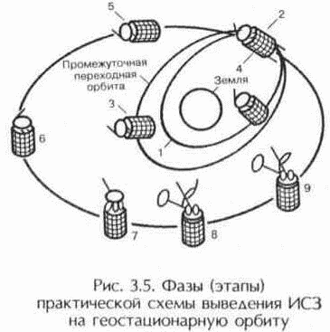

**4 Earth segment**

The term "earth segment" refers to the part of a satellite communications system that is formed by earth stations used to transmit and receive any kind of communications traffic signals transmitted to and from the satellite and forming a junction with terrestrial networks.

The main element of the earth segment is the Earth station (AP), which is the terminal transmitting and receiving link of a communication line via satellite.

The various types of communications and services that the equipment of the earth segment should provide, have predetermined a huge number of technical solutions necessary for the implementation of specific tasks.

The nomenclature of earth stations and terminals is very extensive. There are two reasons for this diversity:

- More than 100 major manufacturers of communications equipment for satellite systems are represented on the world market (with the advent of personal satellite communications, leading companies traditionally producing equipment for cellular and trunking networks, such as Alcatel, Ericsson, Motorola, Panasonic and other);

- an extremely wide range of services (voice, data, video, etc.) and various purpose of the AP, and hence the variety of their design (stationary, portable, automobile, rail, sea, airplane).

In addition, earth stations differ in their role in the structure of the earth segment: trunk, VSAT stations, as well as interface nodes and coordinating stations that provide for the organization of communications in the region. Depending on the method of organizing communications, earth stations are divided into:

- receiving stations of distribution systems (receiving stations of television and television broadcasting for individual and collective use and pagers);

- transmitting stations (satellite broadcasting systems, beacons and radio beacons);

- transceiver (including central control station, HUB and gateways);

- control - stations that monitor the operation mode of the space station repeater, over the observance by the earth stations of the network of the most important parameters: radiated power, operating frequencies, etc .;

- Earth stations of the satellite control and monitoring system — stations that control the operation of the entire space segment (space station).

The lock station (gateway) consists of several transceiver complexes (usually at least three), each of which has a tracking parabolic antenna.

Transceiver complexes operate as follows:

- The 1st complex enters into communication with the i-th spacecraft;

- the 2nd complex enters into communication with the i +1 th spacecraft;

- then the 1st complex, after leaving the visibility of the 1st spacecraft, enters into communication with the i + 2nd spacecraft;

- the 2nd complex, after leaving the zone i + 1 of the spacecraft, enters into a relationship with the i + 3th spacecraft, etc.

- The 3rd complex, as a rule, is in reserve and, if necessary, can replace the 1st or 2nd complex.

Another classification of the AP by belonging to the type of satellite service: fixed - FSS, broadcasting - RSS or mobile - MSS.

In many respects, the structure and characteristics of the spacecraft will depend on the type of orbit of the spacecraft with which the given spacecraft works (GEO, MEO, LEO), and the corresponding degree of distance of the spacecraft from the repeater.

APs for the 6/4 GHz and 14 / 11-12 GHz bands are often classified only by the size of their antennas:

- Large stations: antennas from about 33 m to 15 m;

- middle stations: antennas from about 15 m to 7 m;

- small stations: antennas from about 7 m to 3 m or less;

- Microstations for VSAT networks: antennas from 4 m to 0.7 m.

**4.1 Main characteristics of AP**

The general block diagram of a typical satellite communications satellite is shown in Figure 4.1.

The station includes the following main subsystems:

- antenna system;

- low noise receiver amplifiers;

- transmitter power amplifiers;

- communication equipment (frequency converters and modems);

- sealing / decompression equipment;

- equipment for connecting to a terrestrial communication network;

- auxiliary equipment (control and monitoring equipment, measuring equipment, service channel equipment);

- power supply equipment (network power supply with redundancy and uninterruptible power supplies);

- general-purpose infrastructure (all premises, buildings and structures).

Figure 4.1 - General block diagram of a typical satellite communications satellite

Consider a brief information on the subsystems of the AP.

ZS should be designed in such a way that high-quality indicators, and therefore the cost of the subsystems included in the station, correspond to each other. Low-noise amplifiers (LNAs) of the ES receiver are necessary in order to receive a very weak signal from the satellite. At present, LNAs with an effective noise temperature of 45 K at 4 GHz and 150 K at 11 GHz are quite acceptable (achieved under stabilization at ambient temperature). The LNA is usually broadband: it amplifies simultaneously all carriers coming from the receiving port of the antenna diplexer. Typically, a backup amplifier is also installed (1 + 1 redundancy).

The receiving device pre-amplifies the signals using the input low-noise amplifier (LNA) and converts them to an intermediate frequency. A design feature of the main LCs is the location of the LNA not in the main room, but next to the antenna feed, which reduces losses in the feeder path and thereby increase the sensitivity of the station. In modern LNAs operating in the C and Ku bands (bandwidth from 500 MHz to 1 GHz), the equivalent noise temperature is 50-150 K, and the gain is 30-40 dB.

The output power of the transmitter is up to 1 W, 1 kW for a television carrier. Two types of microwave devices are used in power amplifiers ЗС - traveling wave tubes (TWT) and klystrons.

For small stations of small capacity, it may be sufficient to use solid-state amplifiers on transistors with a field effect. Currently, the output power of this type of amplifier on the market is several watts, but it can be expected that an improvement in the parameters of transistors or other solid state devices will lead to their widespread adoption at small stations.

The main advantage of klystrons is high stability and low noise level, while TWT provides a large (compared with them) bandwidth. In amplifiers with a power of 0.5-1 kW, they usually use TWT, and in more powerful (1-3 kW) - klystrons.

Connected equipment is usually equipment that modulates the microwave carrier with low-frequency signals (group frequency band) for radiation and extracts (demodulates) these low-frequency signals during reception. Communication equipment consists of frequency converters, modulators and demodulators, signal processing equipment. Signal processing is required, in particular, when using multiple access with time division multiplexing (TDMA). Digital data stream is being formatted: on the transmitting side, this equipment converts a continuous input digital data stream for transmission via satellite using a modulator. This data is entered into the system frame with TDMA, for which it is converted (using the buffer memory) into a very fast data stream consisting of short packets entered into the frame. Thus, a station can transmit packets to a number of addresses in the same way as a multicast carrier in the case of FDMA.

Even if all the transmissions are analog and the interface to the terrestrial network is also analog, the compaction / decompression operations are almost always required due to the need to change the distribution of telephone channels (for example, primary groups) within the group frequency band. In digital satellite transmission, the telephone signals to be transmitted, or more often the standard group signals received from the terrestrial network, are regrouped and converted into a data stream for transmission from the station (for example, after grouping into packets for transmission using the TDMA method). At the reception, the reverse process is used to isolate the streams destined for the given station (from packets transmitted by corresponding stations in the case of transmission using the TDMA method).

In the case of telephony, the earth station is usually connected to the terrestrial network through a switching center. This can be a transit center in the case of an international station, or a large or medium-sized national network station, or, possibly, a telephone exchange in the case of small local stations of national networks.

Specific equipment that is usually required for such a connection:

- land line between the earth station and the switching center. A coaxial cable can be used on this line, although more often according to the terrain it is necessary to use a radio relay line;

NOTE In the case of small stations in the national network, the station and the switching center can be located on the same site,

- echo cancellers (or echo cancellers) and various peripheral signaling equipment.

In the case of television, the earth station is connected:

- with the studio where the program is being formed, while performing the transfer functions;

- with a local broadcast transmitter when performing reception functions.

The connection is usually made using a radio link. Small receiving stations are often directly connected to the local television distribution network.

The auxiliary equipment of the AP consists of: control and monitoring equipment; measuring equipment; service channel equipment.

Uninterrupted operation of a power supply unit primarily depends on the correct design of power sources (this is usually a network power source, with the possibility of redundancy and an uninterruptible power supply (UPS)). For large stations, the UPS power can reach 50 - 100 kVA.

The general-purpose infrastructure of the AP includes all premises, buildings, structures and services. Its dimensions depend on the type of station and the number of antennas used on it.

The main characteristics of the AP should include:

a) frequency ranges for reception and transmission.

AP operate at frequencies allocated to satellite communications systems.

Most earth stations of satellite communication systems (SSSS) operate in the 4 and 11 GHz bands for reception and 6 and 14 GHz for transmission, which corresponds to the accepted symbols C and Ku.

  The allocation of frequency bands between various radiocommunication services is dealt with by the International Telecommunication Union (ITU). Currently, such a allocation of frequency bands is made from 9 kHz to 275 GHz. In addition to radio services, the allocation of frequency bands also provides for the division of the globe into 3 Regions:

1) Region 1 (Europe, Africa, Russia, Kazakhstan, Mongolia, etc.);

2) Region 2 (North and South America);

3) Region 3 (Asia, Oceania, Australia);

b) the quality factor of the station for receiving GA / T (measured in dB / K), GA is the gain of the receiving antenna, T is the effective noise temperature of the receiving path. The values ​​of Q-factors for reception for ES are in the range of 20 ... 40 dB / K;

The quality factor is calculated by the formula

GA / T = 10 * log (GA / T), dB / K.

c) the diameter of the antenna DA determines the size and cost of the ES, its spatial selectivity.

The range of diameters is very wide (from about 0.45 m to 32 m).

In addition to the diameter of the antenna, it is important to know the polarization characteristics of the antenna, the characteristic of the side lobes, a full-circle antenna that can be sent to any point in the sky, or part-turn (limited guidance area), or fixed (for working with geostationary satellites).

At present, VSAT type (Very Small Aperture Terminal) - a terminal with a very small diameter antenna is widespread;

d) effective radiated isotropic power (EIRP) is the product of the transmitter power, the efficiency of the waveguide path and the antenna gain.

The values ​​of this parameter for various SSSS are in the range of 50 - 95 dBW.

In contrast to airborne antennas, in which the shape of the radiation pattern must be “consistent” with the served earth's surface (global, narrow, profiled beam, etc.), antenna antennas of the main grounding stations do not have such requirements, since they are oriented strictly towards specific spacecraft.

The main parameters of the antennas are: amplification, effective aperture area (aperture), radiation patterns and beam width, side lobes, polarization and noise temperature.

The antenna noise temperature (or “antenna temperature”) should be kept as low as possible by appropriate

design for high quality.

The ZS antenna transceiver system includes a reflector (mirror), an irradiating system, a waveguide path (VT), a rotary support device with drive equipment and guidance equipment.

At the AP, mirror types of various types are used. Since these antennas have high antenna gain, low levels of side lobes, good polarization cleanliness, low noise temperature and good matching of impedances are maintained throughout the wide frequency band for reception and transmission. For example, in the 6/4 GHz band of INTELSAT-VI, the total antenna band starts at 3.625 and goes up to 6.425 GHz (more precisely, from 3.625 to 4.2 GHz, plus the range from 5.850 to 6.425 GHz).

Most mirrored antenna systems — front-feed parabolic or Cassegrain and Gregory — are axisymmetric. However, to obtain particularly high quality, antennas with a remote irradiator can be used, that is, antennas that use an asymmetric reflecting system (as shown in Table 4.1).

High quality is achieved due to the fact that these antennas are not affected by shading.

The characteristics of the side lobes of the earth station antennas are one of the main factors in determining the minimum separation between satellites and, therefore, the efficiency of using the orbit / spectrum.

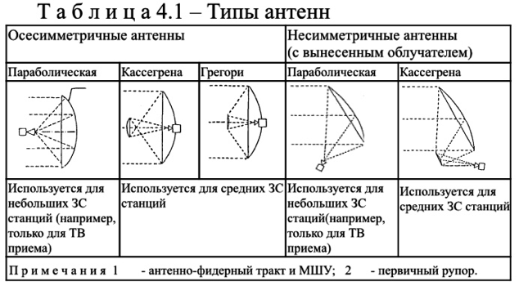

The cost of an earth station and its main operational parameters are determined by the size of the antenna used. The larger the diameter of the antenna, the higher its cost and throughput.

So, in the Intelsat system, stations with an antenna diameter of 30 m and a Q factor of 10 log (G / T) = 40.7 dB / K in the frequency range 4-6 GHz were originally used. As the spacecraft was improved and the radiation power increased, the main indicators were reduced to 16-18 m (antenna diameter) and 35 dB / K (quality factor). The price of such a station is about $ 8 million, but when the antenna diameter is reduced to 5 m, the cost of the AP decreases to $ 2 million.

4.2 Intelsat international stations

To enter a new earth station into the INTELSAT Global Communications System, that is, to service international traffic, the concerned administration should refer to the general document of the INTELSAT system called Procedures governing the use, approval, verification and operation of earth stations in the INTELSAT system Eight standard types of earth stations are allowed to work in the INTELSAT Global System, although other (“non-standard”) types (for temporary work) on an individual basis can be taken into consideration. pecifications requirements Intelsat system, these eight types of stations designated as standards A, B, C, D, E, F, G and Z.

The main characteristics of APs corresponding to various standards are given in Table 4.2.

In the technical conditions, the requirements for the composition and parameters of the antenna system are defined.

The gain of the antenna system for transmission should be more than 52.65 dB, and for reception - more than 50.52 dB. The antenna system together with the waveguide path must provide isolation between the receiving and transmitting paths of at least [80 + Pp], where Pp is the transmitter power, dBW. AP transmitters must provide the transmission of one or more

bearing in trunks allocated for work. Operating frequencies are determined by the system and satellite used. The operating range of the transmitter — the main characteristic of the ES — determines the requirements for the possibility of tuning the modulator and the upconverter. The maximum level of spurious emissions should be no less than 50 dB lower than the level of the main signal, but not exceed 100 mW.

Table 4.2 - Characteristics of APs of various types

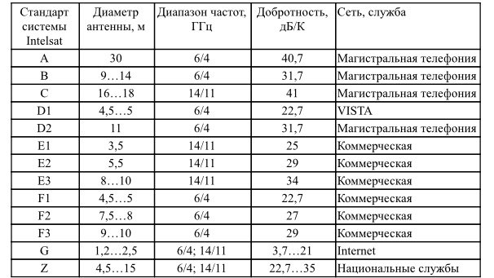

AP receivers should provide reception of one or several non-existent trunks allocated for operation. The operating frequency range of the receiver is the main characteristic of the station and determines the requirements for tuning the demodulator and the buck converter. The selectivity of the receiver on the adjacent and mirror channels should be at least 30 dB and 50 dB, respectively. The output signal level of the demodulator should be in the range from minus 35 to minus 5 dBm.

The AP modem is interfaced with channel-forming equipment (COA) at the joints in accordance with ITU-T Recommendations G-703 and G-704. As part of the KOA, the use of information protection equipment is allowed. The standards for various types of terminal equipment (transcoder, transmultiplexer, codec) are determined by ITU-T Recommendations.

The characteristics of the channels being organized must comply with the requirements of international documents (ITU-R and ITU-T), interstate and state standards.

4.3 Earth stations in regional or national systems

Several types of earth stations are intended for regional and national use. The choice of one type or another depends on the general organization of the system and on the characteristics of the connected payload of the satellite. These stations, which typically use medium-sized antennas, can be divided into categories according to the following criteria:

a) stations operating through the space segment - 6/4 GHz trunks leased on INTELSAT satellites.

These stations are usually similar to standard B stations (see table 4.2,), but with the following differences:

- the diameter of the antenna is usually from 7 to 15 m;

- communication modes (modulation and compaction methods) can be different and are usually chosen in order to optimize the operation of the entire system. In particular, telephony is usually transmitted using the OKN-FM method with companding or PDA-FM (with or without companding).

Specific options for optimizing the transmission parameters and the energy budget of communication lines allow the use of cost-effective medium-sized earth stations for the transmission of a fairly large number of channels.

To make it easier to obtain approval from INTELSAT, it is recommended that these stations meet the specifications of the new “standard Z” of INTELSAT to earth stations.

Z standard stations operate in the 6/4, 14/11 or 14/12 GHz bands. The antennas of national earth stations can have different sizes in a wide range, and the minimum requirements are presented to the owner of the earth station. The following parameters are not included in the required characteristics of the stations (see table 4.1): maximum eirp on the carrier; modulation method; G / t; transmission gain; channel quality.

b) stations operating in the 6/4 GHz bands within dedicated satellite systems, such as the Indonesia PALAPA system, the ARABSAT system and others: these stations are also often similar to INTELSAT standard B stations. The reason is that the required limited land coverage allows for high eirp trunks operating on directional satellite dishes. Due to this, a large number of channels can be transmitted during operation to rather simple earth stations equipped with medium-sized antennas;

c) stations in the 14/11 GHz bands: the 14/11 GHz (14/12 GHz) bands are increasingly being used for regional and national satellite systems.

The EUTELSAT system is an example of a regional system whose operation is based solely on the use of these ranges.

**4.4 VSAT earth stations**

VSAT (Very Small Aperture Terminal) station - a satellite communications station with a small diameter antenna, on the order of 0.45 ... 2.4 m. VSAT stations are used to exchange information between ground points, as well as in acquisition systems and data distribution. CCC with a network of earth stations such as VSAT provide telephone communications with digital voice transmission, as well as the transmission of digital information.

The class of earth stations VSAT (Very Small Aperture Terminal) includes satellite communication stations, the technical characteristics of which satisfy the following requirements of Rec. ITU-R S.725 “VSAT Technical Specifications” [ITU VSAT Systems and Earth Stations Handbook, 1994]:

- control and management of VSAT stations in the network is carried out centrally, but local station monitoring and control systems can be additionally used;

- VSAT stations belong to the Fixed Satellite Service (FSS) and must satisfy the requirements of the Radio Regulations and ITU-R Recommendations, like all FSS earth stations;

- VSAT stations are usually used in dedicated networks (private, business) to transmit data and telephony in digital form in operating modes only for reception (simplex) or for reception / transmission (duplex);

- VSAT antennas usually have a diameter of 1.8 ... 3.5 m, but in separate systems large antennas (up to 6 m in diameter) can also be used;

-data transfer rate in digital form from VSAT stations usually does not exceed 2 Mbps;

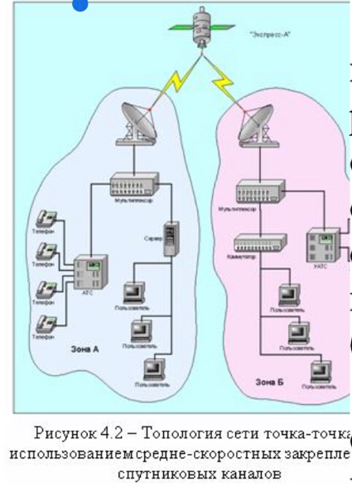

- VSAT stations use a low-power radio transmitter (usually from 1 to 20 W) with mandatory limitation of radiated power for safety reasons.

         Currently, VSAT station networks most often operate in the FSS frequency ranges 6/4 GHz and 14 / 11-12 GHz.

The technical parameters of VSATs during transmission should satisfy the requirements of the following ITU-R Recommendations:

         Rec. ITU-R S.726 “Maximum permissible spurious emissions level VSAT”;

         Rec. ITU-R S.727 “Cross-polarization isolation for VSAT”;

Rec. ITU-R S.728 “Maximum permissible level of off-axis density of the EIRP VSAT”;

        Rec. ITU-R S.729 “Monitoring and control of VSAT stations”.

An attractive feature of VSAT stations is the possibility of placing them in close proximity to users, which, due to this, can do without land lines.

By design, a VSAT-type satellite station consists of a high-frequency (OutDoor Unit –ODU) external module and a low-frequency (InDoor Unit –IDU) internal module. An ODU consisting of an antenna and a transceiver is located outside the building, in which an IDU consisting of a modem and a multiplexer (channel forming apparatus) is installed. ODU and IDU are interconnected by radio frequency cables. Goes on them

intermediate frequency signal. The intermediate frequency is 70 MHz or 140 MHz.

An external, or as it is sometimes called a high-frequency unit, consists of an antenna and a transceiver unit that is installed on this antenna. The transmitter-receiver unit provides the conversion of the low-frequency signal, its amplification and transmission “up”, as well as the reception of the high-frequency signal from the satellite, its conversion into an intermediate frequency signal and transmission to the indoor unit.

Depending on the distribution of traffic between subscribers, the architecture of satellite communications networks differs in the following ways: in terms of traffic configuration and management structure.

The point-to-point network allows direct duplex communication between two remote subscriber stations via dedicated channels. Such a communication scheme is most effective with a large load of channels (at least 30 - 40%).

The advantage of such an architecture is the simplicity of the organization of communication channels and their complete transparency for various exchange protocols.

In addition, such a network does not require a control system.

Figure 4.3 shows an example of creating point-to-point satellite channels for combining and / or expanding telecommunication networks, as well as for solving telephony problems in remote regions based on VSAT stations.

One station is installed in the immediate vicinity of the main telephone network node and interfaces with the central exchange, and the second is installed in a remote region and interfaces with the local exchange. A remote station can be a slave (all its settings are set and controlled from a central node).

A star network is the most common architecture for building CCC with subscriber stations of the VSAT class. Such a network provides multidirectional radial traffic between the central earth station (DSS or HUB) and remote peripheral stations (terminals) according to an energy-efficient scheme: a small DSS is a large DSS equipped with a large diameter antenna and a powerful transmitter.

A drawback of the star architecture is the presence of a double jump in communication between network terminals, which leads to noticeable signal delays. VSAT networks of this architecture are widely used to organize information exchange between a large number of remote terminals that do not have significant mutual traffic, and the company's central office, various transport, manufacturing, and financial institutions.

Similarly, telephone communication networks are being built to serve remote subscribers, which provide access to a public switched telephone network through a central station connected to a ground-based switching center or telephone exchange. The monitoring and control functions in a star network are usually centralized and concentrated in the central control station (CSC) of the network. The NCC performs the service functions of establishing connections between network subscribers (both terrestrial and satellite terminals) and maintaining the operational status of all peripheral devices.

In star networks created by large operators, several stand-alone VSAT subnets can be provided to the resource by the DCC. Such a solution turns out to be economically viable, since one central control center / central data center costs several million dollars and can serve up to 10 thousand or more terminals, and the average network of one client rarely exceeds 100 terminals.

In the “each with each” network, direct connections are provided between any subscriber stations (the so-called “one-hop” communication mode).

The number of required duplex radio channels is N x (N - 1), where N is the number of subscriber stations in the network. Moreover, each subscriber station should have N - 1 channels of reception and transmission. Such an architecture is optimal for telephone networks created in hard-to-reach or remote areas, as well as for data networks with a relatively small number of remote terminals.

Due to the fact that for the operation between two small terminals, VSAT requires large energy resources in comparison with the star network, in networks of the type “each with each” at subscriber stations it is necessary to use more powerful transmitters and antennas of a larger diameter , which significantly affects their price.

Each of these topologies has its advantages and disadvantages. In real situations, a wide range of services is often required, each of which is better implemented in different topologies. Therefore, many networks are built on mixed topologies.

With centralized management of such a network, the network control center (NCC) performs the monitoring and control service functions necessary for establishing a connection between network subscribers, but does not participate in the transmission of traffic. Typically, the NCC is installed on one of the subscriber stations of the network, which accounts for the most traffic.

In the decentralized version of the network control, the DCC is absent, and the elements of the control system are part of each VSAT station.

Similar networks with a distributed control system are characterized by increased survivability and flexibility due to the complexity of the equipment, the expansion of its functional capabilities and the cost of VSAT terminals. This control scheme is advisable only when creating small networks (up to 30 terminals) with high traffic between subscribers.

VSAT technology is very flexible and allows you to create networks that meet the most stringent requirements and provide a wide range of services for the transfer of voice, video, data in any combination. In many cases, they have undeniable advantages over terrestrial networks:

low cost, fast deployment, high quality communications, ease of reconfiguration, high reliability.

Installing and connecting a VSAT class terminal to the network takes several hours.

VSAT networks provide reliability of digital information transmission no worse than 10 * 10 -7, i.e. no more than one error per 10 million transmitted bits of information, which corresponds to approximately one error per 500 pages of textual information.

Reconfiguration of the network, including changing exchange protocols, adding new terminals or changing their geographical location is very fast. VSAT class terminals provide reliability during operation up to 100 thousand hours.

The popularity of VSAT in comparison with other types of communication when creating corporate networks is explained by the following considerations: for networks with a large number of terminals and with significant distances between subscribers, operating costs are significantly lower than when using terrestrial networks.

There are several types of VSAT earth stations. They can be divided into three generations. The emergence of each new generation of VSAT became possible with the advent of new technologies, the creation of more powerful communication satellites and the development of new frequency ranges.

First-generation VSATs operated in the C-band and were used only in broadcast type networks, i.e. subscriber terminals could only receive data streams from the DSC, and the transmission mode was not provided for in them. Broadcast networks are still widely used for distributing financial and business information, stock exchange reports, transfer of newspaper pages, and asymmetric Internet access systems. For example, the well-known DirecPC high-speed Internet access system is essentially a satellite broadcast network.

The second generation of VSAT earth stations is characterized in that they can support two-way (duplex) communications. These terminals are used by banking and financial organizations in various computer networks to exchange data, retail and wholesale networks, and industrial enterprises to communicate with branches and suppliers. They also found wide application for organizing high-speed two-way Internet access. VSAT stations are also used by telecom operators to create dedicated trunk channels between remote nodes with a large amount of data exchange between them. Most of them operate in the Ku band, although in some countries C networks are still used in networks.

The third generation terminals are widely used, with antennas with a diameter of 1.2 m or less. They are used in large networks, from those with low traffic levels. At the same time, traffic is sporadic (intermittent) in nature. Such terminals are simple in design, have a low price and operate exclusively in the Ku-band.

In recent years, the fourth generation of VSAT for multimedia applications has appeared on the market. They operate in Ku- and Ka-bands and provide speeds of up to several megabits per second. At the same time, the size of their antennas (in the Ka-band) is approximately 70 cm.

The central earth station of the VSAT telephone network (Figure 4.3) monitors and controls subscriber stations and provides subscribers with access to public telephone networks and terrestrial digital data transmission networks.

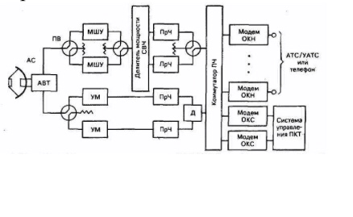

Currently, VSAT subscribers are provided with the following

services:

- access of VSAT network subscribers to specialized telephone exchanges for access to the public telephone network and the interurban and international communication network;

- ground connection of the subscriber to the VSAT network;

- access of subscribers of VSAT networks to digital public networks (Golden Line, MACOMNET, SPRINT, ASTELIT, etc.);

- access of VSAT subscribers to the Internet.

**4.5 Methodology for measuring earth station parameters**

The list of measured parameters of the ES and the participants in the measurements are given in table 4.3.

Verification measurements of the characteristics of the ES, which should be carried out using the space segment and with the participation of the Control Station (CRS), are carried out under the CRS program. At the same time, by the beginning of testing, service communication lines and instrumentation should comply with technical requirements.

Measurements should be carried out in accordance with the technical documentation for the AP equipment in accordance with the procedures.

Figure 4.3 - Functional diagram of the central control center of the telephone network VSAT:

AVT-antenna-waveguide path; AC antenna system; IF power divider;

OKN - one channel per carrier; ACS-common signaling channel;

PV switch waveguide; FCT provision of channels on demand; RF frequency converter; Power amplifier

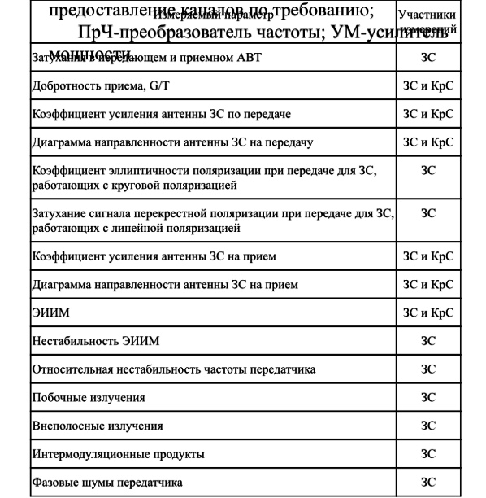

All actions in the process of measuring the characteristics of equipment using the space segment should be coordinated by the CRC operatively through the channel of official communication with the AP.

AC access to the space segment is made with permission and under the control of the Control Station of the corresponding region.

Immediately before going to the satellite, the personnel of the AP should check the equipment for receiving and transmitting, check the coordinates of pointing to the satellite and accurately point the antenna of the station using the pilot signal or the control carrier from the CS, and also check the working polarizations and frequencies of the test signals for transmission and reception.

At the initial exit of the AP by satellite power, the AP personnel must adhere to the following order:

- control the frequency and power of the signal, the levels of spurious and off-band emissions at the output of the transmitter;

- make sure the accuracy of the station’s antenna pointing at the satellite;

- make sure that there are no unwanted signals from the onboard transponder in the reception in the frequency band allocated for measurement;

- establish operational communication with KRS through the channel of general use or the channel of system-wide official communication;

- set the necessary frequency and EIRP of the carrier of the test signal at the command of the KRC;

- go out to a satellite with a power only at the command of the CRC and at the initial moment with a level of 10 dB below the established EIRP rating (usually 50 ... 55 dBW);

- set the nominal value of the EIRP carrier under the control of the CRC;

- operational personnel should be present at the AP for the entire time of measurements;

- at the end of the measurements, turn off the transmitter.

When making measurements, it must be taken into account that the accuracy of the measurement results to a certain extent depends on weather conditions, especially for the Ku range. The preferred measurement conditions are clear sky conditions in light winds. When conducting measurements under other conditions, it is necessary to take into account the correction for possible additional attenuation in the atmosphere.

AP personnel should verify that the measuring equipment used complies with the recommendations of the CRS and / or ITU recommendations and is certified (verified) by the metrological service.

The use of modern measuring instruments is allowed while maintaining the required measurement accuracy.

The requirements for the characteristics of the measuring equipment are given in table 4.4.

Table 4.4 - Specifications for measuring equipment

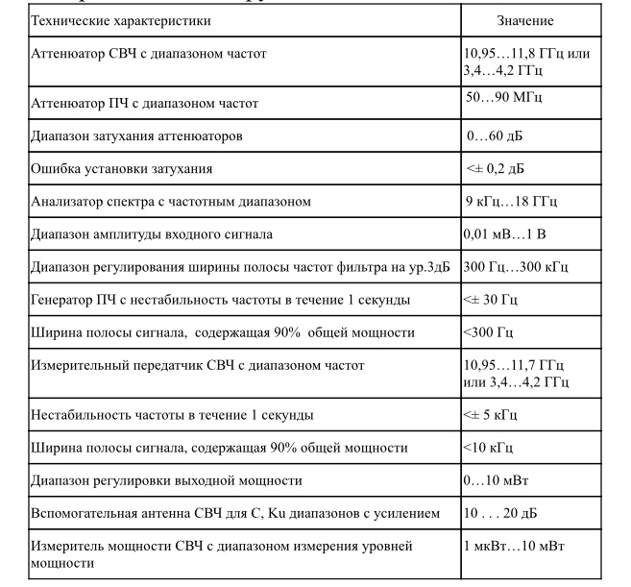 After completion of verification measurements of the characteristics of the AP equipment, separate protocols are drawn up by the AP and KS, which give the test results. If the measured parameters deviate from the technical requirements of the Regulation, the owner of the AP prepares the AP for re-testing.

Measurement of the attenuation in the transmitting (receiving) antenna-waveguide path.

The composition of the measuring equipment ZS:

- attenuation meter and VSWR panoramic (reflectometer);

- waveguide short circuit.

To measure the attenuation in the transmitting antenna-waveguide path (AWT), assemble the measurement scheme according to Figure 4.4.

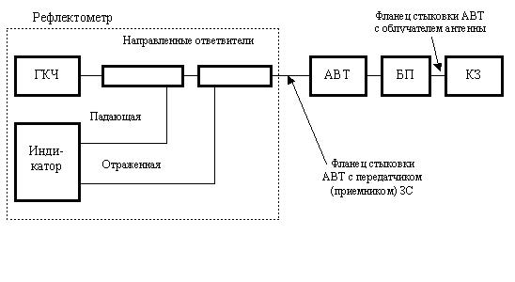 Figure 4.4 - Structural diagram of measurements in the antenna-waveguide path ZS

The measurement of the Q-factor of the G / T GC reception is made by the Spectrum Analyzer using a satellite in geostationary orbit and the Control Station.

To confirm the correctness of the results obtained, it is recommended to carry out measurements in the range of receiving frequencies and intermediate frequencies.

G / T = LFS + LATM + B + K - EIIIMSAT / ЗС + (PC - PN)

where LFS - loss in free space in the direction of the AP, dB

LFS = 92.45 + 20 logS + 20 log F;

F is the reception frequency, GHz;

S - oblique range, km;

km;

b - elevation angle of the AP, deg .;

LATM - losses in the atmosphere with a clear sky in the direction of the AP, dB (0.2 dB for 11 GHz; 0.25 dB for 12 GHz);

B - equivalent noise frequency band (analysis band) in which measurements are taken, dBHz;

K - -228.6 dBJ / K - Boltzmann constant, expressed in dB;

EIIMSAT / ЗС - EIIM of the satellite in the direction of the AP, dBW, calculated from the measured value of the EIIM of the satellite in the direction of the COP

EIIIMSAT / ЗС = EIIIMSAT / КС + LКС - LЗС,

where LKS, LZS - contour losses, dB;

(PC - PN) - ratio of measured power levels;

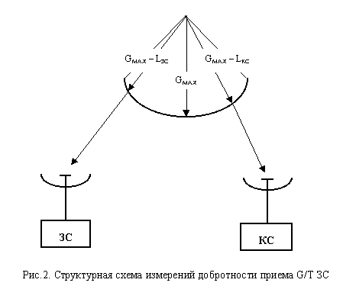 10lg [(signal + noise) / noise], dB.

Figure 4.5 - Block diagram of measurements of the quality factor of receiving G / T AP

Measurement procedure

1. CRC transmits the reference carrier at a frequency and at the level specified in the test plan. If necessary, the Central network control station provides regulation of the gain of the repeater at the request of KPC.

2. CRS measures the level of EIRP provided by the satellite during transmission of the reference carrier, and calculates the corresponding level of EIRP in the direction of the ES.

3. When installing the antenna in the direction of the satellite, the AP measures the level of the reference carrier at the high and intermediate frequency interfaces. When measuring with a beacon, the resolution band used must be consistent between the CRC and the AP. ZS reports the measured values ​​of KpS.

4. With a small frequency shift relative to the reference carrier (for example, 100 kHz), the ES measures the noise level.

5. AP removes the antenna from the direction to the satellite, preferably in azimuth, by an angle of at least 5 °. When turning the antenna, the noise level is controlled. The movement of the antenna should be stopped when the noise level stops decreasing.

6. The measured value of the noise level is reported by the CRC.

7. ZS connects the spectrum analyzer to the high-frequency interface, and, conducting operations, measures the noise level. ZS reports the measured value on KpS.

8. The operation of claim 7 is repeated when the spectrum analyzer is connected to the intermediate frequency interface.

9. AP reports the appropriate correction factors and frequency band to the SC. AP returns the antenna to the position of the bearing to the satellite.

10. The CS reports the EIRP level of the satellite in the direction to the ES and calculates the G / T ratio.

Since in the general case measurements are performed using a spectrum analyzer, it is necessary to introduce corrections for the noise level displayed on the screen in the analysis frequency band and for detection. In modern spectrum analyzers, such correction is achieved through software that allows you to directly read the normalized noise level (noise marker). If such a function is not available, the operator must refer to the appropriate instructions for using the measuring device to obtain the correct values.

Typical are the following values ​​used to correct the noise level observed on the screen:

conversion from a resolution band to a noise frequency band of -0.8 dB;

combined correction for detector characteristics and logarithmic curve detection + 2.5 dB.

A typical total correction is +1.7 dB. In this case, the actual noise level is 1.7 dB higher than that observed on the screen.

**4.6 Earth stations for receiving TV**

In the field of television, satellites are currently used for the international exchange of television programs, for the distribution of television programs among broadcasting organizations, terrestrial television transmitters for relay, among cable networks, as well as for direct television broadcasting (NTV), which allows direct reception.

In recent years, thanks to the successes achieved in the development of microwave technology, it has become possible to create relatively simple and inexpensive installations with antennas of acceptable sizes for the individual reception of television broadcasts not only in broadcasting, but also in the fixed service. Therefore, many viewers from different countries purchase installations for receiving television broadcasts from FSS satellites. In this regard, those FSS satellites whose transmitters operate at frequencies adjacent to the frequencies of the BSS (11.7 ... 12.5 GHz) are of most interest. These are the frequency bands 10.7 ... 11.7 and 12.5 ... 12.75 GHz. The satellites of the international satellite communications organization IntelSat, the European satellite communications organization EutelSat, as well as satellites belonging to the commercial associations Telecom (France), Kopernicus (Germany), Astra (Luxembourg) and others operate within these frequency bands.

In television systems, television radio signals emitted by satellite transmitters are significantly different from signals emitted by terrestrial centers. The brightness signal of the image is transmitted by a satellite repeater with frequency modulation of the carrier frequency. A feature is also the use in satellite systems of direct television broadcasting of a carrier frequency located in the centimeter wave range, which includes the 12 GHz band, in contrast to terrestrial television operating on meter waves. At such high frequencies, transmitting a received signal from an antenna to a television receiver using a coaxial cable, as is common in terrestrial television, is simply impossible. These features require the appropriate construction of a television receiver circuit or an additional device (set-top box) to a standard television designed for receiving terrestrial television.

In analogue satellite television systems, FM modulation of the luminance signal is used. The advantages of FM are also low requirements for linearity of the amplitude characteristic of the path and the possibility of the output stage of the satellite transmitter in saturation mode, in which a high efficiency is achieved.

Another type of processing that has found application only in satellite broadcasting systems is the introduction of an additional low-frequency modulating signal to the TV signal on the transmitting side, which provides more uniform dispersion (dispersion) of the TV signal energy in the barrel frequency band in order to reduce interference to other communication systems, in first of all radio relay lines. In case of unfavorable scenes of the image (uniformly illuminated field), almost all signal power can concentrate in a narrow frequency band and lead to multiple excesses of the norm for radiated power. The addition of a sawtooth or triangular signal with a frequency from units of hertz to tens of kilohertz allows effective scattering, regardless of the plot. The deviation of the carrier dispersion by the signal depends on the required degree of scattering and is chosen equal to from 600 kHz (CCIR recommendation for all satellite TV systems) to 4 MHz (in the Moscow system).

The exception of the dispersion signal at the reception is achieved by the use of schemes for fixing the level of the video signal: with deviation of more than 1 MHz, special tracking devices are additionally used. The sound signal of television in traditional FM systems is usually transmitted together with the image signal at a subcarrier frequency located above its spectrum. To achieve the necessary noise immunity, the transmission is carried out by the method of frequency modulation of the subcarrier, and the deviation of the subcarrier frequency is chosen, as a rule, greater than in terrestrial television - up to 100 and even 150 kHz. The subcarrier value is also higher and amounts to 7.0 ... 7.5 MHz with a video signal band of 6 MHz, 5.8 ... 6.8 MHz with a band of 5 MHz and 5 ... 6 MHz with a band of 4.2 MHz, which allows to reduce crosstalk from the image channel to the sound channel and ease the requirements for filtering signals.

If it is necessary to transmit more than one audio signal together with the image signal (audio broadcasting, sound in foreign languages, stereo sound), several subcarrier frequencies located above the spectrum of the video signal are used. Their number is limited by the occurrence of crosstalk and the deterioration of the quality of the TV image due to a decrease in the proportion of carrier deviation attributable to the video signal. Almost with satisfactory quality, it is possible to transmit two to four additional signals. For example, in satellite TV channels organized through the European satellites Eutelsat II and Astra, along with the main sound channel, up to four more high-quality sound channels are formed that are used to transmit monophonic or stereo programs. The transmission is carried out by the FM method at subcarrier frequencies of 7.02, 7.20, 7.38, 7.56 MHz, the sound signal is subjected to adaptive pre-distortion and companding (Wegener Panda 1 system).

Companding is used to increase the noise immunity of sound transmission. It involves compressing the dynamic range of the transmitted signal in accordance with the change in the envelope of the audio signal and restoring the original dynamic range at the reception. There are distinguished “managed” companders, in which information about the initial dynamic range is transmitted in a separate control channel (with a frequency of 11000 ± 125 Hz), and “uncontrolled”, in which this information is contained in the transmitted signal. With controlled companding of audio signals, the influence of changes in the residual attenuation of the channel is reduced, and the conventional compander system reduces the level of intra-channel interference of the transmission channel (the dynamic range of the signals at the compressor output DVY.K and at the input of the expander DVX.E are the same and are associated with the dynamic range of the signals at the input and the output of the DC channel by the ratio DC / DВХ.Э = β = 1 / α,

where β is the expansion coefficient, α is the compression coefficient.

The gain in noise immunity due to companding reaches an average of 12 ... 13 dB in the presence of a signal and a 20 dB pause in the signal. A managed compander was used in the Moscow system, an unmanaged compander in the Moscow-Global system.

A more efficient way to transmit multiple audio signals energetically and free from crosstalk is to transmit on a subcarrier in discrete form. The signals of individual channels are converted into digital form and combined (multiplexed) into a common digital stream, which modulates in phase the subcarrier frequency located above the spectrum of the video signal. This method, for example, is used in the Japanese NTV BS-3 system. The 5.73 MHz subcarrier is modulated by a digital stream at a speed of 2.048 Mbps, containing PCM audio signals, error correction pulses, control pulses. The system produces either four sound channels with a band of 15 kHz, or two channels of very high (studio) quality with a band of 20 kHz.

A method is used to transmit audio signals in the spectrum of a video signal with their separation in time - in the interval of the backward beam or in free lines. The considered method was used in the Orbit system, in which using pulse-width modulation provided the formation of one channel with a band of 10 kHz or two channels with a band of 6 kHz. The current level of discrete circuitry can significantly increase the throughput of the method. These features are implemented in the MAC standard.

In MAC-type systems, analog luminance and color signals are compressed in time and transmitted alternately, which helps to avoid cross-distortion of luminance and color signals, reduces noise in the color channel due to its translation in the low-frequency region, and increases the image resolution due to a wider signal frequency band brightness and color. Compression of the analog signal is performed by gating the signal with a certain clock frequency, converting the samples to digital form, accumulating them in the buffer memory, accelerated reading with a new, higher clock frequency and the reverse conversion to analog form.

Sound signals are converted to digital form and transmitted in the interval of the reverse beam. The highest frequency in the spectrum of the audio signal is 15 kHz; the sampling frequency is chosen to be 32 kHz. Depending on the requirements for sound quality, linear analog-to-digital conversion with an accuracy of 14 bits / count or almost instantaneous companding with an accuracy of 10 bits / count is used, noise-resistant two-level encoding provides effective error protection. The digital stream speed in different versions is from 352 to 608 Kbps.

Digital broadcasting systems. The main coding algorithm has become the MPEG standard. The algorithm underlying MPEG standards includes a certain basic set of sequential procedures.

The component TV signal RGB is used as the source signal, then it is matrixed into the YUV signal; sampling, as in the digital standard "4: 2: 2" is carried out with a clock frequency of 13.5 MHz for the luminance signal and 6.76 MHz for color difference signals. At the pre-processing stage, information that impedes coding, but not significant in terms of image quality, is deleted. A combination of spatial and temporal nonlinear filtering is usually used.

The main compression is achieved by eliminating the redundancy of the TV signal. Three types of redundancy are distinguished - temporary (two consecutive image frames differ little from each other), spatial (a significant part of the image is made up of uniformly colored areas) and amplitude (the sensitivity of the eye is not the same for light and dark image elements).

For satellite television, MPEG2 is certainly more promising, designed for processing an input signal with interlaced scanning and various digital stream speeds (4 ... 10 Mbit / s and more), each of which corresponds to a certain resolution. According to this parameter, the standard defines four levels: low (at the level of a domestic video recorder), primary (studio quality), high-definition television with 1,440 elements per line, and a full HDTV with 1920 elements.

It can be calculated that in a satellite channel with a bandwidth of 20 ... 25 Mbit / s, you can transmit four to five programs of good quality corresponding to the main channels of program delivery, or 10. .12 programs with quality corresponding to a VHS standard VCR.

Part of the MPEG1 and MPEG2 standards includes algorithms for transmitting audio signals with digital compression, which can reduce the digital stream speed by six to eight times without subjective deterioration in sound quality. One of the widely used methods is called MUSICAM.

The DVB standard uses cascaded noise-resistant coding. The external code is the shortened Reed-Solomon code (204.188) with t = 8, which provides an "error-free" reception (the probability of an output error is less than 10-10) with an input error probability of less than 10-3. The internal code is ultra-precise with a relative speed of 1/2, 2/3, 3/4, 5/6 or 7/8 and a code restriction length of K = 7, decoding is performed using the Viterbi algorithm with a soft solution. The type of modulation is a four-position FM.

On the receiving side, the decoder performs all the above operations in reverse order, restoring the output image is very close to the original.

High-definition television (HDTV) refers to image transmission with a number of lines approximately twice that of existing standards, and a frame format (ratio of frame width to height) 16: 9. The amount of information contained in each frame of the HDTV image increases by five to six times in comparison with conventional television. Image signals are transmitted in the satellite channel using the FM sound signal - using the four-position FM method.

In the near future, the adoption of the national HDTV standard in the United States, suitable for use in both terrestrial and satellite systems, is expected.

The adoption by each group of countries of its own HDTV standard may impede international TV exchange, as has happened in the past with black-and-white TV standards and color television systems. Recently, under the auspices of the International Telecommunication Union, efforts have been made to create a unified world standard for HDTV.

The digital compression methods developed under the MPEG-2 standard are fully applicable to the HDTV and today they can transmit an HDTV signal with a digital stream speed of 20 ... 30 Mbit, which roughly corresponds to the throughput of a satellite RF barrel with a bandwidth of 27 ... 36 MHz.

The satellite television system "Moscow" was commissioned in 1980 and used five satellites of the type "Horizon" (according to the international classification "Stationary"), placed in a geostationary orbit. C4 satellite with the coordinate of 140 west It is designed to serve Europe; C5 at 530 East served the central part of Russia with a time shift of 2 hours; C13 with a coordinate of 800 east - Trans-Urals with a shift of 6 hours; C7 at 900 East - Eastern Siberia with a shift of 6 hours; C7 with coordinate 1400 east - Chukotka, Kamchatka and Sakhalin Island with a shift of 8 hours.

The Moscow system is designed to receive a signal from satellites by the Moscow ground receiving installations, followed by feeding to low-power ground-based television transmitters (power up to 100 watts.

PS

CM

PCB

UPH

Php

BH

Um

   UG

WU

Dm

Osch

Osch

ULF

ULF

Exp

Exp

Figure 4.6. - Structural diagram of the receiving station

TV broadcasting systems “Moscow”

The Earth-Cosmos line operates in the 6 GHz band, and the Cosmos-Earth line at a frequency of 3675 MHz. The power of the satellite transmitter is 40 watts. The parabolic antennas of terrestrial receiving installations have an aperture diameter of 2.5 m and a helical feed, which is necessary for receiving a circularly polarized signal.

Figure 4.6 shows the structural diagram of the reception desk "Moscow".

Input - input signal from the LNA;

PS - receiver bandpass filter;

SM - mixer;

UUM - amplifier-local oscillator frequency multiplier;

UG - controlled local oscillator;

PUPCH - pre-amplifier IF;

UPCH - IF amplifier;

FPF - IF filter;

BH - frequency detector;

VU - video amplifier;

Video - video output;

Signal Disp. - dispersion signals extracted with a band-pass filter (triangular waveform with a frequency of 2 Hz) control the local oscillator frequency so as to keep the intermediate frequency of 70 MHz unchanged; in fact, in this way, dispersion signals introduced on the transmitting side to equalize the energy spectrum of the radio signal and to alleviate EMC problems are eliminated on the receiving side;

DM - power divider;

OSH - threshold lowering demodulator with frequency feedback (lowering the FM threshold by 4 ... 5 dB);

VLF - bass amplifier;

Exp - expander, part of a managed compander;

ЗВ - TV channel sound output (1cl.);

RV - output channel broadcasting (1kl.).

The NTV-Plus satellite television system is Russia's first truly direct-receive satellite television system.

In January 1994 and November 1995, television relay satellites of the Hals-1 and Hals-2 type were launched into geostationary orbit. The power of the transmitters installed on these satellites is 85 and 45 watts, respectively.

Through these satellites, the NTV-Plus broadcasting company is relaying television thematic programs.

The transmitters of their transceivers operate at frequencies of 11.91928 GHz (wide beam) and 11.76584 GHz (narrow beam). According to special commands from the Earth, satellite antennas can be switched to one or another transmitter, and the direction of their radiation to one or another region can be changed by order of the tenant.

In 1999, NTV-Plus leased the French satellite TDF-2 and transferred it from its previous position 19 * w. to the new 36 * E, where the Hals satellites are located. This satellite contains three transponders with carrier frequencies of 11.881, 12.034 and 11.804 GHz.

On May 25, 2000, another Eutelsat-W 4 satellite was launched into orbit, allowing it to expand the broadcast area. It is brought to the position 36 * east and serves the European part of Russia, Belarus and part of Ukraine. It contains 8 transponders with a frequency band of 33 MHz each, of which 6 will be used to transmit television programs in digital form. Thanks to frequency multiplexing, each repeater can transmit 8 programs. Eutelsat-W 4 contains 19 repeaters, which will allow broadcasting up to 100 television programs, mostly in digital form.

Since the transmission of television programs is carried out in digital form and using coding, a digital tuner with a slot for a key card must be installed on the side of the viewer. This card contains an integrated memory chip that carries all the necessary data to decode the received signal.

The composition of the direct reception.

Figure 4.7 shows a block diagram of a ground-based installation for the direct reception of television broadcasts relayed by artificial Earth satellites.

Figure 4.7 - Block diagram of the receiving installation

Due to the fact that the signal received by the antenna can have one of the used types of polarization, a polarizer is installed at the output of the antenna, which selects electromagnetic waves having the polarization that is needed and filters out signals of other types of polarization. Polarizer control is usually carried out remotely.

The signal received by the antenna should be fed, as usual, to the input of the radio receiver (tuner), in which it should be amplified, isolated from the mass of other signals and interference, inevitably received by the antenna, and converted into the form that is designed for a household television receiver.

In order to avoid strong attenuation of the signal of the centimeter wave range, a frequency converter (converter) is installed in the cable between the polarizer and the tuner, in which the signal is pre-amplified and the carrier frequency is converted from the 12 GHz band to the first intermediate frequency, which is usually in the range 950 ... 1750 MHz. At this frequency, the signal is fed through the coaxial cable to the tuner input. The output of the tuner produces a standard television signal of the decimeter range, suitable for playback by a household television receiver.

Thus, a satellite television receiver usually consists of an antenna, an irradiator with a polarizer integrated in one design, a short waveguide connecting the irradiator to the converter, a coaxial cable connecting the converter to the tuner, and the tuner itself. In modern designs, the irradiator, polarizer and converter form a single unit called a high-frequency head (RF head), which eliminates the need for a waveguide. The indicated components of the installation are structurally divided into two blocks: an outdoor unit, which includes an antenna with an RF head, and an indoor unit consisting of a tuner and a power supply unit for the entire installation.

Sometimes in high-end receivers, remote control of the direction of the antenna to one or another satellite is used. For this, the antenna is equipped with electric motors, and the tuner includes an antenna drive control device with a memory device, which is called a positioner.

The power of satellite transmitters is small and the distance between the geostationary satellite and the Earth's surface exceeds 36,000 km, which also leads to a significant attenuation of the signal.

For these reasons, the field strength of the received signal at the receiving point on the Earth's surface also turns out to be quite small. Therefore, for the direct reception of satellite television, special receiving antennas are used. The types of antennas used are shown in table 4.1.

The diameter of the antenna depends on the power level of the signal received from the satellite. The irradiator is located in the focus of the reflector and is designed to transmit a signal to subsequent elements of the receiving device. Of great importance is also the antenna gain pattern of the irradiator itself. It is important to prevent the irradiator from receiving signals from behind the edge of the reflective mirror. The simplest irradiator is the open end of the waveguide, to which a horn is usually attached to match the wave impedance of the waveguide with open space and to prevent the possibility of receiving a signal directly from space. Circular waveguides are more technologically advanced in production and are more consistent with signals of different types of polarization. In addition, the radiation pattern of the open end of a circular waveguide or canonical horn is axisymmetric and equally receives signals reflected from different points of the antenna reflector. Rectangular waveguides and pyramidal horns are more difficult to use for circular polarization of the signal, and their reception of signals reflected by various points on the surface of the paraboloid is not the same.

In terrestrial receiving installations of satellite television, irradiators made using an electromagnetic lens, which consists of several concentrically arranged cylinders, have found application. This design of the irradiator is shown in Figure 4.8. The irradiator is made in the form of a segment of a circular waveguide, which with its open end is directed to the reflector. At a half-wave distance from the closed end, communication loops are installed. Loop “a” receives signals with horizontal polarization, and loop “b” - with vertical. One end of the loop is soldered to the inner wall of the waveguide, and the other is brought out through a small hole and connected to the output terminal of the converter.

Figure 4.8 - the design of the irradiator

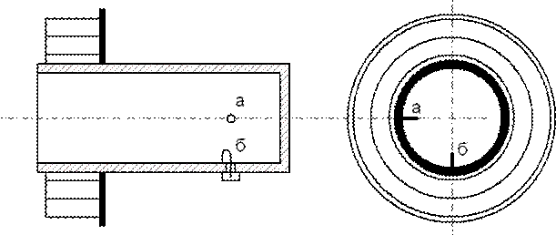

Figure 4.9 - Appearance for the irradiator

 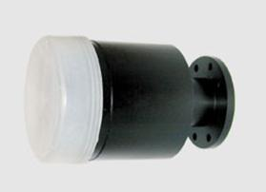

To protect against climatic influences, the irradiator is placed in a sealed casing of high-frequency dielectric. Figure 4.9 shows the appearance of industrial irradiators.

Polarizers. Due to the fact that different programs are transmitted with different directions of linear or circular polarization, it becomes necessary to switch the polarizer from receiving a vertical polarization signal to receiving a horizontal one and vice versa. The polarizer wire loop is a signal output that connects to the input circuit of the converter. Depending on the polarization of the received signal, that is, on the direction of the vector of the magnetic component, the coupling loop is installed at a certain point in the cross section of the waveguide so that the plane of the loop is perpendicular to the direction of the magnetic component of the field. A similar connection can be performed by a metal probe isolated from the walls of the waveguide, which senses the electric component of the electromagnetic field. The position of the probe is determined by the direction of polarization of the signal: it must be installed parallel to the electric component of the field inside the waveguide. Switching the polarization can be carried out by rotating a special element of the waveguide containing the communication loop or probe using a stepper motor. Such a mechanical switching system, due to the presence of movable elements, is not sufficiently reliable and allows only two fixed polarization directions to be obtained: either vertical or horizontal.

More reliable in operation is the device of electromagnetic polarizers, which provides rotation of the plane of polarization of the signal depending on changes in the current flowing through the coil with a ferrite core. Such devices do not contain moving structural elements and allow for smooth adjustment. This is necessary because the signal emitted by the satellite has a polarization parallel or perpendicular to the Earth’s surface only if the satellite is located at the same longitude as the receiving point. If the longitude of the satellite does not coincide with the longitude of the receiving point, the direction of polarization becomes oblique due to the curvature of the Earth's surface: and the larger the difference in longitudes, the greater the angle of inclination. When it is necessary to receive signals from several satellites, for each of them it is necessary to smoothly change the position of the polarizer by changing the value of the control current.

In the case when two separate television receivers are served by one antenna, the viewers of these receivers choose programs whose signals have different directions of polarization. To solve this problem, more complex polarizers are used, which contain two orthogonal (located at an angle of 90 °) communication loops or two of the same probes, the signals from which are fed to separate outputs.

If necessary, convert circular polarization to linear using special converters of circular polarization to linear. One of these converters is shown in Figure 4.10.

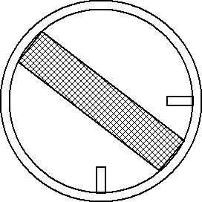

Figure 4.10 - Polarizer with a dielectric plate

Its design contains an element of a circular waveguide, inside of which a plate of high-frequency dielectric and two communication loops or two probes located at an angle of 45 ° to the dielectric plate are installed. As a result, in the zones of action of each communication loop or probe, there is already a linear polarization of the signal corresponding to their positions. Such a converter can also be installed inside the illuminator shown in Figure 4.9.

Antennas intended for direct reception of satellite television are usually located at a relatively large distance from the tuner, which sometimes amounts to tens of meters. The task of transmitting a centimeter range signal from the antenna directly to the receiving device is solved quite simply by using a frequency converter. Consider the structural diagram of the high-frequency head forming the outdoor unit. Figure 4.11 shows the complete structural diagram of the installation for direct reception of satellite television. On the way from the antenna to the receiving device, there is no longer any need to stay within the centimeter range. Therefore, the main unit of the high-frequency head is a frequency converter, similar to a converter of a superheterodyne radio receiver.

The converter consists of a first local oscillator G and a first cm 1 mixer, which is usually assembled according to a balanced circuit. A feature of this converter is as follows. Frequency tuning from one channel to another is more convenient to do in the receiving device. Therefore, the head local oscillator operates at a fixed frequency, approximately 10 GHz, and the converter is a converter.

The frequency of the first local oscillator is stabilized by a dielectric cavity resonator. At the converter output, the first IF is equal to the difference between the frequency of the input signal and the local oscillator frequency and, unlike the superheterodyne receiver, is not constant, but lies in the range 950 ... 1750 MHz.

Any frequency converter introduces an additional level of noise that is superimposed on the signal. In order not to worsen the ratio of signal level to noise level during the frequency conversion, a broadband low-noise transistor amplifier of the LNA input signal is installed between the polarizer P and the converter.

The band-pass filter PF serves to separate the noise lying in the band of the mirror channel, even before they can get to the input of the converter connected between the LNA and the converter.

From the converter output, the IF signal is fed via cable to the indoor unit.

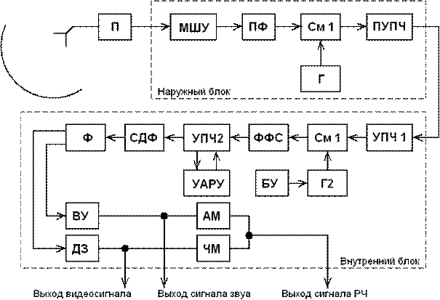

Figure 4.11 - Block diagram of the receiving device

To match the large output impedance of the converter with a low wave impedance of the cable, as well as to compensate for the subsequent attenuation of the signal in the cable, a pre-amplifier PCH IF is used. The amplified IF signal is then transmitted through a coaxial cable to the input of the indoor unit of the receiving device.

The indoor unit, usually called a tuner, is an electronic device whose purpose is to generate such a standard television signal that is suitable for reproduction by an ordinary household television of an image and sound accompaniment corresponding to a satellite relay program. In addition to performing the function of generating a standard television signal, the tuner contains all the adjustment elements necessary for receiving TV programs relayed by satellites, as well as the power supply unit of the tuner and the outdoor unit. In this case, the supply voltage to the outdoor unit is supplied through the same coaxial cable, through which the signal from the outdoor unit to the tuner input is received, without laying additional wires.

We will consider the tuner device according to the standard scheme shown in Figure 4.11. An amplifier of the first IF UCH1 amplifier is installed at the tuner input, which is characterized by a wide passband in the range of 950 ... 1750 MHz, followed by a second frequency converter, consisting of a second SM2 mixer and a second local oscillator G2. In the process of secondary frequency conversion, the necessary frequency channel is selected. For this, the second local oscillator can be tuned in frequency by changing the voltage using the control unit BU. Restructuring is performed either manually at each transition from receiving one program to another, or automatically using a storage device.

The signal of the second IF from the output of the second mixer is fed to the filter of concentrated selection of the FSS, which provides the necessary shape of the frequency response. The second IF is usually 70 MHz. The filter passband is about 30 MHz. The main amplification of the tuner is provided by the amplifier of the second IF UCH2 equipped with a device for efficient automatic gain control of the UARU with a gain control depth of up to 30 dB. A deep AGC is necessary to compensate for changes in the level of the input signal due to a variety of reasons: the size and gain of the antenna, the power level of the satellite transmitter, the length of the coaxial cable, the electromagnetic field strength in a particular area from different satellites and other factors.

To demodulate the FM signals in the tuner, a synchronous-phase detector SFD is used, which has high noise immunity and linear detection characteristics. The low-pass filter filters out the high-frequency components of the detected signal. If the input signal of the SFD is not modulated in frequency, the error signal adjusts the generator to the frequency of the input signal. In the presence of an FM SFD, it emits a modulating signal.

The filter f is designed to separate the image signals and sound of the television transmission. The image channel contains a VU video amplifier with a black level reference device and a predistortion compensation loop. From the VU output, the signal is fed to the input video signal connector and to the AM amplitude modulator, where it modulates the carrier frequency of the image produced by a separate generator, not shown in the diagram. The sound channel contains an amplifier and a frequency detector of the sound signal DZ, from the output of which the voltage of the RF is supplied to the output connector of the sound signal and the FM frequency modulator, where FM modulation of the carrier frequency of the sound is carried out. The carriers of the image and sound carrier frequencies are usually stabilized by quartz resonators and operate at frequencies corresponding to one of the channels used in terrestrial television. From the output of the modulators, after summing, the standard television signal at a frequency of a certain channel is fed to an output intended for connection to the antenna socket of a household television receiver.

Figure 4.12 shows the appearance of a household satellite receiver.

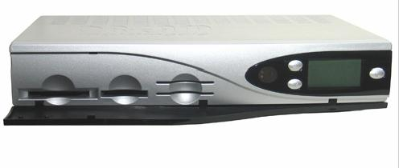

Figure 4.12 - Satellite receiver Elanvision EV-8000S PVR 80Gb

**5 Space Services Plans**

Already at the beginning of space exploration, the Communications Administrations, members of the International Telecommunication Union, thought about ways to use the geostationary orbit for communication and broadcasting and decided that, given the different technological level of development of the countries of the world, it is desirable to provide for the reservation of some frequency resource, as well as separate sections of the geostationary orbit to ensure equitable access by all countries to this orbit. The proven approach of such reservation, repeatedly used for various terrestrial communication services, is the development of appropriate plans that take into account the achievements of communication technology and the requests of the Administrations (within reasonable limits). So in 1977, the first Plan for the Broadcasting Satellite Service (BSS) appeared. In the early 80s, along with the broadcasting-satellite service, the fixed-satellite service (FSS) was actively developing, therefore the Administrations, members of the International Telecommunication Union, came to the conclusion that it was necessary to develop an FSS Plan in addition to the BSS Plan.

**5.1 Plan BSS**

The original version of the Plan was adopted at WACR-77 for Regions 1 and 3, and for Region 2 in the frequency band 12.2-12.7 GHz at RAKR-83.

The plan for Regions 1 and 3 was revised 20 years later at WRC-97 (Switzerland, Geneva), and then at the next WRC-2000 conference (Turkey, Istanbul). In essence, this Plan consists of two parts: the Plan of lines Cosmos - Earth and the Plan of lines Earth - Cosmos (Plan of feeder lines).

The Plan for Regions 1 and 3 (Space-to-Earth), which covers the frequency bands 11.7-12.2 GHz in Region 3 and 11.7-12.5 GHz in Region 1, is a detailed a priori Plan in which the satellites are uniformly distributed in orbit (usually every 6º), ensuring that in each broadcasting service area there is an equal number of channels. The entire frequency band in this Plan is divided into 40 frequency channels with a width of 27 MHz. The value of the carrier frequency of each channel can be determined by the formula

11708,30 **+** 19,18**×** n

where n – channel number.

The BSS Plan for Regions 1 and 3 provides for the output of satellites to 73 orbital positions:

**W**: 0,80; 1,00; 1,20; 4,00; 7,00; 12,80; 13,00; 13,20; 18,80; 19,20; 24,80; 25,00; 25,20; 30,00; 33,50; 36,80; 37,00; 37,20; 160,00; 178,00;

**E**: 4,80; 5,00; 9,00; 11,00; 16,80; 17,00; 17,20; 20,00; 22,80; 23,20; 28,20; 29,00; 33,80; 34,00; 34,20; 36,00; 37,80; 38,00; 38,20; 42,00; 42,50; 44,50; 50,00; 52,50; 56,00; 56,40;62,00; 68,00; 74,00; 80,20; 86,00; 88,00; 91,50; 92,20; 98,00; 104,00; 107,00; 109,85; 110,00; 116,00; 121,80; 122,00; 122,20; 128,00; 134,00; 140,00; 146,00; 152,00; 158,00; 164,00; 170,00; 170,75; 176,00.

In addition to the nominal position of the satellite on the civil defense and the numbers of the assigned frequency channels, the following are recorded in the Plan:

- EIIM onboard transmitter;

- Class of radiation;

- BR antenna parameters (gain, polarization, aiming point, beam parameters, etc.

The frequency assignments for the Republic of Kazakhstan are as follows:

KAZ 06600 – beam number

- orbital position 56.40 E;

- channel numbers 1; 3; 5; 7; 9; eleven; 13; fifteen; 17; 19;

- aiming point 65.73E; 46.40N;

- beam parameters (4.58º / 1.76º / 177.45º);

- polarization CR (right circular);

- BR antenna gain 35.38dB;

- EIIM BR 58.9 dBW;

- radiation class 27M0G7W

where 27M0 is the radiation bandwidth of 27 MHz;

G - modulation of the main carrier (phase);

  7 - the nature of the signal modulating the main carrier (two or more channels with digital or quantized information);

W - type of information transmitted (combination of different types of information).

**The Plan's feeder links for Regions 1 and 3 use different frequency bands of 14.5-14.7 GHz (only for Administrations outside Europe) and 17.3-18.1 GHz.**

**5.2 Plan FSS**

The FSS World Plan was put in place at WACR-88. In this Plan, not every Administration has a frequency band of 800 MHz in two sub-bands:

- 6 GHz (6.725 - 7.025 GHz) - uplink (feeder line); 4 GHz (4,500 - 4,800 GHz) - downlink (C - band);

- 13 GHz (12.75 - 13.25 GHz) - uplink (feeder line); 10 - 11 GHz (10.70 - 10.95 GHz and 11.20 - 11.45 GHz) - downlink (Ku - band).

The FSS plan consists of two parts:

- Part A: national allotments, according to which each Administration has at least one frequency allotment (800 MHz with access to the orbital position);

- Part B: which includes networks using the planned bands that have already been announced in the ITU before the date of development of the Plan (“existing systems”).

The Republic of Kazakhstan does not have an allocation in Part A of the FSS Plan, but may receive it. For this, it is necessary to submit a request to the ITU Radiocommunication Bureau with the following information:

a) geographical coordinates for no more than 10 control points for determining an ellipse covering a national territory;

b) altitude for each control point;

c) other requirements, except for a fixed orbital position.

**6 Design of satellite communications systems**

Initial data :

- the required service area (territory, or individual points);

Bandwidth of the communication system (it is necessary to provide for a possible increase in requirements for the life of the system from 6 ... 7 to 20 ... 25 years), here there should also be a list of the types of transmitted information and requirements for the quality of transmission, additional requirements for classifying messages;

- reliability of communication channels (and in connection with this, the necessary amount of backup equipment on the SSSS and on the satellite, the number of satellite)

- parameters of the used satellite or its barrels (EIRP, frequency band, etc.), if the development of a new satellite is not required;

- during the development of a new satellite, the maximum mass and overall dimensions of the spacecraft are set, the requirements are set for the onboard repeater, and the accuracy of the satellite’s retention in orbit;

- the permissible period for the implementation of the system is determined;

- the maximum allowable cost of creating the system is determined.

System design procedure:

- selection of the satellite's standing point at the GSO;

- calculation of the parameters of the satellite’s onboard antennas (beam parameters are needed: aiming point, angular dimensions of the beam, orientation relative to the orbit plane, the use of a beam of a special shape is possible), with known aperture angles of the antenna beam, you can determine the gain of the onboard antenna

GКС = 44,4 – 10 lg α**1** – 10 lg α**2,**db

where α**1,** α**2 –** aperture angles of the antenna beam, degrees.

and equivalent isotropically radiated power:

EIIM = PКС× η ×GКС, Вт

where PКС – transmitter power KS, W;

η – transmission coefficient of the waveguide path;

GКС – antenna gain of the KS.

There are recommendations on the optimal ratio between power and trunk bandwidth: for a trunk band of 35 ... 40 MHz for a duplex communication system, its power (RKS × η) should be 5 ... 20 W; EI-IM = 23 ... 31dBW with a Q factor of 25 ... 39 dB / K (if the Q factor is reduced, it will be necessary to proportionally increase the EIRP).

  From the selected value of EIRP, it is possible to determine the power flux density created at the Earth's surface

W=10lg[EIIM/(4πd²LДОП)], dBW / m².

Signal strength at receiver input

РС = PАПРМ= W×SЭ= W× q ×SA, Вт

where q – aperture utilization (0,6-0,8);

SA – antenna aperture area, m2.

From here, the size of the antenna is selected. Choosing the diameter of the antenna ZS, it is possible to change (RS / PSh) VX, achieving the desired value of this ratio. The noise power at the input of the ES receiver is determined by the well-known formula: Pш = k T∑ ∆fш. Typically, the value obtained by this formula is increased by 20 ... 30% (the stock takes into account interference from other systems and barrels). Practically, for receiving different signals with different modulation and reliability of reception, they accept (RS / PSh) BX = 10 ... 20dB.

**6.1** **Energy calculation of satellite lines**

The energy calculation of satellite lines is carried out at the design stage.

The purpose of the calculation: to determine the values of the transmitter power of the ground transmitting station RPRDZS and the transmitter power of the on-board repeater RPRDB, in which the satellite channel works reliably in the conditions of interference and does not contain excessive energy reserves. We derive the calculation formulas.

Effectively Isotropically Radiated Power:

EIIM(or Рэ) = РПРД ηПРД GПРД.

The gain of a parabolic antenna can be calculated by the formula



where q – aperture utilization (0,6-0,8);

DA- antenna diameter, m;

λ – wavelength, m

Decibel antenna gain can be calculated

G=20(lg DA(м)+lgf(ГГц))+18,35, дБ.

Signal attenuation due to spherical divergence of the wave front

Lo =16π²d²/λ²

where d – distance between transmitting and receiving antennas, m;

λ – длина волны, м.

The distance from the earth station to the geostationary satellite depends on the geographical coordinates of the ES and CS and is calculated by the following formula



where ϕЗС – geographical latitude of the AP, city .;

βЗС – geographic longitude of the AP, city .;

βКС – geographic longitude of the COP, city

Complete attenuation of the signal along the propagation path

LР(дБ) = Lo + LДОП

where LДОП – additional path losses (absorption of signal energy in the atmosphere, losses due to refraction, losses due to inconsistent polarization of antennas, etc.) do not significantly affect the satellite line energetics. When designing, the average value of LDOP = 5dB is taken.

Signal strength at receiver input

РПРМ = РЭGПРМ ηПРМ/LР=РПРДλ²GПРДGПРМηПРДηПРМ**/**(16π²d²LДОП) . (6.1)

When calculating the line, it is often not the signal power at the input of the receiver that is set, but the signal-to-noise ratio, therefore, it should be substituted into formula (6.1)

РПРМ = РШ (РС/РШ)ВХ, W

where РШ=k T∑ ∆fШ– total noise power at the receiver input, W;

k=1,38×10E-23, Вт/Гц×К- Boltzmann constant;

∆fШ- noise band of the receiver, Hz;

Т∑=ТА+Т0[(1-η)/η]+TПРМ/η - equivalent noise temperature of the receiving path, K;

ТА - noise temperature of the antenna (includes cosmic radio emission, radiation of the atmosphere, the earth's surface, intrinsic noise of the antenna), K;

To ≈290K;

ТПРМ - own noise temperature of the receiver, K.

Substituting РПРМ and solving equation (6.1) regarding the transmitter power, we obtain:

.

Of practical interest is not one site, but two (Earth-satellite and satellite-Earth). Each section will have its own expression:

1) ;

2) 

To move from the equations of individual sections to the general equation for the entire line, it is necessary to establish a relationship between the signal-to-noise ratios at the output of the line and at each of the sections. In the absence of signal processing on board, the noise of each of the sections is added, and the total noise / signal ratio at the end of the communication line

(РШ/РС)∑=(РШ/PC)ВХБ+(РШ/PC)ВХЗ (6.2).

Obviously, the signal-to-noise ratio in each of the sections should be higher than at the end of the line:

(PC/PШ)ВХБ = а (РС/PШ)∑ (6.3)

(PC/PШ)ВХЗ = b (PC/PШ)∑ . (6.4)

Having solved the system of equations (6.3.6.4), we obtain

a = b/(b-1).

Given b = 1.26 (1dB), we find the necessary excess on the Earth-satellite section a = 5 (7dB).

Based on the foregoing, the equations for the satellite communication line, consisting of 2 sections, will finally take the form

,

.

The block diagram and level diagram of the satellite communication line, consisting of two sections, are shown in Figure 6.1.

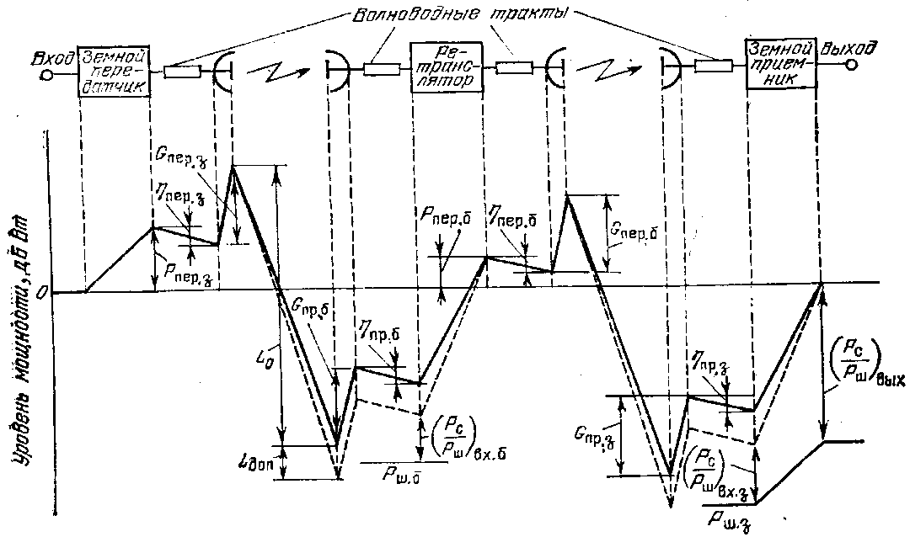

Figure 6.1 - Block diagram and level diagram of the communication line from two sections

The final stage of the calculation is recalculation (PC / PCH) ∑ to the LF channel. Consider the example of the transmission of television by FM

(PC/PШ)НЧ= (РС/PШ)∑ gТВ ВВ ∆ k1

where где gТВ = 1,5∆fЧМ ∆fД²/FВ³ - modulation gain

∆fЧМ = ∆fШ spectrum width;

∆fД- peak deviation;

FВ- high frequency of the signal spectrum;

BВ- gain due to the visometric coefficient;

∆ - gain from the introduction of pre-emphasis;

k1=9db – conversion factor of the amplitude of the sinusoidal signal into an effective value;

BВ ∆ = 14…18db.

**6.2** **Electromagnetic compatibility of satellite and terrestrial communication systems**

In the frequency bands allocated for the operation of satellite systems, a fairly large number of terrestrial communication systems operate (in particular, direct-visibility RRL).

To reduce interference in terrestrial systems from satellite emissions, the maximum signal power flux density developed at the Earth's surface is limited W. W (dBW / m²) must satisfy the following conditions:

W = W**0** at ε ≤ 5°,

W = W**0** + 0,5 (ε – 5°) at 5°**<** ε ≤25°,

W = W**0** + 10 at 25°**<**ε ≤90°,

where ε - elevation angle;

W**0**= − 152 dBW / m² for 3,4-7,75 GHz

W**0** = − 150 dBW / m² for 10,7-11,7 GHz

W**0** = − 148 dBW / m² for 12,2-12,75 GHz

W**0** = − 115 dBW / m² for 17,7-19,7 GHz and 31-40,5 GHz.

W is determined within the conditional control frequency band: 1 MHz for the ranges 17.7-19.7; 31-40.5 GHz and 4 kHz for the rest (lower frequency).

The power flux density can be determined by the formula

W= PАПРМ/SЭ=РЭGПРМ/LРSЭ=РЭ 4π/LPλ² , W / m²

where РАПРМ,- power at the output of the receiving antenna ZS, W;

SЭ – effective area of the antenna that directly determines the energy flow intercepted by the antenna, m2;

GПРМ = 4πSЭ/λ² - the gain of the receiving antenna ZS;

РЭ – EIIM of an onboard repeater, W;

LР - attenuation of the signal along the propagation path.

The formula in the logarithmic form

W = PЭ−LР+20lg f +21,5 , dBW / m²

where f- frequency, GHz;

РЭ – EIIP of onboard repeater, dBW;

LР – signal attenuation along the propagation path, dB.

For the broadcasting-satellite service in the frequency band 620-790 MHz, the power flux density (in dBW / m²) in other countries is limited by:

−129 at ε ≤ 20°;

− 129 + 0,4(ε−20) at 20°<ε≤60°;

− 113 at 60°<ε≤90°.

Limitations are introduced, but verification for EMC systems is nevertheless carried out. When the systems are deployed on their territory, it is possible to really assess the degree of interfering influence. When a satellite communication satellite is located in the border regions of its territory, there is a need to build coordination zones (short-circuit for both the transmitting and the receiving satellite). The procedure for calculating the short circuit is established in Rec. CCIR 847. Documents for these APs with the appendix of KZ are sent to neighboring states for coordination (coordination). For real GLs, the coordination distances (RCs) —distance from the location of the LCs in azimuthal directions to the coordination contour (CC) —are 200 ... 500 km.

**6.3** **EMC for geostationary-satellite communications networks sharing the same frequency bands**

Администрация, The administration intending to create an MSS should not earlier than 6 years and no later than 2 years before the planned launch date of the system send to the Radiocommunication Bureau for publication information about the MSS being created. The administration of the existing MSS sends its comments to the notifying administration if it considers that its existing services may be subject to unacceptable interference. Both parties must find a mutually acceptable solution in the coordination process. The need for coordination is calculated by the method described below in Appendix 29, Volume 2 of the ITU Radio Regulations, 1990.

### КС1

### КС2

α1

α2

θ1

θ2

d1

d2

d3

d4

θg

Valid system

Designed System

### ЗС1

### ЗС2

Figure 6.2 - Assessment scheme for the interfering effect of the designed CCC2 on the current CCC1

The calculation method is based on the notion that when exposed to interfering signals, the effective noise temperature of a system subjected to noise increases.

According to this method, the apparent relative increase in the noise temperature of the existing line ∆Т∑ / Т∑ due to the influence of interfering signals created by the designed system is calculated and compared with a threshold value of 6%.

Let us evaluate the interfering influence of the designed system 2 (see Figure 5.2) on the current system 1, therefore, we will be interested in receiving paths in system 1, and transmitting paths in system 2. The following notation is used in the diagram:

d1…d4 – distance between stations;

θ1, θ2 – topocentric angles;

α1, α2- exocentric angles;

g - the geocentric angular separation between the satellites.

γ – a coefficient numerically equal to the transmission coefficient of the path from the output of the receiving antenna KS1 to the output of the receiving antenna ZS1 (usually less than 1);

Т∑ - effective noise temperature of the receiving path ZS2 (without taking into account the disturbing effect).

So, the compatibility criterion

∆Т∑/T∑ ≤ 0,06. (6.5)

Formulas used for calculations

∆T∑ = γΔT↑/Y + ΔT↓/Y (6.6)

where ΔТ↑,ΔT↓ - increment of noise temperature in the section up and down;

Y – the attenuation coefficient of the interfering signal due to polarization mismatch (1 for coinciding polarizations, 4 for circular polarizations with the opposite direction of rotation, and 1.4 in other cases).

ZS of the designed system, using the same frequency band as the ZS of the current system, will cause increments in the noise temperature of the current CS ΔT ↑.

ΔТ↑= SЗС2GЗС2(θ2)GБР1(α1)/( Lp↑), K

where SЗС2 [W / Hz], is the spectral power density of ЗС2;

LР↑ - weakening of interfering signals along the propagation path upward;

GЗС2(θ2) – the antenna antenna gain of the designed system, depending on the topocentric angle θ2;

GБР1(α1) - the antenna gain of the CS of the existing system, depending on the exocentric angle α1;

k = 1,38*10-23 – Boltzmann constant W / (HzK).

The CS of the designed system using the same frequency band as the CS of the current system will cause noise temperature increments of the active CS ΔT↓ .

ΔT↓= SБР2GБР2(α2)GЗС1(θ1)/(kLp↓),K

SБС2– power spectral density of BR2, W / Hz;

LР↓ - attenuation of interfering signals along the propagation path in the downward section;

GЗС2(θ2) – the antenna antenna gain of the designed system, depending on the topocentric angle θ2;

GБР1(α1) - the antenna gain of the CS of the existing system, depending on the exocentric angle α1;

k = 1,38*10-23 - Boltzmann constant W / (HzK).

It is more convenient to use for calculating formulas in which the values are expressed in decibels.

ΔT↓= SБР2+GБР2(α2)+GЗС1(θ1)-k-Lp↓ ,dbK,

ΔT↑= SЗC2+GКС1(α1)+GЗС2(θ2)-k-Lp↑, dbK.

SБР2, SЗС2 – power spectral densities of BR2 and ZS2 in technical specifications are usually indicated in dBW / Hz;

k– Boltzmann constant (-228.6), dB.

Attenuation in free space is determined by the following formula:

Lp = Lo = 20 (lg f + lg d) + 32,45 [db]

where f – frequency, MHz; d – distance, km.

The distance is calculated as in the energy calculation.

GC antenna gain factors are determined by the actual measured characteristic or if such information is not available The Radio Regulations recommends the use of the following reference radiation patterns

For DA **/** λСР ≥ 100

G (θ) = Gmax – 2,5*10-3 (θ DA **/** λСР), db at 0< θ< θm;

G (θ) = G1, db at θm < θ< θr;

G (θ) = 32 – 25 lgθ, db, at θr < θ< 480;

G (θ) = -10, db, at 480< θ< 1800

Where DA – antenna diameter, m; θ is the angle (in degrees), measured from the axis of the antenna, equal to θt;

G1= 2+15*lg*(DA **/** λ) – antenna gain in the direction of the maximum of the first lobe, dB;

Θm= (20 λ/ DA)√ Gmax- G1  - width of the first petal, degrees;

Θr=15,85DA/λ)-0,5, degree.

For DA**/** λср < 100

G (θ) = Gmax – 2,5*10-3 (θ DA **/** λСР), dB at 0< θ < θm;

G (θ) = G1, dB at θm ≤ θ < 100λ/ DA;

G (θ) = 52 – 10 lg DA/ λср –25lgθ, dB at 100λ/ DA ≤ θ < 480;

G (θ) = -10, dB at 480 ≤ θ < 1800

The topocentric angle at earth stations is determined by the following formulas:

θ1= arc cos B1,

,

θg=│βКС1−βКС2│- geocentric angle.

θ2 defined in a similar way.

If CSs have global coverage antennas, then the antenna gain of the onboard repeater GBR (α) will not depend on the exocentric angle α, GBR (α) = GBRMAX.

Under other conditions, the exocentric angle is determined from the cosine theorem, determining the distance between earth stations

d ²зс**1**зс**2** = d**1**² + d**2**² - 2 d**1 ×** d**2 ×** cosα**1,** (6.7)

x**1** = R**З** × cos φ**1** × cos β**1,**

y**1** = R**З** × cos φ**1** × sin β**1**,

z**1** = R**З** × sin φ**1**,

where the radius of the Earth RЗ = 6370 km; φ1, φ2- latitude of the GC;

β**1,** β**2 –** longitude ZS.

We similarly define x**2**, y**2,** z**2.**

d ²зс**1**зс**2** = ( x**2 -** x**1** )² + ( y**2** - y**1**)² + (z**2** - z**1**)². (6.8)

Calculating d ²зс1зс2 and solving equation 6.7 with respect to α1 we get:



Similar calculations are performed for α2 using the distances d3, d4. Thus, to determine exocentric angles, it is first necessary to determine the distance between them from the coordinates of the CS, and then use the cosine theorem.

The antenna gain of the COP is determined by the formulas (in dB):

G(α)=Gm−12(α/αo) at 0,5αo≤α<1,3αo,

G(α)=Gm−20 at 1,3αo≤α<3,15αo,

G(α)=Gm−7−25lgα/αo at 3,15αo≤α<α1,

G(α)=−10 at α1≤α

where αo – half power beam width;

Gm = 44,4−20lgαo – maximum gain.

If the values ΔT ↑ and ΔT ↓ were calculated in decibels, then before substituting into formula (6.6) it is necessary to express them in Kelvin.

Substituting ΔT∑ into inequality (6.5) to determine whether coordination is required.

**7. Communication satellite of the Republic of Kazakhstan “KazSat”**

KazSat is the first spacecraft for Kazakhstan, with the launch and operation of which the implementation of space programs of the republic began.

The prelaunch preparation of the components of the launch vehicle, the upper stage and the spacecraft at the launch site was carried out by specialists from the MV Space Research and Production Center Khrunichev (hereinafter - GKNPTS im. MV Khrunichev) and the Italian company Alcatel Alenia Spazio Italia. The on-board relay complex of the KazSat satellite was manufactured by Alcatel Alenia Spazio Italia using advanced satellite technologies.

The Russian side, which at the time of the launch of the KazSat satellite, had temporarily free orbital-frequency resources in geostationary orbit, provided the Kazakh side on a temporary basis (for the period of satellite’s existence in orbit, but no more than 15 years) a coordinated orbital frequency resource.

The KazSat satellite was successfully launched into geostationary orbit on June 18, 2006 from the Baikonur Cosmodrome of the Proton launch vehicle in the presence of the Presidents of Russia and Kazakhstan.

KazSat will allow providing modern types of telecommunication services to the most remote and inaccessible regions of Kazakhstan and other countries. It is also planned to lease satellite communication channels to operators of the CIS countries. “KazSat” - designed for 864 MHz. Thus, Kazakhstan has a resource for transferring operators to a domestic satellite.

**7.1. Technical appearance and main characteristics of KazSat-103**

More than 15 foreign and domestic companies participated in the creation of the KazSat space system, including leading manufacturers of on-board telecommunication equipment - Boeing, Alcatel Alenia Spazio Italia, ComDev.

The creation of the KazSat space system was carried out by the MV Khrunichev State Scientific and Technical Center on the basis of a small spacecraft for communication and television broadcasting in a geostationary orbit of 103 degrees east longitude belonging to the Russian Federation. The construction of the ground control complex (NKU) and the monitoring system (SMS) is carried out on the territory of Kazakhstan. General view of the spacecraft “Kazsat” is presented in Figure 7.1. Its main characteristics are in table 7.1. The block diagram of the BRSK ICA Kazsat repeater is shown in Figure 7.2, the Kazsat frequency plan in Table 7.2, the EIRP calculation results and the BRTK Q factor according to the simulation data in Table 7.3.

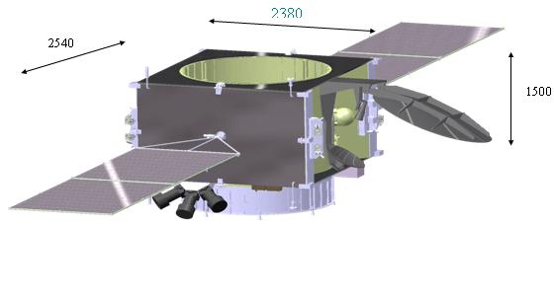

Figure 7.1 - Appearance of the spacecraft “Kazsat”

The Kazsat spacecraft, located in the geostationary orbit, carries out communication and television broadcasting through 12 transponders, covering the entire territory of the Republic of Kazakhstan and part of the adjacent state forces.

Table 7.1 - Main characteristics of the KazSat spacecraft

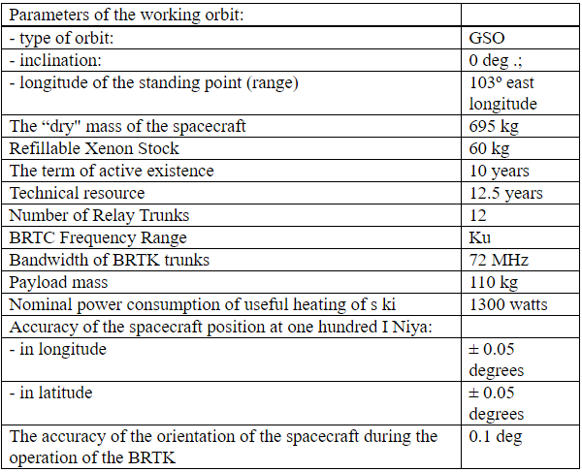

Table 7.2 - Frequency plan of KazSat ICA.

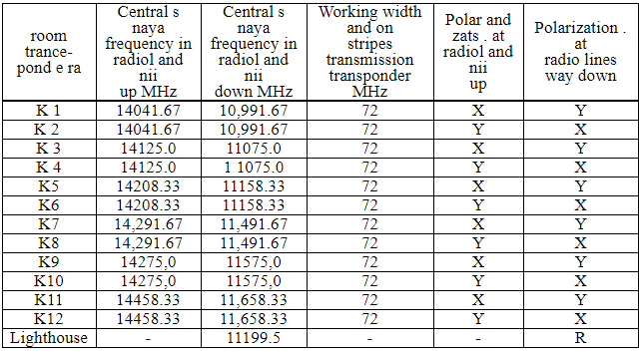

The dimensions of the service area are shown in Figure 7.2. The service area is provided by a combined transmitting and receiving antenna with a radiation pattern of 2.5 x 3.6 degrees formed by a two-mirror system with a profiled main mirror.

Republic of Central Asia, the Caucasus, central parts of the Russian Federation, including the Moscow region, fall into the zone of reliable satellite signal reception.

Table 7.3 - Results of calculations of the EIRP and Q-factor of the FCS “KazSat” ICA according to simulation data.

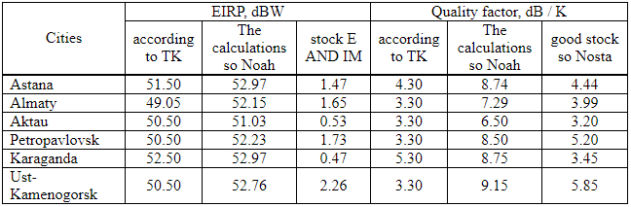

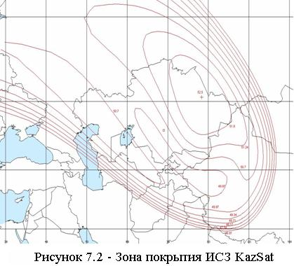

KazSat is intended for the organization of television and radio broadcasting channels, telephone communications, data transmission, broadband access to the Internet, the creation and development of VSAT networks, the creation of departmental and corporate communication networks, and the provision of a multimedia services package.

7.2 Ground control system

Navigation of the KazSat satellite will be carried out in the Terrestrial spacecraft control complex (NKU), which is located one hundred kilometers from Astana in the city of Akkol, Akmola region. The total area of ​​NKU is 6,916 square meters. km The Complex has the most modern equipment to date, which complies with international standards. NKU consists of three main divisions - a monitoring center, a control center and a payload department.

The ground-based control complex (GCC) and the communication monitoring system on the territory of the Republic of Kazakhstan provide the solution to the problems of managing, controlling and maintaining the given characteristics of the spacecraft at the stage of its regular operation. The functioning scheme of the NKU “Kazsat” spacecraft is shown in Figure 7.3.